What is slab heave costing your business?

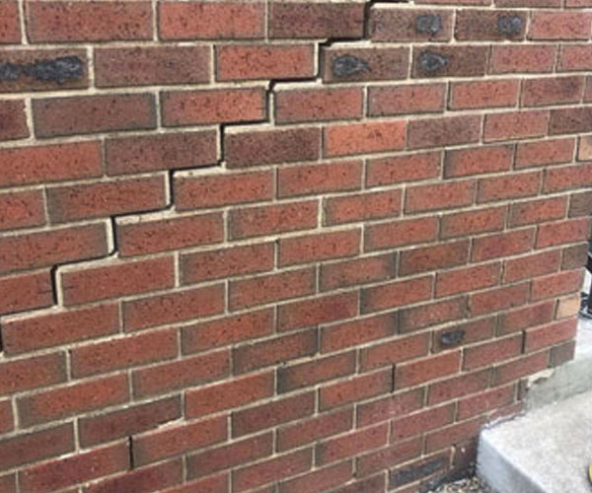
The VBA (Victorian Building Authority) put out a report regarding the growing concern of slab heave in new homes.
One of their recommendations to eliminate the problem is to conduct an independent inspection (rather than self-certification) of installed stormwater drainage systems. This should be an extension of mandatory inspections for building structures.
Drainflow are the only specialized drainage inspectors to offer a cost-effective independent solution to inspect drains on each site.
We are saving our home builder clients a lot of money. Talk to us today about how.

Drainflow; what we do?

Long-term sewer and stormwater damage on new home builds is hitting builders where it hurts, it severely impacts both your reputation and your bank balance.
We've got the solution!
Our fixed-price Drainage Inspection Package catches issues before homeowners move in. Our Post-Slab & Pre Settlement Drain Inspection on every build, sees repairs fixed on the spot, all included in the one low fixed-price. You’ll receive a comprehensive report & video footage for each inspection. We pride ourselves on our reputation, customer service is at the forefront of everything we do.

Heading; We have the capacity to take on the largest volume builders!

Heading; With over 50,000 jobs under our belt, we know a thing or two about drainage problems.

Did you know? From the homes we’ve inspected every second home built has on average 2 breaks in the storm water.
