Sample Website: https://districtgroup.ca/ or https://www.missiongroup.ca/
- Home page
- About Us – Org Chart and Brief Introduction on the company.
- Our Service –
- Project – similar to this one is desirable https://www.landaglobal.com/projects/
- Complete;
- Ongoing;
- Potential;
- Contact us
- Join Us(Hidden) – shown on the home page like the below: https://www.landaglobal.com/

Company logo:
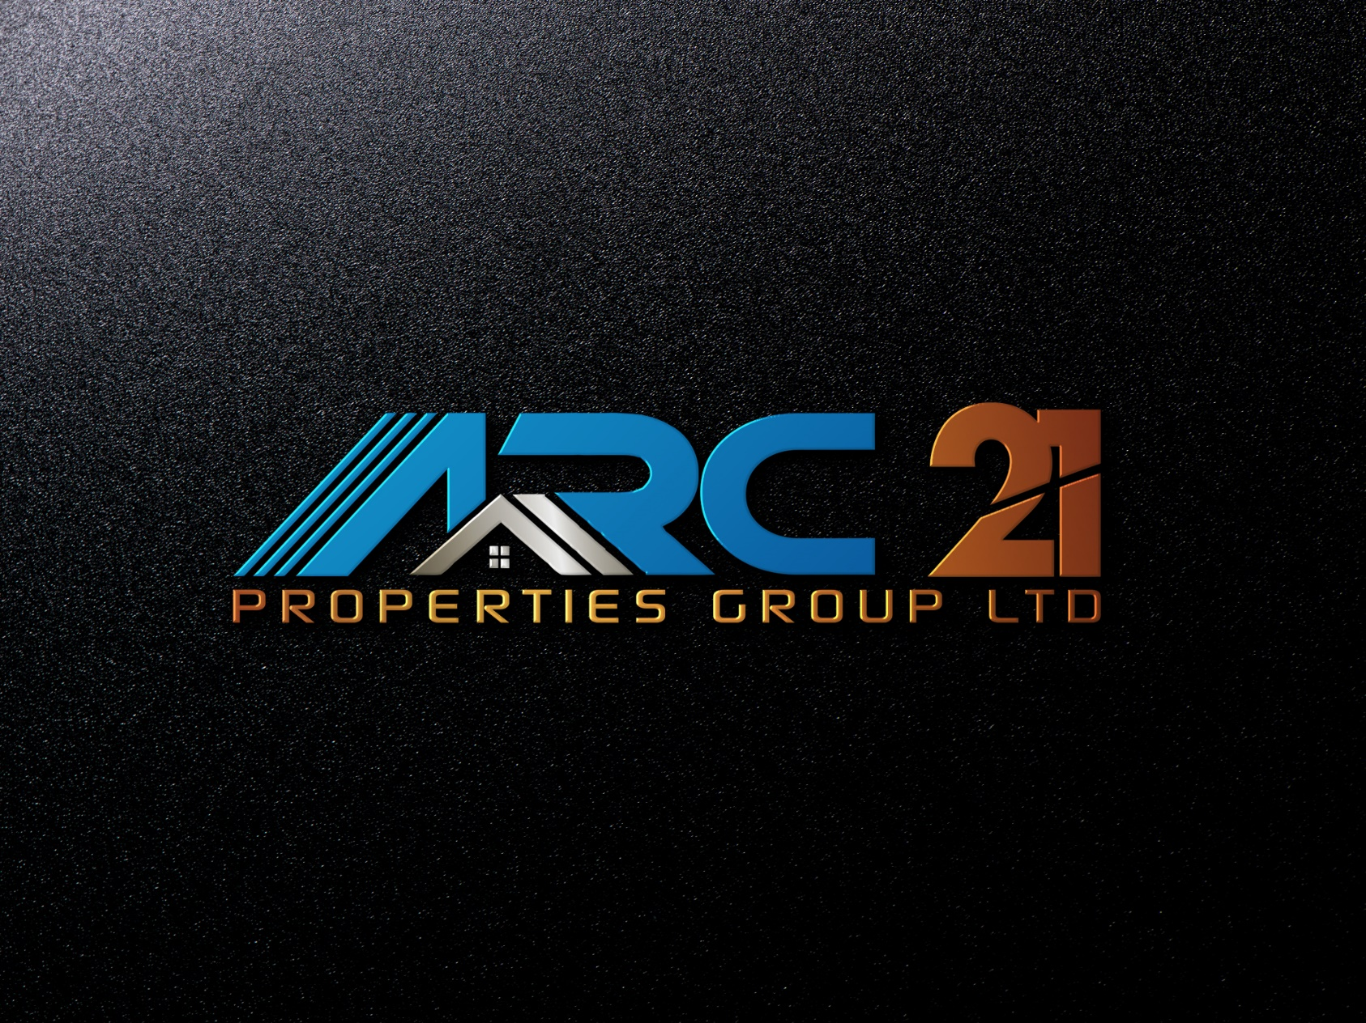

The head bar is to be shown like this
http://forefieldgroup.com/

The projects to be shown like this
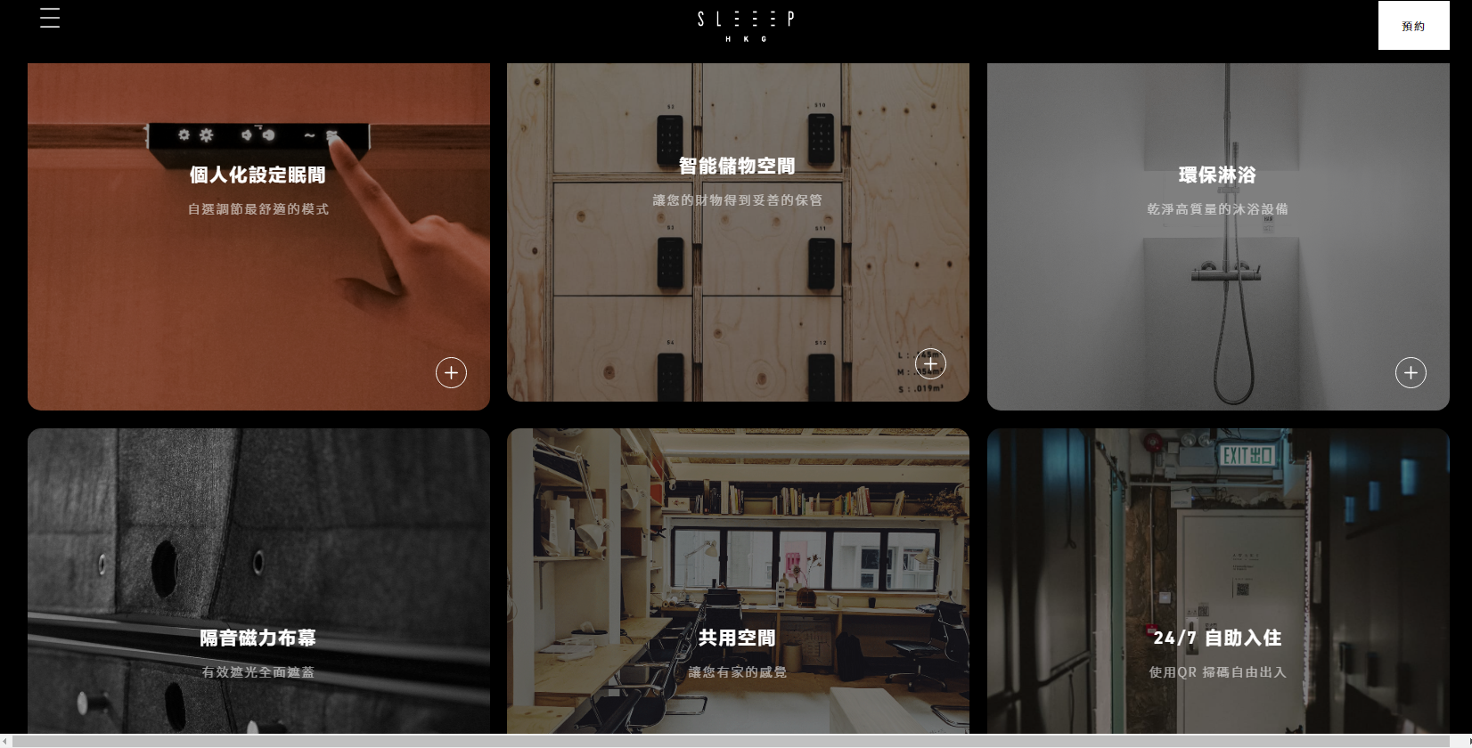
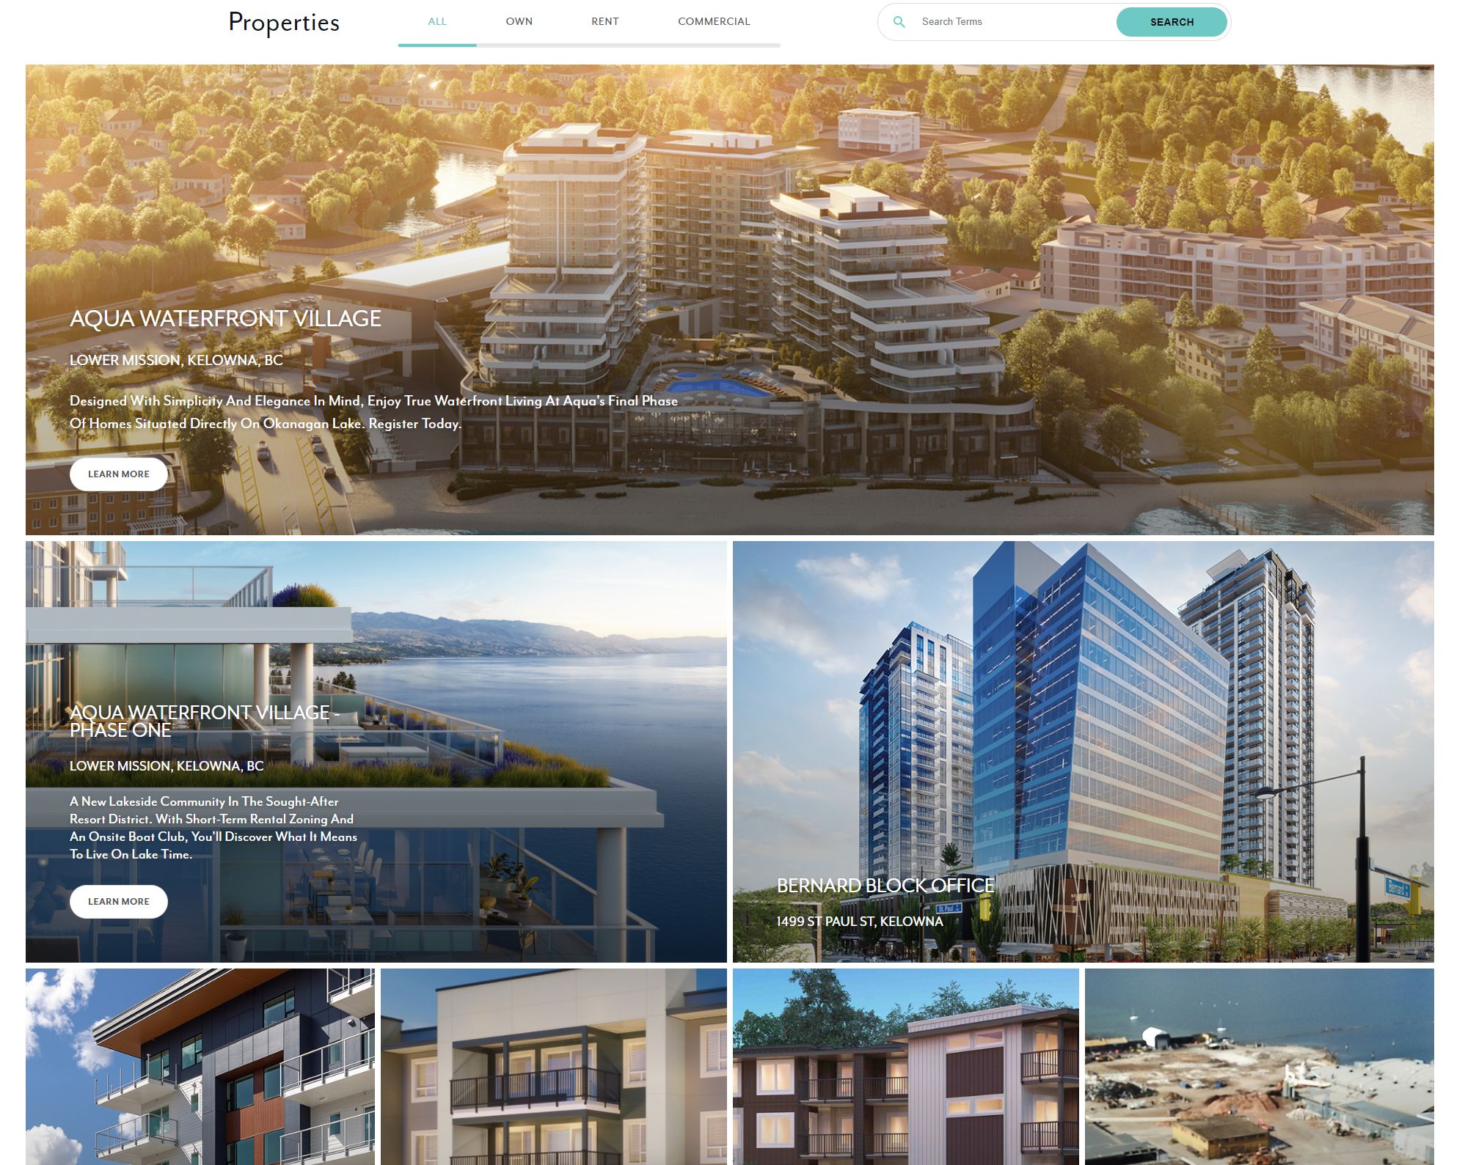
Fonts preference: the below samples are for reference/
