Brief
Create a brand mark and font type (which we’ll use as a logo) for a new fashion label, GRASSO. Grasso is a new brand born from the brains of two friends, and lovers of dance music, Pete and Josh. Grasso are a clothing brand which takes inspiration from the world of dance music, it knows no boundaries a true global name. Its namesake, Francis Grasso, was known for being the first DJ to mix 2 records together, creating the foundation of the modern club DJs technique.
Three fundamental areas of focus for the brand are:
• Focused on sustainability
• Collaborative (customer focused)
• Always emotive (of dance music in particular)

Considerations
The brand must be able to be seen in a saturated market. The brand logo needs to also have a brand mark which can be easily recognisable on garments and recalled by the consumer.

Within the three areas of focus, the branding must consider:

Customer focused
- Limited editions
- Pre-orders / batch ordering
- Transparent with lead times
- Transparent with supply chain
- Collaborations designers of the world
- Consumer collaboration on designs
- Responsive to feedback
- Development of new products with consumers
- Limited editions

Focused on sustainability
- Echo / green
- Fair pay
- Fair trade
- Slow / conscious fashion
- Transparency
- Close that last
- A way to recycle product
- carbon footprint
- Greater ecological integrity
- Vegan

Always emotive – that feeling that music evokes
- Euphoria
- Positivity
- Inclusive
- Unity
- Love
- Goosebumps
- Hedonism
- Escapism

Brand Mark

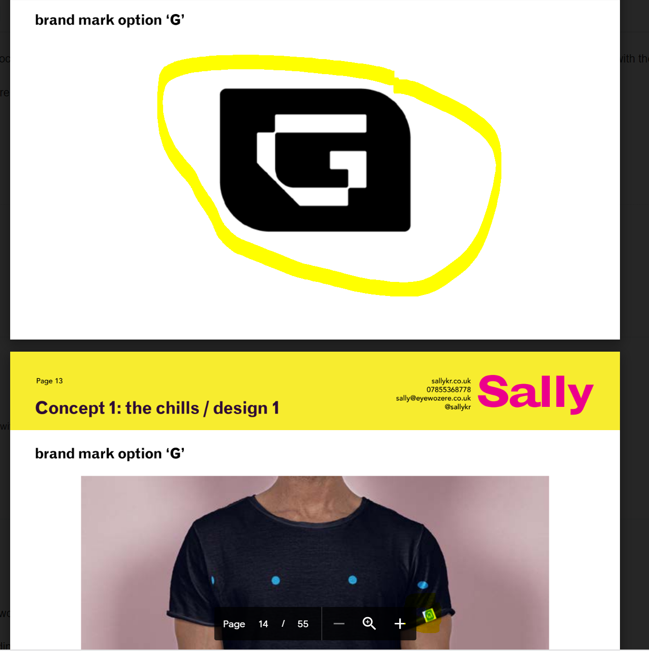
Please note this mark will be on the t-shirt. So please keep in mind that its got to be printed/ embroidered on clothing

