  Perks that come from working with Professionals
  - Free Estimate
  - Professional Interior Design Consultation
  - Insurance Inspections assistance for an accurate assessment
  - Insurance claim advocacy
  - Once stop shop – General Contractor to assist with all of your Restoration and Renovation needs
  - Referral Bonus
  - Military Discount
  - Free Architectural Consultation
  000000000
  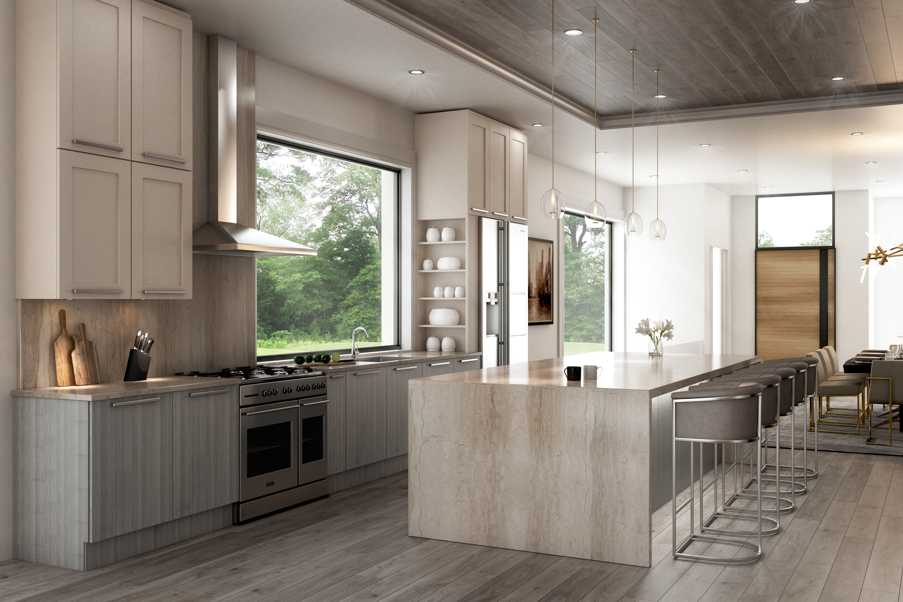
  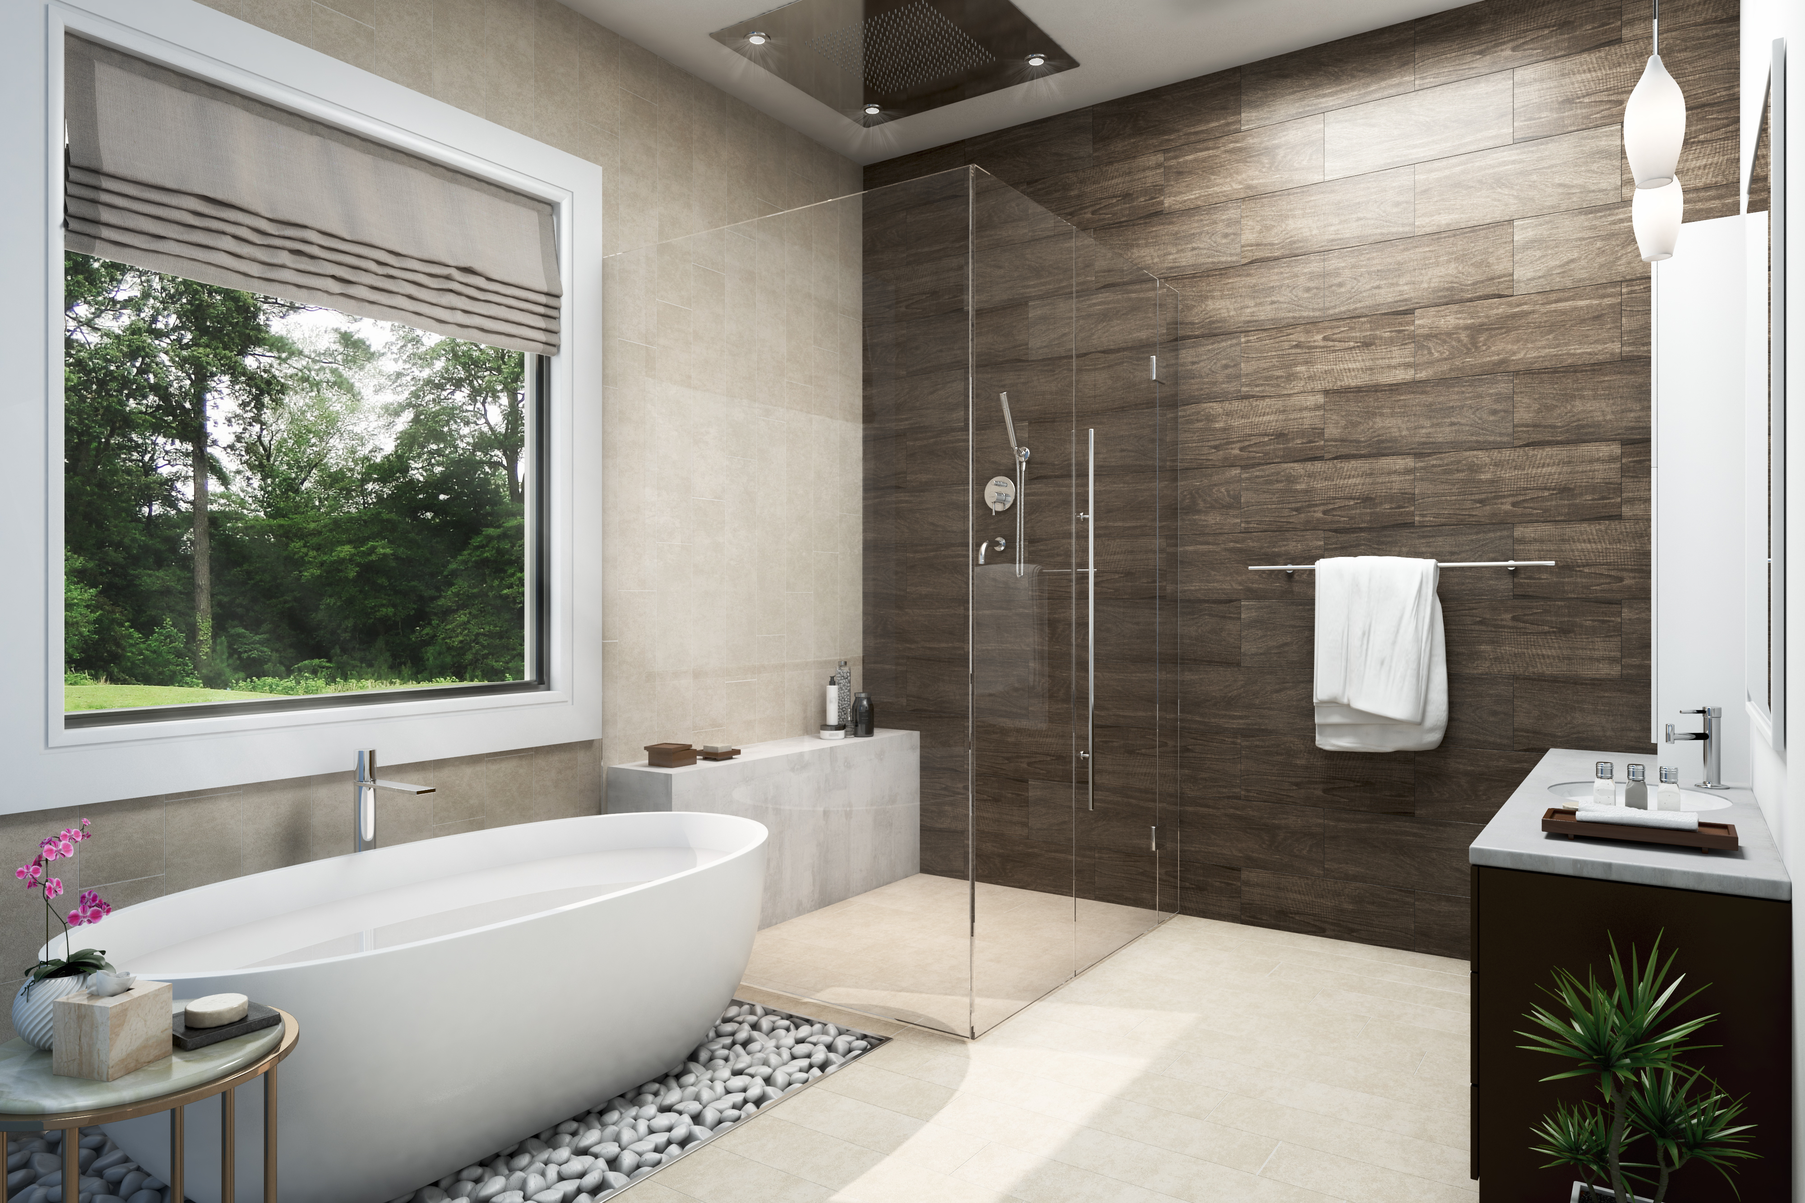
  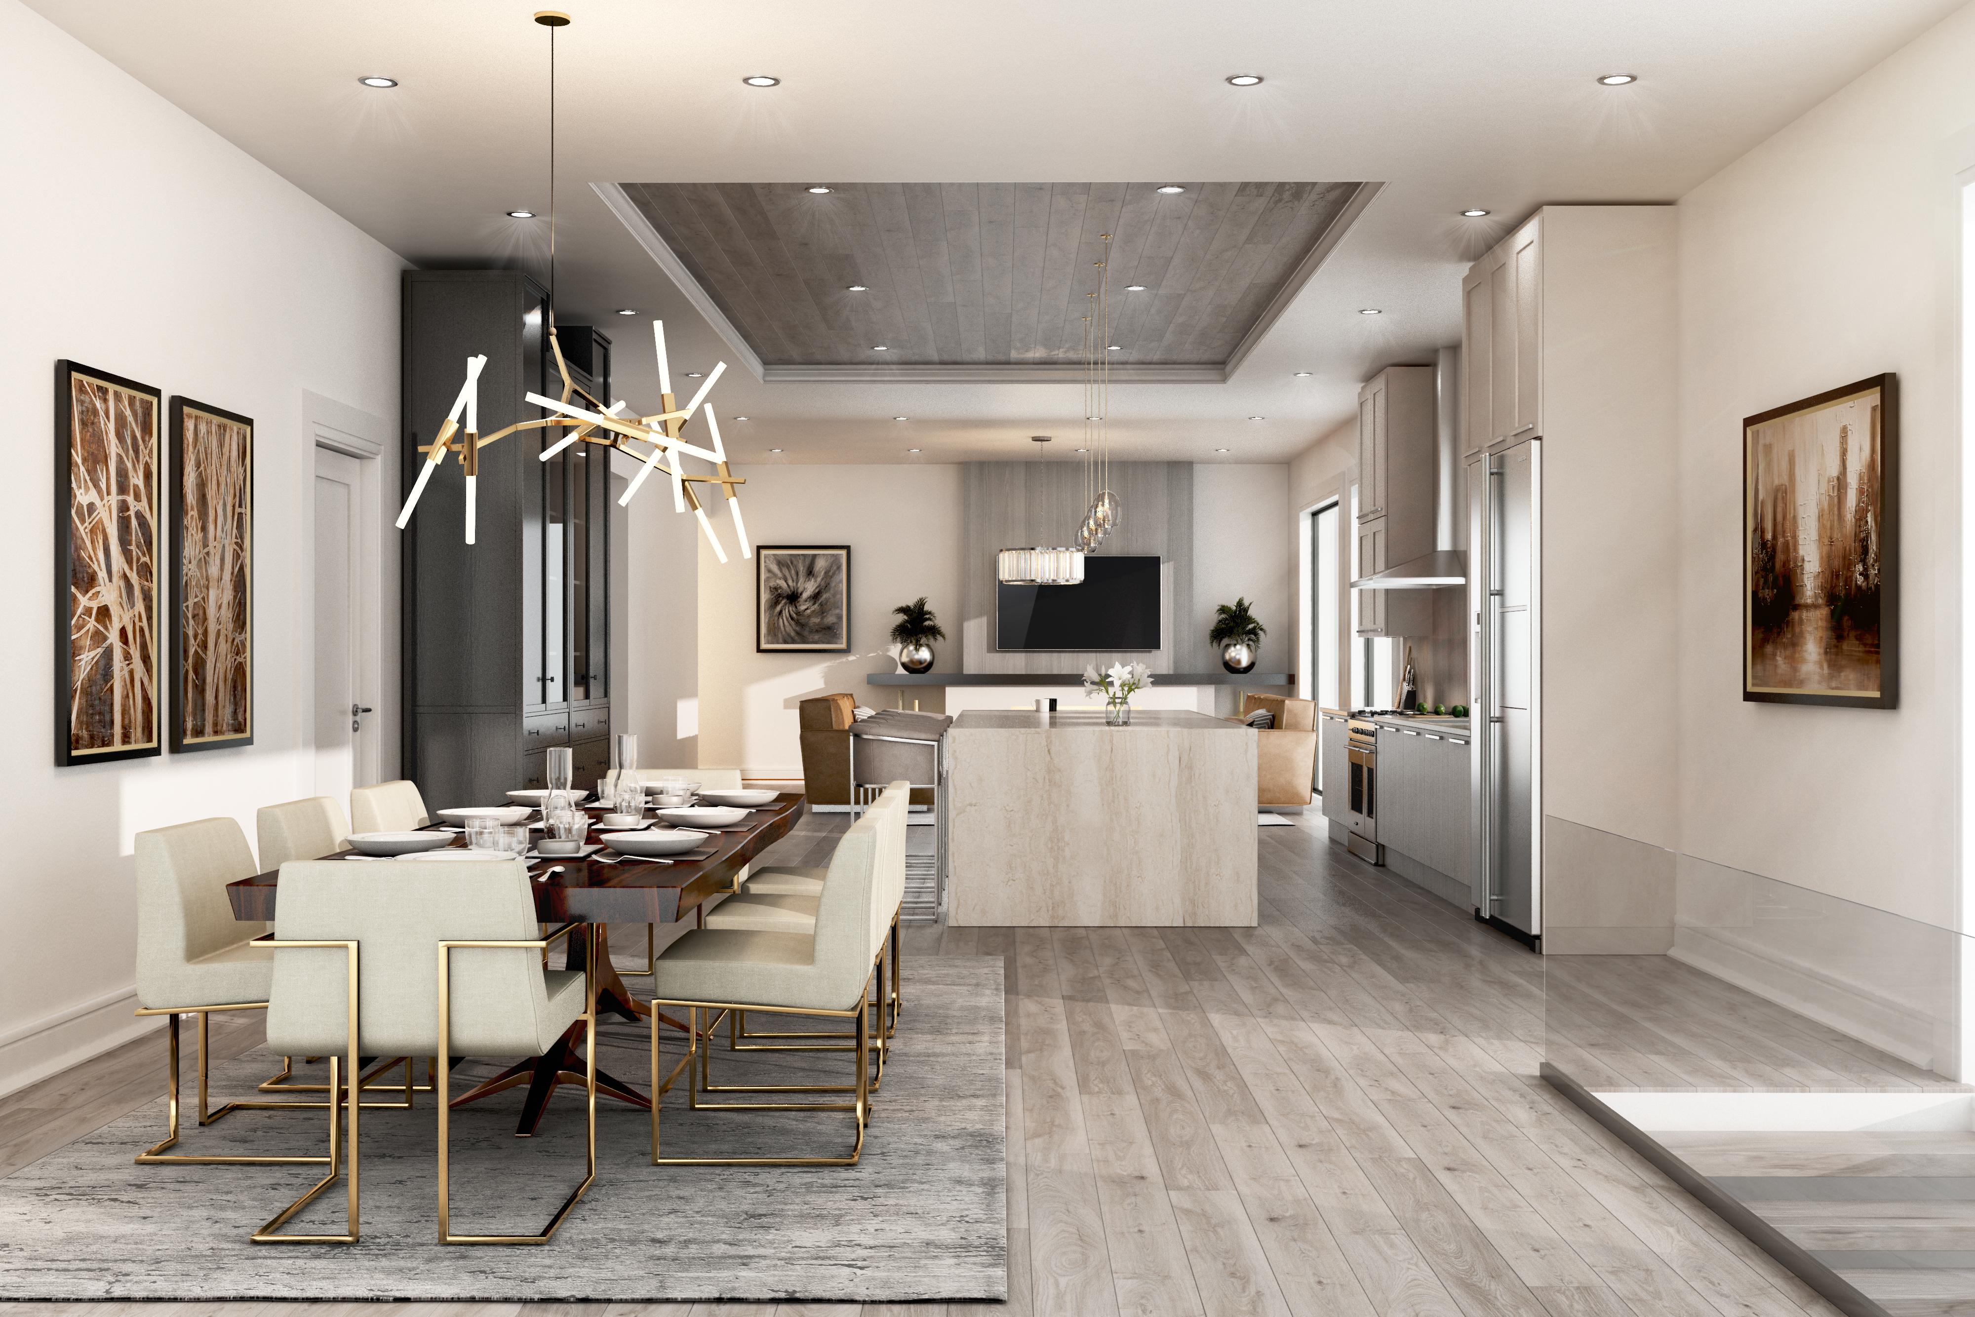
  Naperville Roofing and Construction
    - Licensed and accredited company with over 20 years construction experience in Residential and Commercial Renovation and Restoration.
  Exterior Home Remodeling
  - Roofing
  - Siding
  - Gutters
  - Soffit / Fascia
  Interior Home Remodeling
  - Home Improvement
  - Kitchen Remodeling
  - Bathroom Remodeling
  - Deck / Patio Build Out
  New Construction Dream Homes
  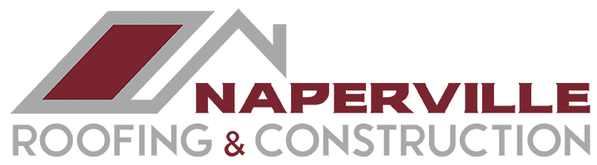
  sSince 1996
  Since 1996
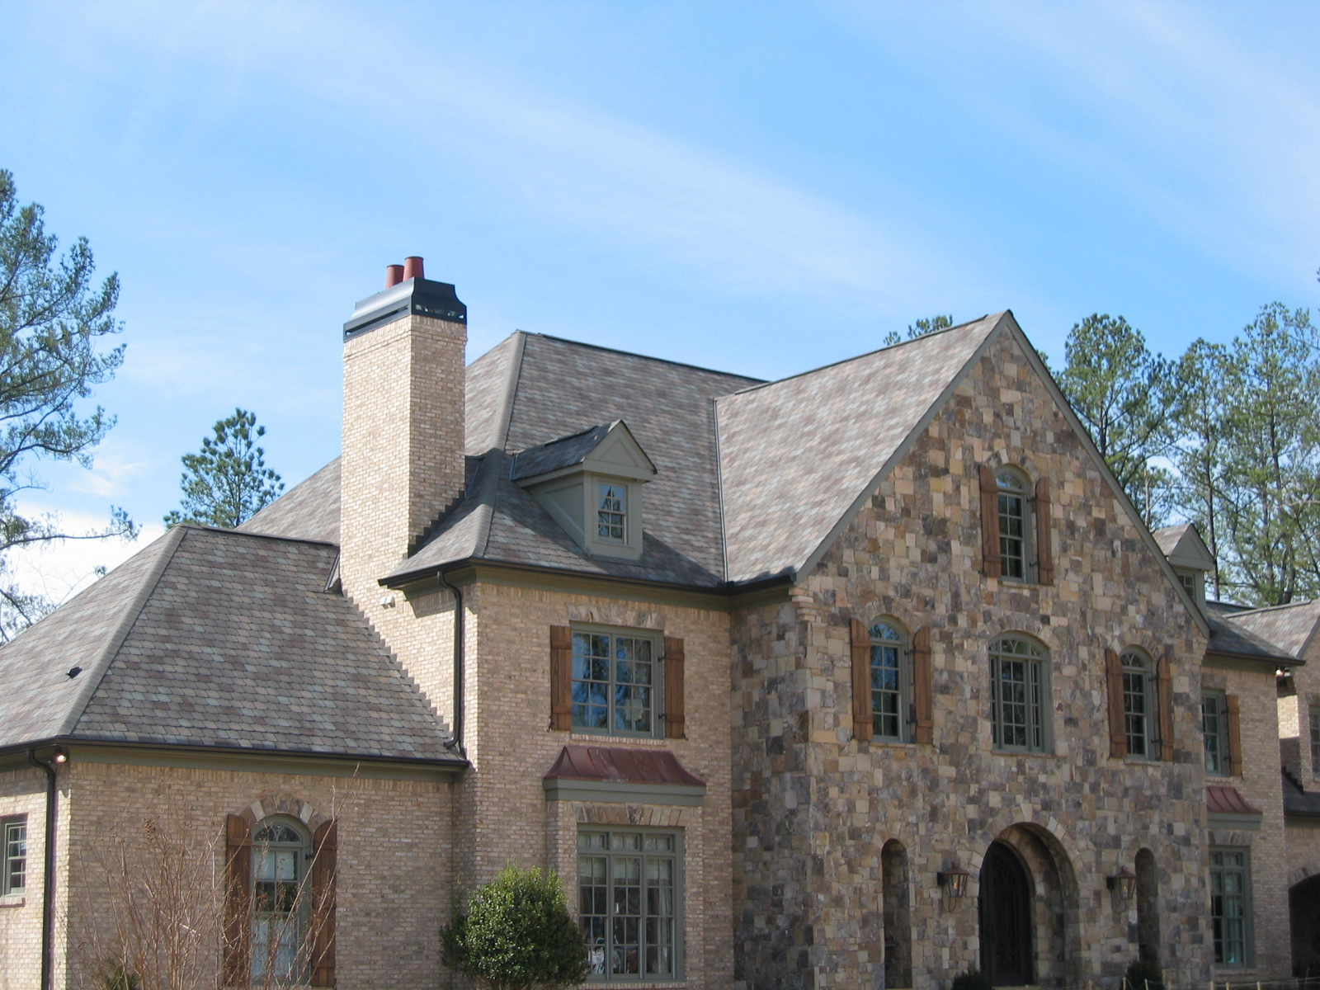
 |  | 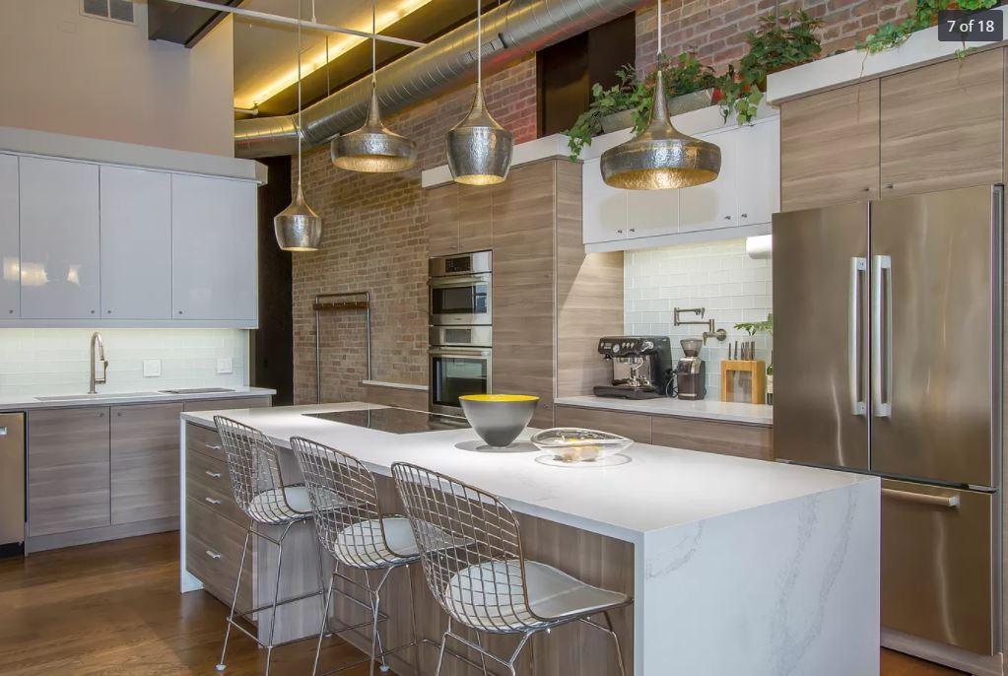
  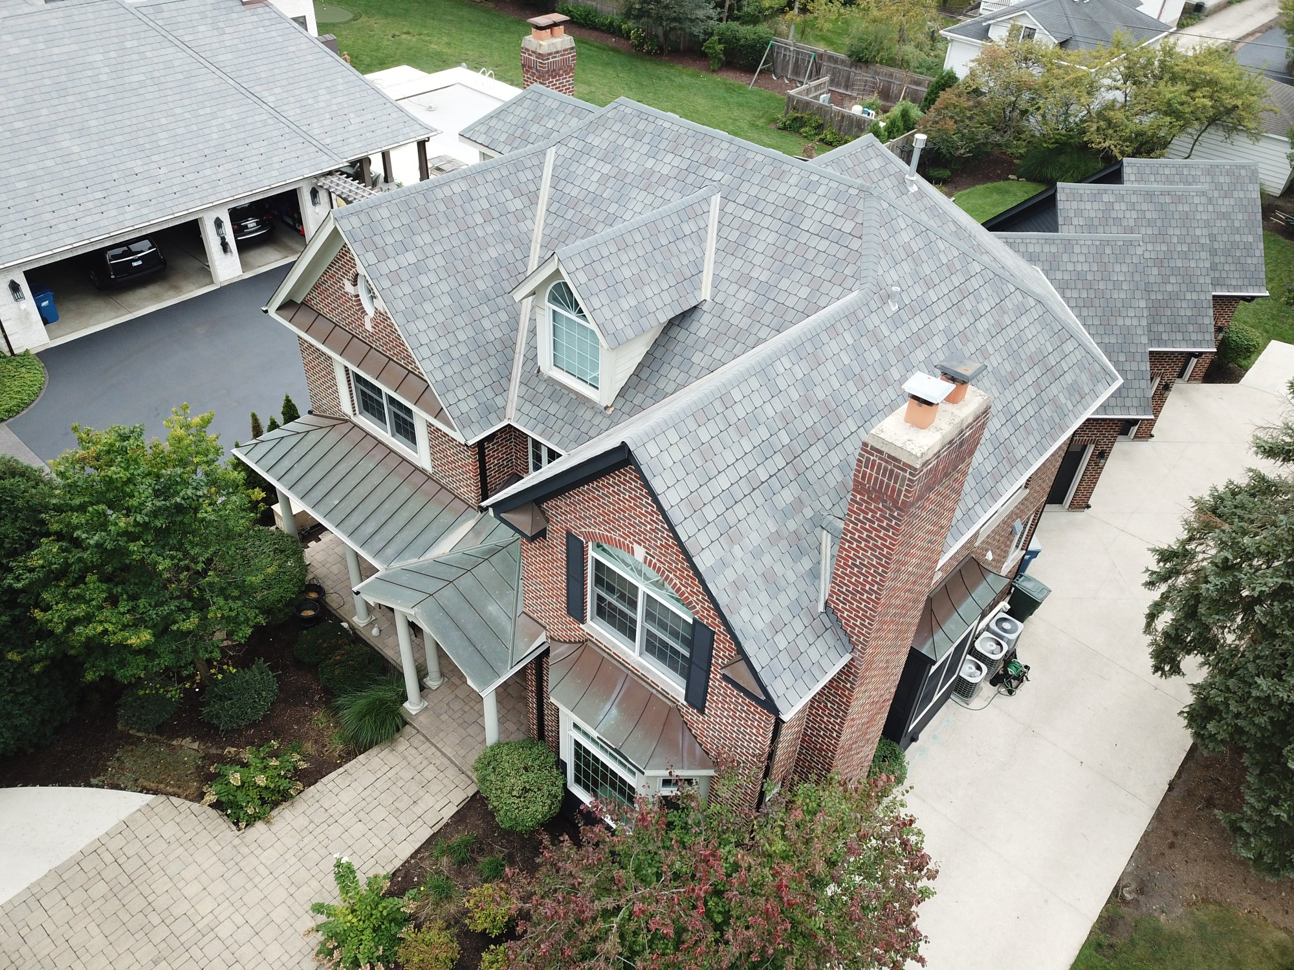
  Roofing,Siding & Gutter
  Whether you’re looking to do roof repair, roof replacement, new gutters, new siding, trust our licensed professionals. We work with the top manufacturers in the industry Atlas Signature Select Roofing System – Storm Master Shake, Pinnacle Pristine
  Lifetime Warranty
  Storm Damage
  Renovation or Restoration
  Time for new Roof, Siding or Gutters? Hail or Storm damage? We are here to assist in every aspect. With decades of experience negotiating with Insurance companies for accurate assessments, we work with the best trades for the project, and ensure your home is not only built well but looks just as beautiful.
  Kitchen Remodeling
  Your kitchen is the central hub of every home. We’ll collaborate with you to make this space open and functional for everyone to enjoy. We use the latest building products and trends to meet and exceed your expectations.
  “I wake up every day excited to use my dream kitchen. Thank you, Naperville Roofing and Construction!” - Janet Murphy
  Bathroom Remodeling
  Make It Picture Perfect
  Give your bathroom a new life and increase the value of your home at the same time. We offer full
  service design assistance to transform the
  bathroom into your very own spa retreat.
  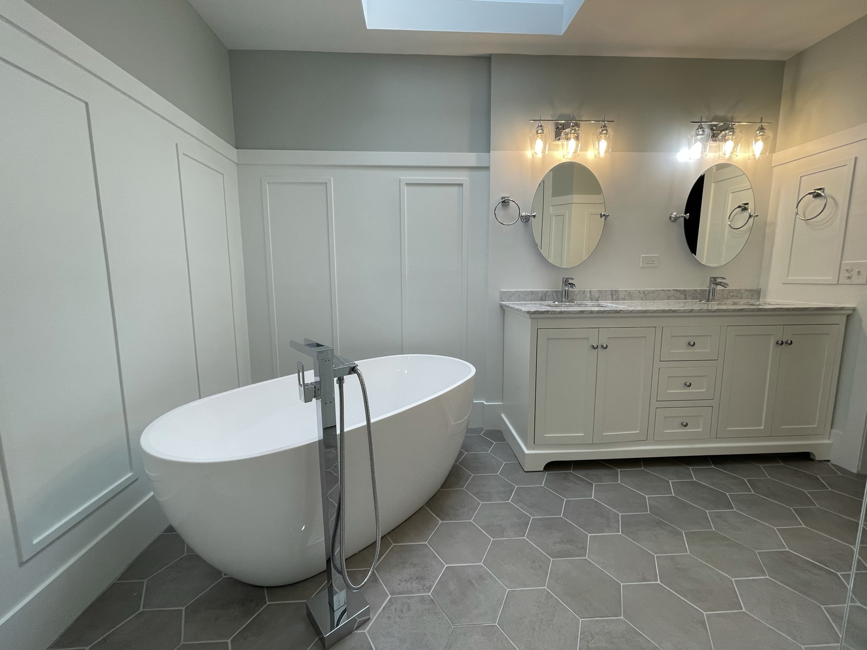
  Contact Us
  Naperville Roofing and Construction
  10220 Bode Street, Suite C
  Plainfield, IL 60585
  630-541-4998
  napervilleroofing@comcast.net

