What we mean by taking the art and implementing it into a webpage is an example below, NOT The Style but just how the art can be a part of the page experience without it looking like a header image of an art scene.

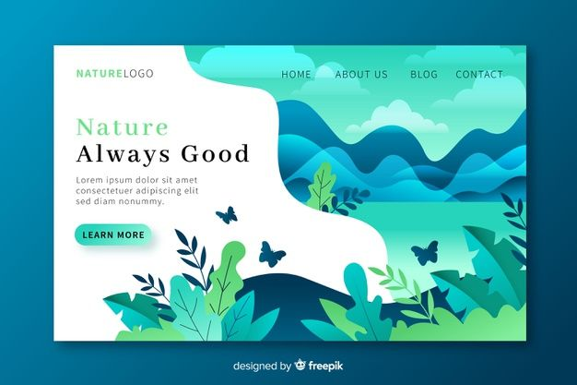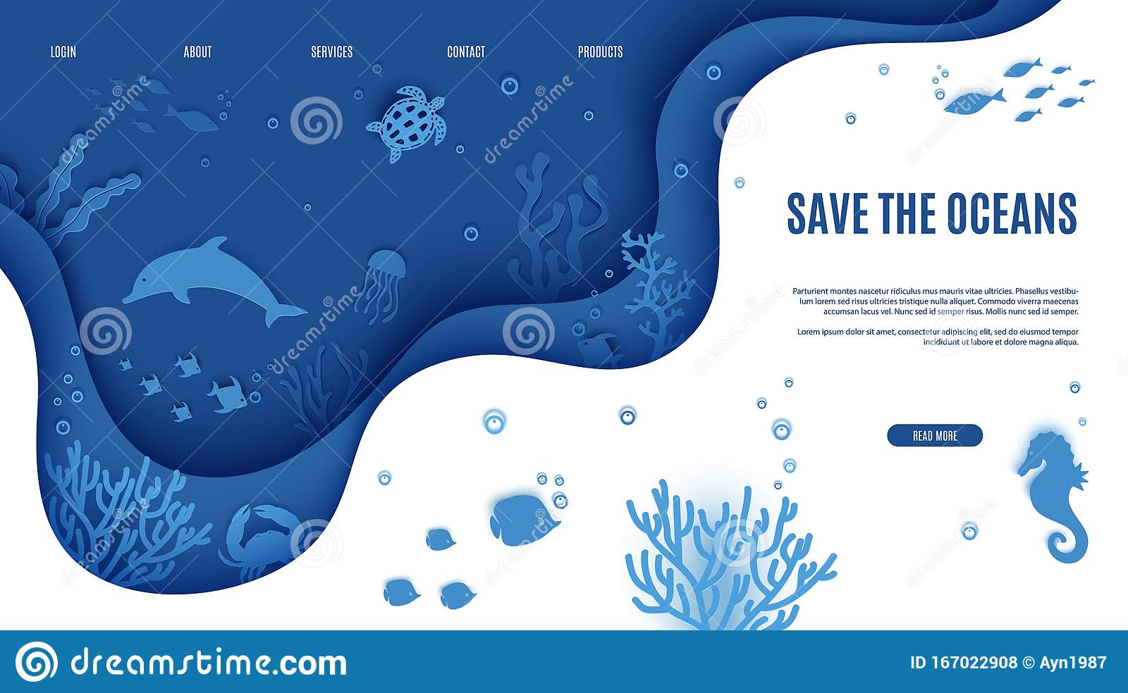

When we mention seamless integration of art that is designed onto the page and still has the web page features this is what we are referring to. https://dcassetcdn.com/design_img/3949793/577927/26589350/h51zg7a2ahr5fxt7p9cfcbtz77_image.jpg

Unlike the pdf version of an attempt at designing our website the designer used the entire scene of each file and just converted it into a website. We want our site to still resemble a website and integrate the artwork into the pages naturally.



Design style we are trying to stick with extreme, badass, style design that is not childish or cartoony. For the art designs we went with dark, dangerous which is what we want to keep. But for the pages background they don’t have to be fully dark like black. Like this example above the mother and daughter could be dark artwork popping off the page that is a lighter color.

When we say we don’t need to use the full scenes of artwork this is what we mean. We don’t want it to look like a header image has just been placed on the page.

