NYE Party
Logo & Design Project Brief

EVENT BACKGROUND
We are looking to create branding for a fun, yet chic New Year’s Eve party. We want this to feel like the true party of the century. The evening will start with a band, but transition into a DJ to pump it up and give an after party feel.

Think Baz Luhrmann’s modernized The Great Gatsby. However, this is not a Roaring 20s Party, nor do we want to allude to the 20s. This snipet of the movie/music video gives you a sense of the feeling and event we are trying to achieve: https://www.youtube.com/watch?v=0ZgjmE6xdaw.

The party will take place at a private club that has both a younger and older membership, our goal is to target the younger crowd. We want the graphics and design to speak to the younger, modern demographic ready to party. However, we do need to keep it classic not crass.

PROJECT SCOPE
We are looking to create branding for a fun, yet chic New Year’s Eve party. We want this to feel like the true party of the century.

We are looking to create a "logo" or consistent branding for this event that communicates our intentions. We have confirmed copy and a vision of graphics that we need laid out together. We have an additional elaborate graphic vision that we would like laid out as well. Further details can be found on the uploaded document.

COPY FOR LOGO
This will appear on the majority of event collateral from Save the Dates to Invitation to day of event pieces. We like the idea of varying fonts that are fresh and modern – a mix of fun script and graphic block lettering. An initial thought was the Celebration of the Century line wrapping around in a half moon above. VHC in a monogram with the H larger as well as Ring in 2023 line below it centered. Last two lines below.

Required Copy:
Celebration of the Century

VHC
Ring in 2023

Pop, Fizz, Clink
This New Year’s Eve

BASIC IMAGERY FOR LOGO
For simple magazine Save the Date and Kick Off Party Event, utilize these images in conjunction with copy. Would tie in and be replicated in the Elaborate Imagery.

Our initial thought was to have a champagne bottle popping in the bottom left corner. Maybe a fresh, more hand drawn looking Dom Perignon bottle. In the top right corner, we would have fireworks or sparklers. We like the hand drawn yet chic feel for this as well.

ELABORATE IMAGERY FOR LOGO/EVENT
This imagery would be used as a background and/or border to printed material including formal Save the Date, Invitation, Cocktail Napkins etc. It could be illuminated on walls or dance floor, utilized in photo booth. Would be used in conjunction with copy. Would not be used with Basic Imagery for Logo. However, the Basic Imagery motifs would be incorporated into this.

Our inspiration is the imagery on DJ Lucy Wrubel’s website (https://www.lucywrubel.com/). See below. We like the modern fresh, handdrawn feel.
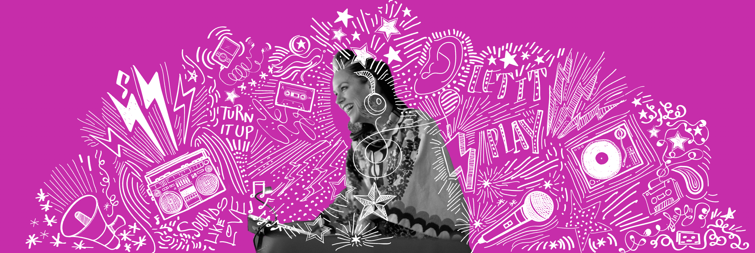

The idea is to create a repeating pattern/print in a modern, fresh, hand drawn feel using iconic NYE imagery as well as wording: Martini Glass, Champagne Flutes, Champagne Bottle (one that is used in Basic Imagery), Drum Set, Microphone, DJ Turn Table, 2023 Eye Glasses, vHc monogram, NYE, Turn It Up, Pop, Fizz, Clink, Stars, Noise Makers, Sparklers and or Fireworks (one that is used in Basic Imagery)

COLOR SCHEME
We are interested in vibrant, fun jewel tones for copy and images. We like the idea of ombre lettering from hot pink to purple to blue. Open to ombre going vertical or horizontal. As for background, we were thinking black.

Inspiration:
