- Panel Tradeshow Booth design Required

- Single panel size: The panels are 970mm wide and 2300mm high, The metal joints are 30mm wide. In total, there are 6, 3 panels on the left and 3 pieces back (in the attachment a sketch of the stand "stand.jpg")
- Colors: in shades of gray and blue, possibly a shade of orange.
- Additional optional elements: background photo(s) of the aircraft or aircraft turbine. The company operates for the aerospace industry.
- Logo firmy: logo_1 lub logo_2
 LUB 
- Logo: AS9100D
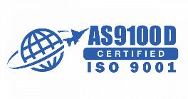
- Website address: www.salloytech.com

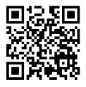
- Adding a QR code using our encrypted website (the correct QR code in the attachment called "QR_Salloytech.png"

MERYTORYKA
- Content:
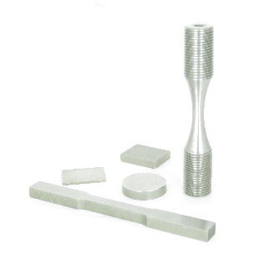
TEST COUPONS, SPECIMENS AND SAMPLES MADE OF:
- NICKEL AND COBALT BASE SUPERALLOYS
- TITANIUM
- HARDENED STEEL

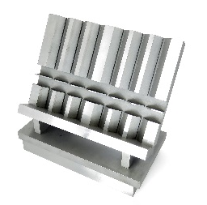
LABORATORY ACCESSORIES:
- FIXTURE DESIGN
- MANUFACTURING

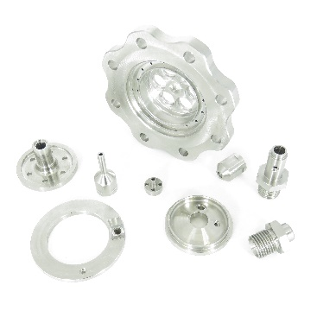
MACHINING OF:
- FIXTURES
- SPARES
- CUSTOM PARTS
- SUPERALLOYS

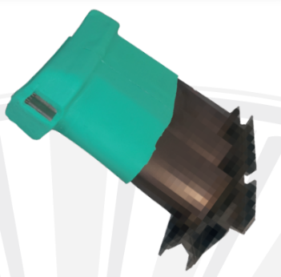
REUSABLE SILICONE MASKING / HARD MASKING FOR:
- THERMAL SPRAY
- GRIT BLAST
- SHOOT PEEN

(photo can be taken from a file “Salloytech_ES.ai”)

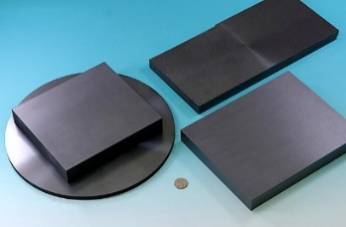
SiC - SiC CMC
- CUSTOM SHAPES
- SAMPLES

