Design Brief for Firewalker Kava
Business Overview
FireWaker Kava is looking to:
- Create a new brand of Kava in the online retail space
- Become the number one Kava brand on the Amazon marketplace
- Provide the highest quality brand in the Kava product category
Firewalker Kava will be opening an Amazon marketplace store. Providing the market with a premium Kava root product. Kava is an herbal plant that is local to the people of the south pacific islands. It has a historic use in ceremonial rituals and social gatherings. People seek out Kava as a non pharmaceutical remedy for anxiety disorders. Traditionally kava would be drunk in a Tanoa fai‘ava (kava bowl).

Firewalker Kava has relationships with suppliers based on the islands where the Kava is naturally sourced. Firewalker Kava’s revenue stream will rely on generating online sales from these locally sourced Kava root products.

Project Objectives
The company needs an eye-catching logo that will entice new customers. Once the customer gives the company a chance, the quality of the product will speak for itself. The logo will need to light up the digital shelf space.

The Problem You’re Facing
The company's immediate need is to create the logo that will be associated with all online platforms. The company needs to start creating all the accounts that can be used for free advertising and in addition, future marketing campaigns.

Project Specific Information

The design template will include a collection of competitor logos that are currently advertised on Amazon. With the brands broken up into the best, mid tier, and bottom tier.

The bags will be black.
The dimensions of the bags will be: 5 7/8" x 3 1/2" x 9 1/8" (Outer Dims)
The bags will be made of: Matte Black Metallized Stand Up Zipper

The customers will be able to buy a package of 8oz to start

There are certain elements that need to be included in the design.

The font needs to be reminiscent of “graffiti font,” and legible.
The name of the company,“Firewalker Kava” needs to be prominently featured
The effigy(silhouette) of a human being should be inserted into the base of the letter,“F.”
The image of the person should be walking left to right over a flame/lit coals and holding or drinking from a coconut shell.
The primary colors of the logo need to be red and orange.

Contact Information
Michael Garcia
Phone number 904-612-4087
Email:FirewalkerKava@gmail.com
Hours available 9:30am-5pm Monday-Friday
Instant messages are the best way to get a hold of Michael
Kava Root Extract market size, share, industry Forecast 2029 (fortunebusinessinsights.com)

Source on the Kava business

Collection of competitors branded products

Best

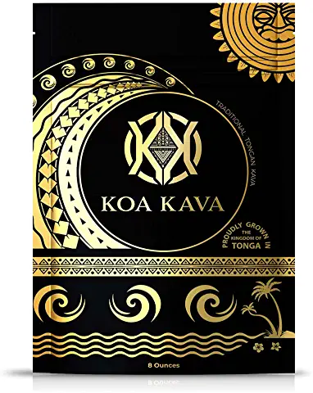

Tongan Kava Kava Root Powder – Noble Pouni ONO Kava Tea Drink for Relaxation

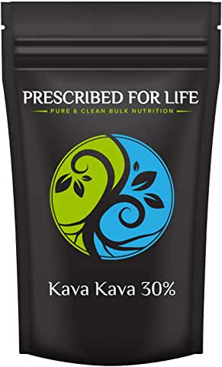

Prescribed for Life Kava Kava - Rhizome Root Fine Powder Extract - 30% Kavalactones

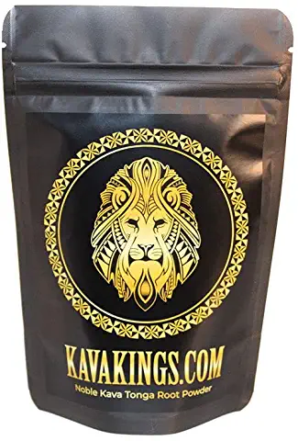

Kava Kings Kava Root Powder-Noble Kava Tonga 5oz-Naturally sourced from 'EUA

Mid tier

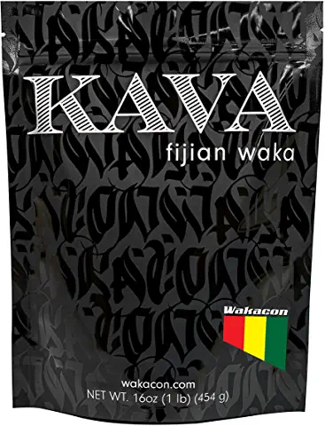Wakacon Kava Waka Powder – Authentic, Noble Kava Root Powder from Fiji

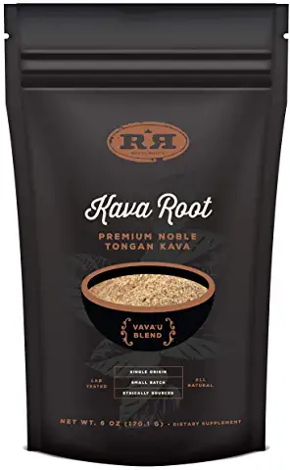

Kava Root Powder - Tongan Noble Premium Natural Kava Drink, Calming Stress Relief,

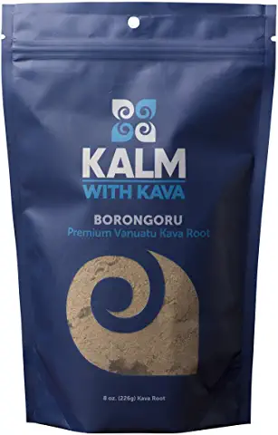

Borongoru Vanuatu Kava Root - 100% Noble Kava-Kava (1/2 LB)

Bottom tier

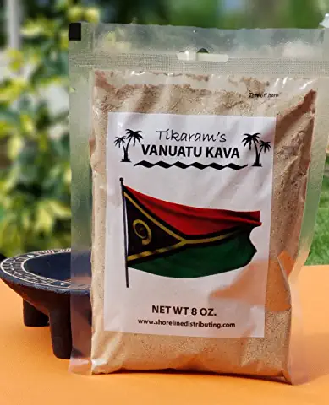

Kava Kava - Premium Vanuatu Kava 1/2 Pound (8oz) - Fiji Market Wholesale

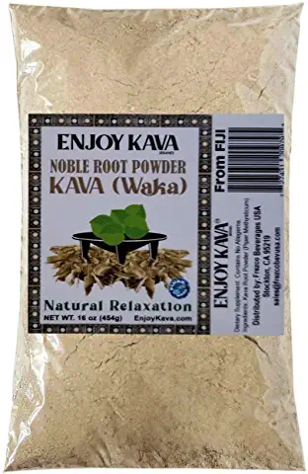

Fijian Trader ™- Noble Kava Root Powder (WAKA) 1 Lb - All Natural Stress Relief | Relax
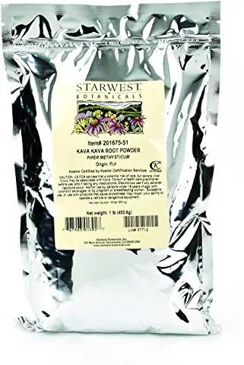

Starwest Botanicals Kava Kava Root Powder, 1 Pound
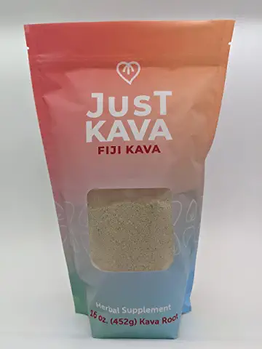

Fiji Kava

