We are looking to freshen up the look of our existing website using a new logo, company name and colour scheme. Needs to be responsive and mobile friendly for all browsers and coded for both Android & IOS. SEO is also important. Want something visually grabbing that displays growth, quality and confidence.
WordPress or Joomla – must be desktop and mobile friendly with fast page load speed. Need the ability to edit ourselves. Need interactive map where can mark as sold, pending, available with prices. Can keep existing map layout but it will need to be refreshed.
Will need instructions or to be shown how the map is edited to change from pending, sold, available, price etc.
Existing website:
https://westanaindustrialpark.com/
Name changing from Westana Industrial Park to Redwater Industrial Park
4 pages
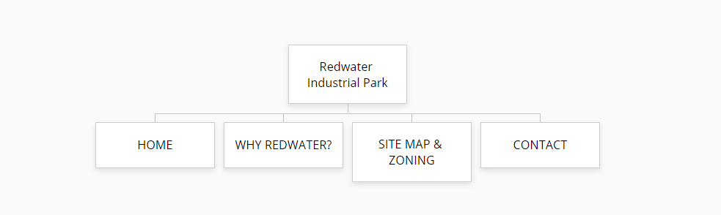
HOME
Redwater Industrial Park is situated in a growing Industrial core for Northern Alberta in the county of Thorhild. With close proximity to the Redwater upgrader, the Agrium fertilizer plant, the town of Redwater, and easy access to Highway 63, the Redwater region is just tapping into its potential as a regional hub.

Insert picture of map of where the land is located.

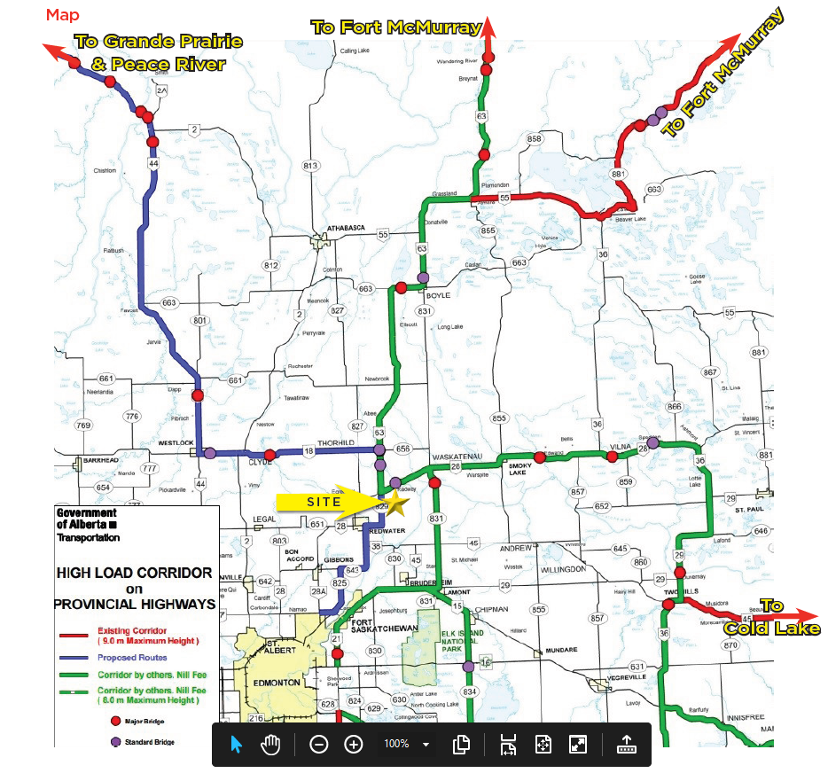
Map on how how to find us.

Call to action – LEARN MORE – linking to WHY REDWATER?
WHY REDWATER?
LOCATION ADVANTAGE
Located approximately 80 kilometers northeast of downtown Edmonton. The two main provincial roadways through the County are Highway 28 and Highway 63. This is the route from the Edmonton region to Fort McMurray, heavily traveled by workers and used to haul equipment and materials to the oil sands.

A NUMBER OF USES

Industrial lots could serve a number of uses including equipment and pipe storage as well as maintenance shops. Ideal location for a staging area for pipeline companies or storage of materials to be shipped to Fort McMurray.

A SPACE TO MEET YOUR NEEDS - BUILD TO SUIT OPTIONS
Have your building tailored to your specifications and purposes. Our build-to-suit service can provide you with a shop, office or other facility from which to run your operations. If you have additional needs, consider the option to incorporate a lay-down yard, storage space, added security, or any combination of the above.
Energy is readily available with gas and electrical services to the property line. Whether you need a large lot of land or just an acre to call your own Redwater Industrial Park can offer you the perfect plot.
Call to action CHECK SITE AVAILABILITY – linking to Site Map & Zoning
Insert site photos
SITE MAP & ZONING
Need interactive map where can mark as sold, pending, available with prices. Can keep existing map layout but it will need to be refreshed.
ZONING

The general purpose of this District is to provide opportunities for light industrial and
manufacturing uses, with heavier industry permitted in approved locations at the
discretion of the Development Authority.

Permitted uses include, but are not limited to:

Animal breeding and/or boarding facilities
Animal hospitals
Automotive and equipment repair shops
Auto wreckers
Buildings and uses accessory to permitted uses
Communication tower facility
Equipment rental establishment
Greenhouses
Heavy equipment sales and service, repair or storage
Intensive agriculture
Industrial use, light
Industrial use, rural
Public or quasi-public services
Public parks
Public utility buildings and uses
Sea cans and shipping containers
Solar energy collection system
Transfer station
Trucking and cartage establishments
Vehicle repair establishments
Veterinary clinics
Warehouse sales establishments
Wind energy conversion system, micro

Discretionary Uses

Auctioneering establishment
Buildings and uses accessory to discretionary uses
Bulk fuel storage and sales
Industrial use, heavy
Natural resource extraction
Surveillance suite
Wind energy conversion system, small
Wind energy conversion system, large

Business That Will Be Moving Into Red Water Industrial Park
Heavy Duty Mechanical Repair Shop
Equipment Sales & Service
RV Storage (Covered)
RV Repair
Feed & Bedding Processing Plant

CONTACT
Reformat and freshen up page

