

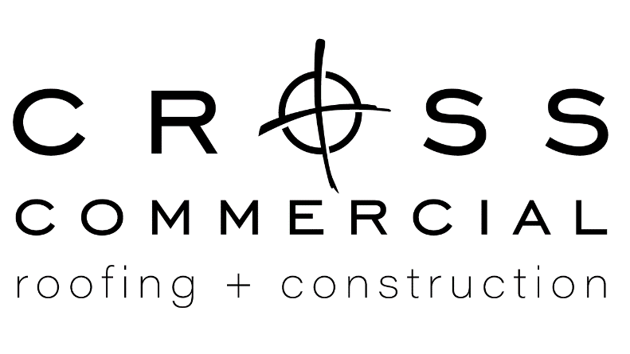
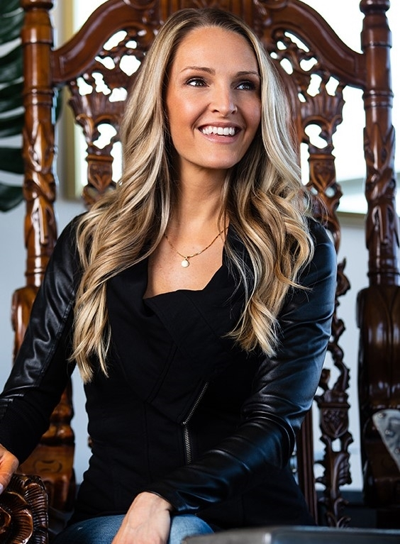
10220 Bode Street, Suite C Planfield, IL 60585
312-650-9155 | www.crossroof.com

World Vision International

Clean Water Efforts
Bring clean water wells, sanitation,
& hygiene to communities in need.

Christian Life Center

Local and World Missionaries
Rebuild and restore, food shortage aid and Christian outreach.

Shared Hope International

End Child Sex Trafficking
Bring an end to sex trafficking through
prevention, restoration, and justice.

10% of all Cross Commercial proceeds support our mission to restore hope and inspire change into the lives of those who we are all connected.

Sign with Cross Commercial

and select one of our sponsored charities:

FAITH BASED, MISSION MINDED
Cross Commercial is a woman-owned business serving the roofing and construction industry. With more than 15 years of experience and strategic partnerships it is our goal to share our industry knowledge and expertise to build and maintain the systems that protect your assets.
We strive to build quality structures and devise the best roofing solution for your requirements and budget. Clients receive the utmost attention to detail in understanding the work scope and expectations of a project from beginning to end. We are committed to quality installation processes and providing safe work environments for our skilled trades men and women.
Founder & Priciple
Jordan Guide, NCIDQ accredited interior designer and builder.
Knowledgeable
Trustworthy
Committed

