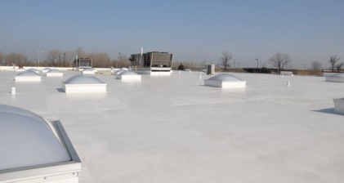
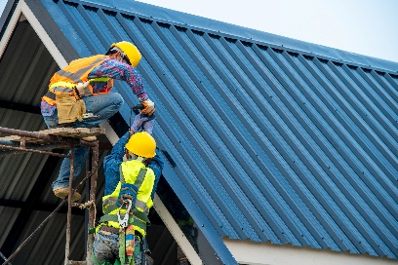
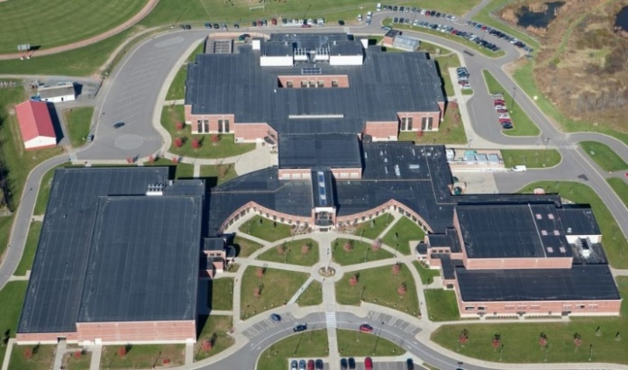
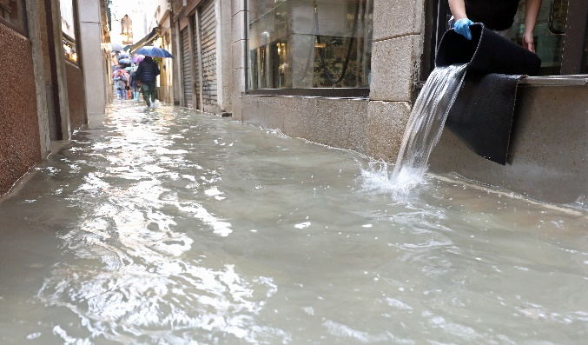
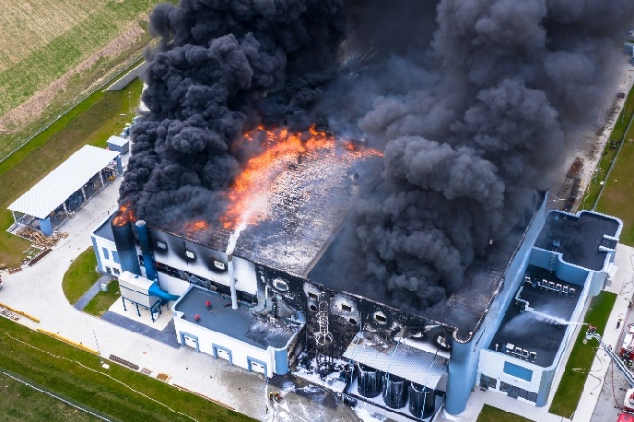
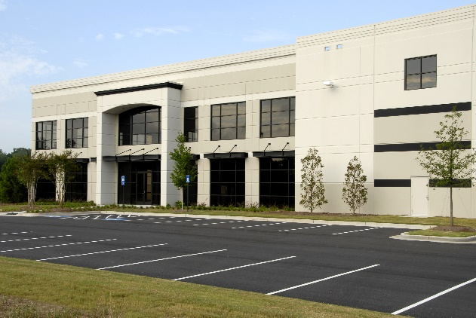
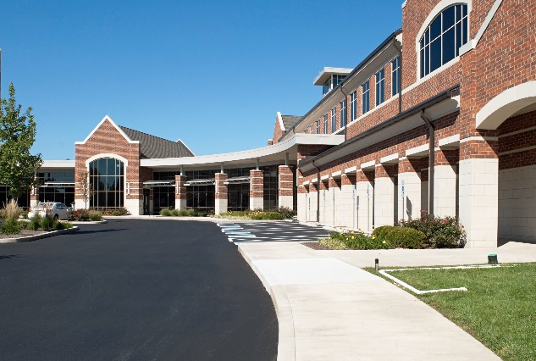


Has your property suffered from a fire or natural disaster? Allow us to pick up the pieces from clean up to rebuild. We work with your insurance company to alleviate the burden by sending an expert team to overcome the damages. It is our priority to restore your property and get you back to business.

• 10,000 – 300,000 SF structures
• State and Local Contracts
• Government and Municiple Bidding
• Architectural + Engineering Drawing
• Commercial Real Estate

• Flat Roof: EPDM, Modified Bitumen, TPO
• Metal Roof: Standing Seam
• Shingles: Standard + Steep Slope Structures
• Glass Atriums + Skylights
• Eco Roofing + Green Roofing

Our free roof evaluation will offer you insight to determine whether you are in need of a routine maintenance plan or if the roof is due for repairs, vented overlay or a full replacement.

Roofing
- New Construction
- Tear off and Replacement
- Vented Full Overlay
- Preventative Maintenance
- Inspections

312-650-9155 | www.crossroof.com

Restoration
- Fire Restoration
- Smoke Restoration
- Flood Restoration
- Mold Remediation
- Storm Restoration

Construction
- New Construction 5,000sf +
- Full Gut Renovation
- Carpentry
- HVAC / Plumbing / Electrical
- Fire Alarm Systems & Testing
- City Storm Water

technology

