Design Brief – Electra Real Estate – March 27, 2022
- LOGO TWEAKS
WHAT WE NEED: new color and font of main logo (no change to word “ELECTRA”). Possible colors for each of 5 daughter companies that goes with main color in main logo.
- MAIN LOGO

MESSAGE: Electra Real Estate is a private equity real estate (PERE) company (in top 30 worldwide) that is global, professional, experienced, trustworthy, accessible, young, dynamic, hi-tech.
COLOR: more soothing color for pacman image and subtext
FONTS OF SUBTEXT: either like in https://www.blackstone.com/ or like in presentations (Montserrat Black & Montserrat Light, Century Gothic, Blair ITC, Almoni Neue DL 4.0 AAA Medium, Almoni DL AAA)
- LOGOS OF DAUGHTER COMPANIES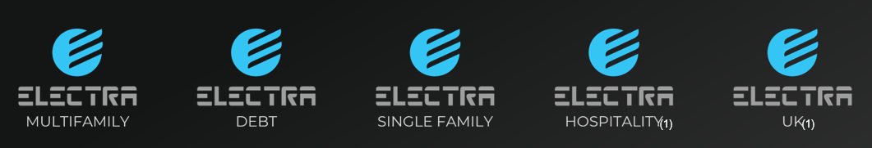
COLORS OF PACMAN IMAGE AND SUBTEXT: 5 shades that work with color chosen for main logo above – belonging but distinctive
FONTS: same as used in main logo above

- WEBSITE DESIGN CREATION
WHAT WE NEED: design template for homepage and for inner page in PSD format so we have layers with which to work. Please provide color codes. Please include colors of buttons on hover.
SITE GOAL: sophisticated, attractive brochure site that aggregates info in the 5 daughter company sites into one accessible site.
TARGET MARKET: institutional investors and private wealthy investors
MESSAGE: Electra Real Estate is a private equity real estate (PERE) company (in top 30 worldwide) that is global, professional, experienced, trustworthy, accessible, young, dynamic, hi-tech.
WEBSITES OF DAUGHTER COMPANY: Electra America | Apartments
WEBSITES THE CLIENT LIKES: Home - Blackstone
STYLE:
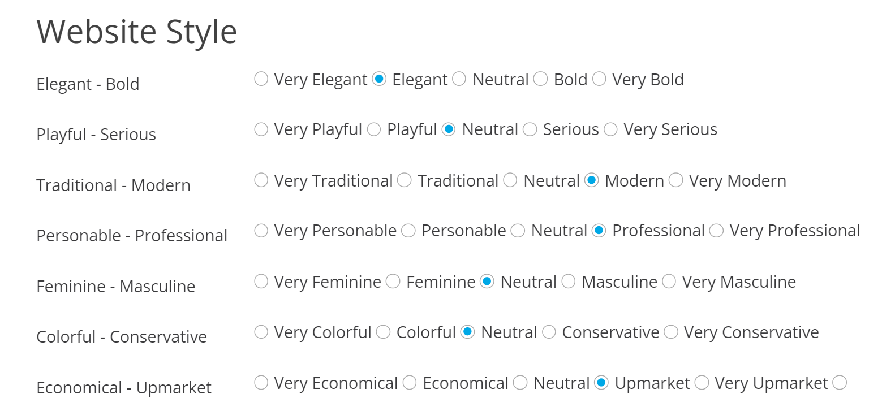
CONTENT - MAIN NAVIGATION MENU BAR:
- ABOUT US
OUR PEOPLE AND OUR RESPONSIBILITY (ESG) dropdowns could move up to level 1
- OUR BUSINESSES (info about 5 investment platforms)
- INVESTORS LOBBY (dynamic content like Investors Lobby-en – (ecp.co.il))
- NEWS (company news and capital markets news)
- CONTACT US
- LOGIN BUTTON
CONTENT - HOMEPAGE LAYOUT
LOGO | MAIN NAV BAR (with full width dropdown like in Home - Blackstone)
BACKGROUND VIDEO (like in Home - Blackstone)
With LOGO AND MAIN BAR ON TOP
With Slogan and About Us button
succinct ABOUT US text with animated numbers counter
OUR INVESTMENT PLATFORMS
2 suggestions for layouts:
- 1 row with 5 columns (hover animation on images):
IMAGE  TITLE  DESCRIPTION  LINK | IMAGE  TITLE  DESCRIPTION  LINK | IMAGE  TITLE  DESCRIPTION  LINK | IMAGE  TITLE  DESCRIPTION  LINK | IMAGE  TITLE  DESCRIPTION  LINK

- 5 rows with 2 columns (fullwidth like in Melton School of Adult Jewish Learning - Melton School:
TITLE  DESCRIPTIVE TEXT  LINK | IMAGE
IMAGE | TITLE  DESCRIPTIVE TEXT  LINK
TITLE  DESCRIPTIVE TEXT  LINK | IMAGE
IMAGE | TITLE  DESCRIPTIVE TEXT  LINK
TITLE  DESCRIPTIVE TEXT  LINK | IMAGE

OUR EDGE (like Electra America | Apartments)
teaser text, image and “Investor Information” button that links to Investors main page
STAY UPDATED
newsletter sign up form
OUR RESPONSIBILITY
teaser text, image and “Read More” button that links to ESG main page
GET IN TOUCH
contact form
IMPORTANT LINKS  Links to most important pages | EXPLORE ELECTRA REAL ESTATE  Links to important site pages | CONTACT DETAILS  Address, phone, email, social media icons/links
Copyright
Links to Legal (terms, privacy…)

