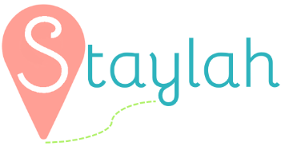
Logo Ideas:

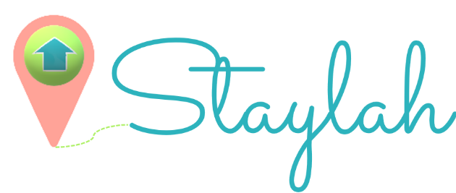

Font ideas:

Sacramento | Staylah
Poiret One | Staylah
Bellota | Staylah

Some sample colors
#FFA398 Pink
#FFC48C Orange
#F9FAB4 Yellow
#5ED0D9 Blue
#D0F7A6 Green


Sample photos of the property type:
