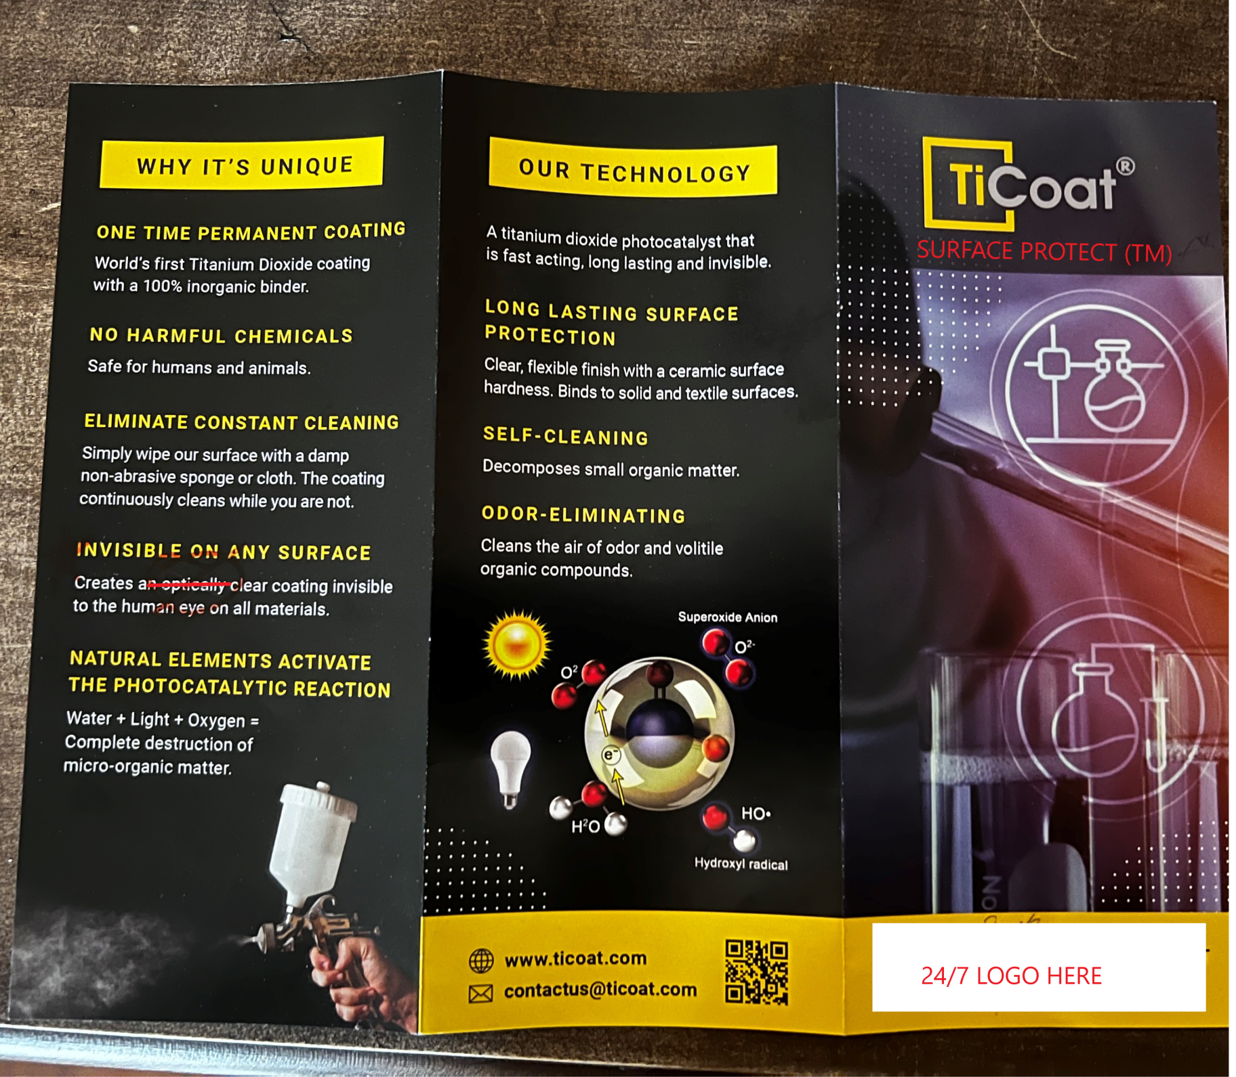
Update cover and surface protect logo. Add the 24/7 logo as well on cover. Remove the optically clear text

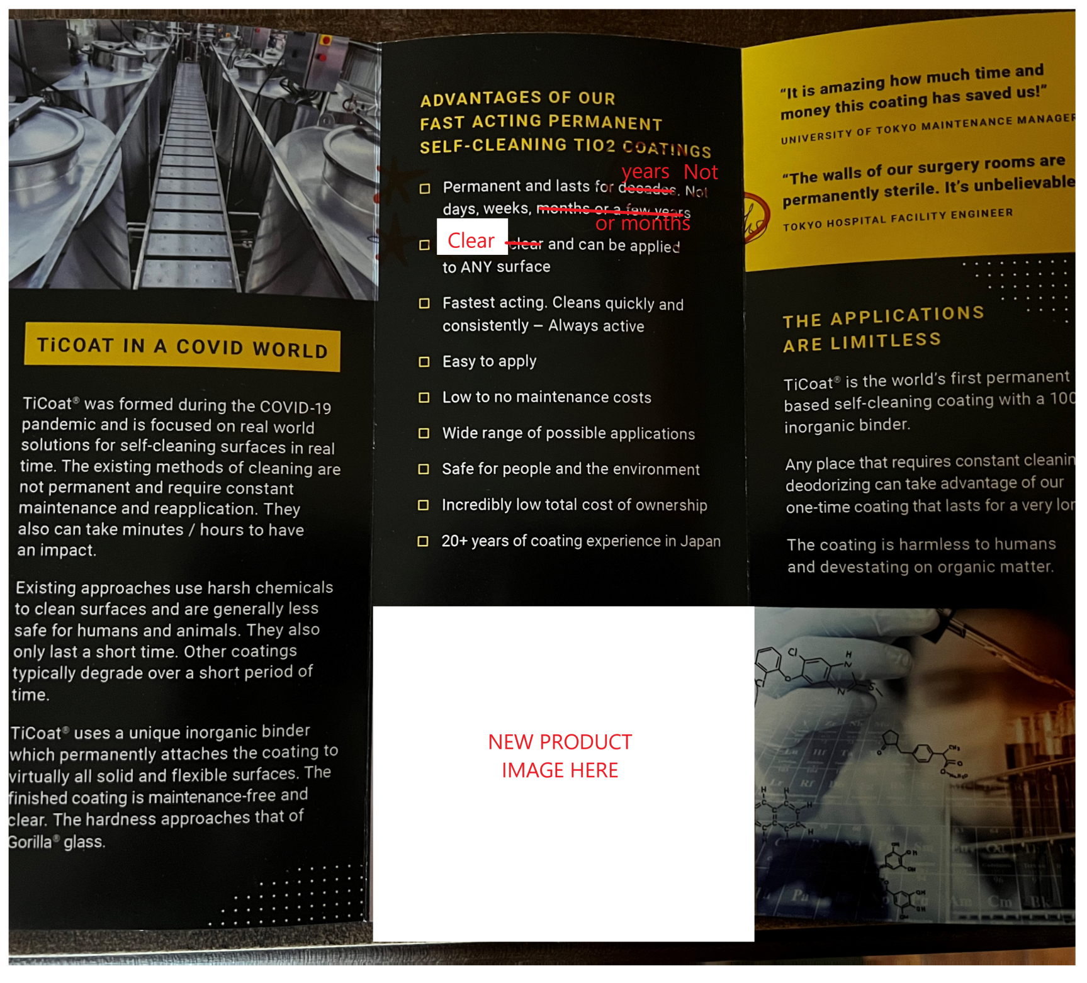
Insert- Update product image with attached image.

