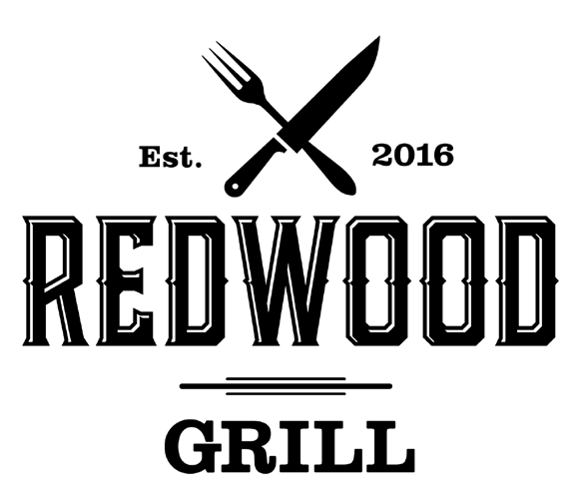

STARTERS

LUCY’S GRILLED AVOCADO 17
stuffed with shrimp salad, topped with chipotle aioli and served with housemade tortilla chips

WINGS. 13
honey sriracha, buffalo, or BBQ
Join Us!

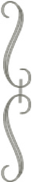
SUNDAY NIGHT – Prime Rib (after 5pm) WEDNESDAY – Fried Chicken (all day) WEEKENDS – Brunch (until 2:30pm)

DEVILISH EGGS. 8
(four) topped with candied bacon, chives and tangy BBQ

NACHOS. 13
housemade cheese sauce, black beans, jalepeños, sour cream and guacamole ADD: pork or chicken 4

SOUPS & SALADS

SEASONAL CHOPPED 16
rotisserie chicken, romaine, avocado, beans, broccoli, feta cheese, cucumber, and roasted red peppers, tossed in our house vinaigrette

CRISPY BRUSSELS. 10
tossed in white truffle oil ADD: fried egg 1.5

DYNAMITE SHRIMP 15
lightly battered fried shrimp tossed in a sweet chili aioli

BURGERS & SANDWICHES
BELOW ITEMS COME WITH A CHOICE OF ONE SIDE:
golden fries, coleslaw, smoked potato salad, black beans or sweet potato
fries (ADD 1), truffle fries(ADD 1.5) onion rings (ADD 2.5)

GREENS & GOATS 15
mixed greens, beets, red onions, dried cranberries, candied pecans and goat cheese tossed in our housemade raspberry vinaigrette

KALE CHICKEN CAESAR 15
kale, romaine, rotisserie chicken, toasted chickpeas, cherry tomatoes, tossed in housemade caesar dressing and parmesan cheese

WEDGE SALAD 12
blue cheese crumbles, chives, tomatoes, and bacon with topped with blue cheese dressing

THE REDWOOD BURGER 17
angus burger, caramelized onions, lettuce, tomato, and house spread on a brioche bun *bun contains egg

CRISPY CHICKEN SANDWICH 15
havarti, lettuce, tomato and house spread on a french roll

GARDEN SIDE SALAD 6
SIDE CAESAR SALAD 6
TOMATO SOUP cup 5 / bowl 7
ADD TO ABOVE SALADS: fried egg 1.5 • grilled salmon 10 •
grilled shrimp 9 • grilled chicken 6 • thinly sliced tri-tip 10

THE DIP 20
slow roasted tri-tip on a french roll served with au jus and a side of creamed horseradish
BLT 15
thick cut applewood bacon, lettuce, tomato, and house spread on toasted sourdough

THE IMPOSSIBLE BURGER 18
patty made entirely from plants, caramelized onions, lettuce, tomato, and house spread

GRILLED CHEESE 15
blend of jack, cheddar and swiss, caramelized onions, and mustard horseradish on sourdough garlic bread
ADD: cup tomato soup 4

MAINS
BELOW ENTREES COME WITH A CHOICE OF TWO
SIDES: sautéed vegetables, whipped potatoes, farro pilaf, black beans, coleslaw, smoked potato salad or crispy brussels sprouts tossed in truffle oil (ADD 2)

ST. LOUIS RIBS. 24
pork ribs slow cooked and glazed with BBQ sauce

SALMON FILET 27
fresh Altlantic salmon topped with a citrus beurre blanc

GARLIC SHRIMP 22
sautéed in herb butter

ROTISSERIE CHICKEN 20
bone in breast with a caper salsa

FLAT IRON 28
ADD TO ABOVE SANDWICHES: american, cheddar, havarti, swiss, jack, pepper jack, blue cheese or fried egg 1.5 • bacon or avocado 2.5
- grilled chicken 6 • salmon 10 • garlic herb mushrooms 2
drizzled with chimichurri sauce

GOLDEN FRIES 7 • TRUFFLE FRIES 9 SWEET POTATO FRIES 7 • COLESLAW 4 FULLY LOADED FRIES 7 • ONION RINGS 7 BLACK BEANS 5 • WHIPPED POTATOES 3.5 FARRO PILAF 5 • SAUTEED VEGETABLES 6 SMOKED POTATO SALAD 4
ADD IT ON
MAC-N-CHEESE (bacon & herb crumbs) 9

BELOW ENTREES COME WITH PRESELECTED SIDES

TACOS (3) 15
served with housemade tortilla chips, black beans and salsas CHICKEN: guacamole, sour cream and cotija cheese SHRIMP: guacamole and chipotle aioli sauce
PULLED PORK: onions, cilantro, green chili aioli and cotija cheese

FARRO FRIED RICE 15

Gluten Free Vegetarian Dairy Free Vegan
*some items not marked gluten free due to a shared fryer
farro pilaf, egg, brussels, carrot, celery and shallots in a sesame tamari glaze with dynamite aioli on the side

*We are concerned with your well-being. If you have any allergies, please alert us. We cannot guarantee food allergens will not be transferred through cross contamination or manufacturing methods.
all-natural fresh
We Care

locally raised and
all eggs

5% Operational Surcharge will be added to each check. This fee is intended to be equitably distributed amongst our operational increases as a result of
and prepared meats
free range chicken
cage free



increased vendors and supplier costs. This is not a gratuity for services provided. Thank you for your continued support!
*The consumption of raw or undercooked meats, eggs, seafood or shellfish may increase your risk of foodborne illness

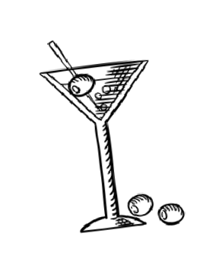
12” ARTISAN PIZZAS
AFTER 4PM (take our dough to-go in market!)
WHITE TRUFFLE 19
garlic oil, fresh mozzarella, parmesan, white truffle oil and fresh cracked pepper
BUFFALO CHICKEN RANCH. 21
tomato sauce, buffalo chicken, roasted cherry tomatoes, cheese blend, housemade ranch and cilantro
IMPOSSIBLE BURGERTM SAUSAGE. 22
tomato sauce, dried tomatoes, impossible burger sausage, fresh mozzarella, cheese blend, parmesan
VEGGIE. 20
tomato sauce, zucchini, yellow squash, mushroom, feta cheese and pickled red onions
CHEESE 17
tomato sauce, fresh mozzarella, cheese blend
ADD: pepperoni 2
WINE LIST
*House Wine
6 oz 9 oz bottle
SIGNATURE $13
COCKTAILS. . . .

REDWOOD SUMMER
PROSECCO. . . . . . . . . . . . . . . . . . |  |  | 12
Lamberti (187 ml)
BRUT. . . . . . . . . . . . . . . . . . . . . . . . | 8 | 14 | 30
Wycliff
ROSÉ. . . . . . . . . . . . . . . . . . . . . . . . | 10 | 13 | 35
Skyline, Portola Valley
SAUVIGNON BLANC. . . . . . . . . . | 14 | 18 | 48
Whitehaven, New Zealand
PINOT GRIS . . . . . . . . . . . . . . . . . | 11 | 14 | 38
Kris, Italy
CHARDONNAY*. . . . . . . . . . . . . . | 10 | 13 | 32
Hayes Ranch, California
CHARDONNAY. . . . . . . . . . . . . . . | 14 | 17 | 45
Farmstead, Napa Valley
CHARDONNAY. . . . . . . . . . . . . . . | 15 | 18 | 55
Sonoma-Cutrer, Sonoma Coast
PINOT NOIR. . . . . . . . . . . . . . . . .  Poppy, Santa Lucia | 15 | 18 | 55
PINOT NOIR. . . . . . . . . . . . . . . . . | 14 | 17 | 45
Meomi, California
CABERNET SAUVIGNON*. . . . . | 11 | 14 | 38
Hayes Ranch, California
CABERNET SAUVIGNON. . . . . . | 16 | 23 | 66
Luuma, Napa Valley
CABERNET SAUVIGNON. . . . . .  Justin, Paso Robles | 18 | 25 | 68
MERLOT. . . . . . . . . . . . . . . . . . . . .  Chateau Souverain, California | 11 | 14 | 38

vodka, pineapple, cucumber, lemon

RWG MARGARITA
tequila, lime and an orange liqueur float

ELDERFLOWER COOLER
gin, cucumber, and lime with a touch of elderflower liqueur

OLDWOOD FASHIONED
bourbon, orange bitters, angostura bitters and brandy cherries

EMERALD HILLBILLY
bourbon, lemon, orange juice, earl grey, Angostura bitters

RED MORTON MULE
refreshing mix of vodka, strawberry, ginger beer and lime

ZINFANDEL. . . . . . . . . . . . . . . . . . . 16 23 66
Ridge, Sonoma County
*Corkage Fee Policy: $25 per 750ml bottle

ROTATING DRAFTS
ASK YOUR SERVER ABOUT OUR ROTATING SEASONAL DRAFTS

BARREL AGED COCKTAILS $14

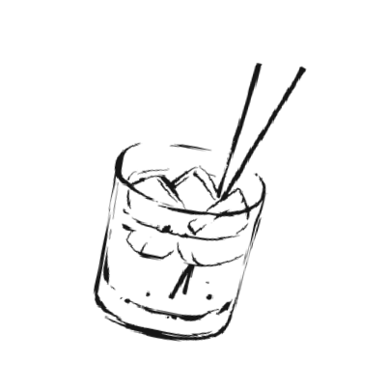
BLACK MANHATTAN
aged in barrels with Italian liqueur and topped with bitters

RUM OLD FASHIONED
oranges and vanilla aged in barrels and topped with orange bitters

THE WOODSIDE

single malt scotch, elderflower liqueur, grape, lemon, Angostura bitters

BOTTLES & CANS
SOUTH CITY CIDER *dry or sweet 7
BECKS *non-alcoholic 5

BUD LIGHT 5

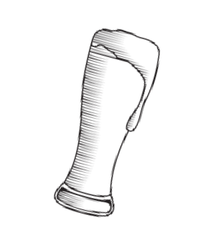
BUDWEISER. 5

RACER FIVE IPA. 7

WIDMER BROTHERS HEFEWEIZEN 7

SHINER SEASONAL 7

DOS EQUIS. 7

00 PROOF
(SINGLE SERVE)

SOFIE GOOSE ISLAND 8


STRAWBERRY LEMONADE. 5
ORANGE VANILLA LEMONADE. 5
PINEAPPLE GUAVA SPRITZ. 5
DEVILS CANYON ROOT BEER. 6
TOPO CHICO MINERAL WATER. 4
WATERLOO 3
EAST BROTHER OATMEAL STOUT 9
COKE • DIET COKE • SPRITE • ROOT BEER GOLD PEAK ICED TEA • LEMONADE • ARNOLD
DRINKS
PALMER • CLUB SODA (free refills) 4 ORANGE JUICE • GRAPEFRUIT JUICE 4 MILK OR APPLE JUICE 3

