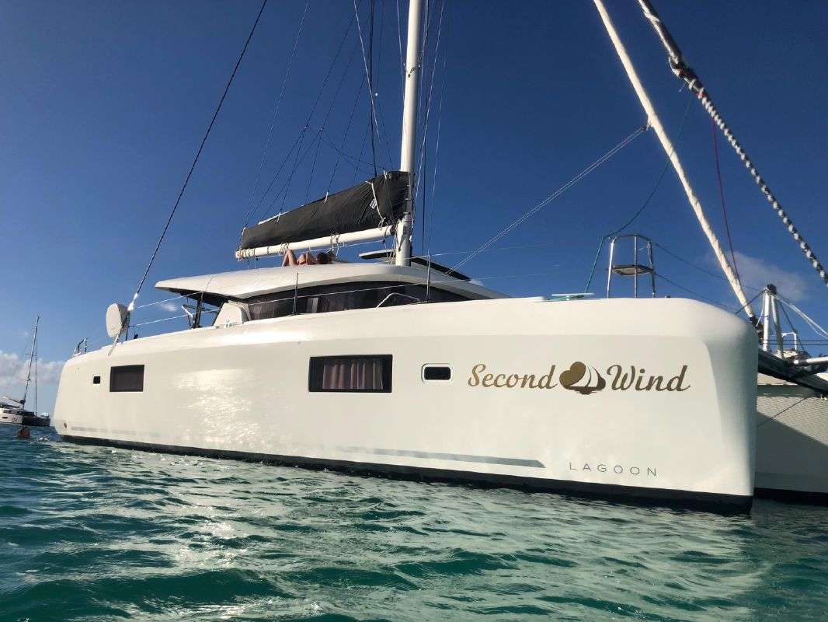

The “Sunshine Daydream” logo will replace the “Second Wind” logo on the side of the boat so the design should be longer than it is high.
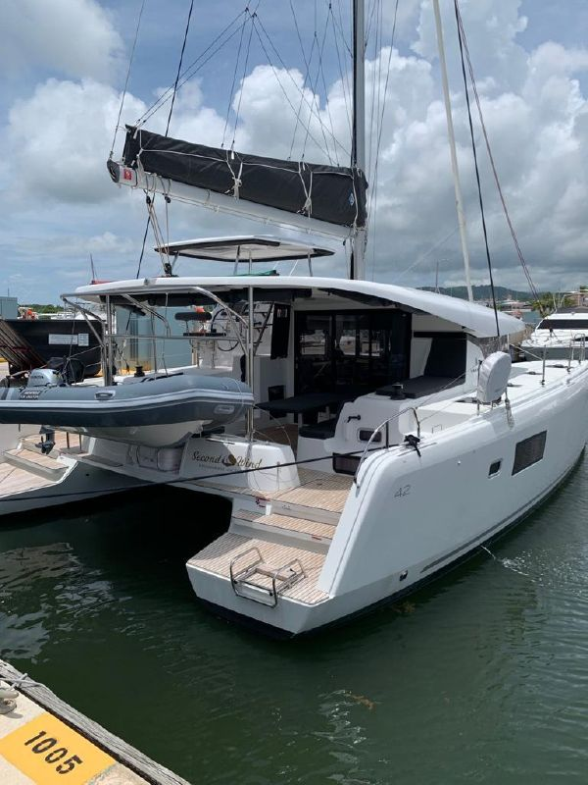

The “Sunshine Daydream” logo will also replace the Second Wind logo on this small area on the back of the boat. Below the logo, the homeport name “St. Petersburg, FL” will be printed.

