ICONS
Icon ideas + photo original product for E-mobility products.
Target is to creat our own ‘style’ of icons, a ‘red thread’ than can be recognized in all 5 icons but at the same time it needs to indentofy the individuel product group we are making the Icon for
Yjr msin product groups / Icon needs are:

Onewheeler:
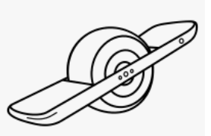
Original OneWheeler photos www.onewheel.com
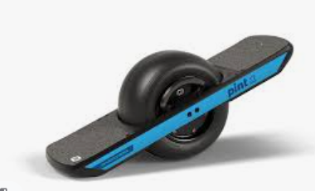
E-(kick) Scooters:
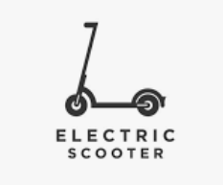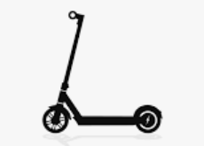

E-bike, but ONLY FAT Tire E-bike like 73 / Mate / Coast Cycles: (have not found a sample), starting point is to have the Icon look like this (Mate) E-bike:
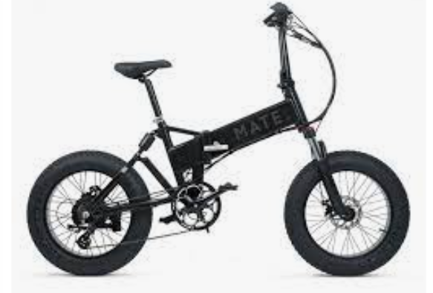

E-scooter, 1 model i want to have the icon look like (Ride Cake Makka) www.ridecake.com, i love the slightly “off-road” tires look & feel of the first photo
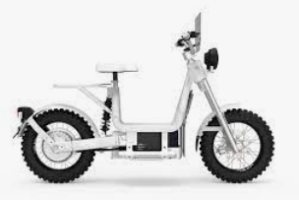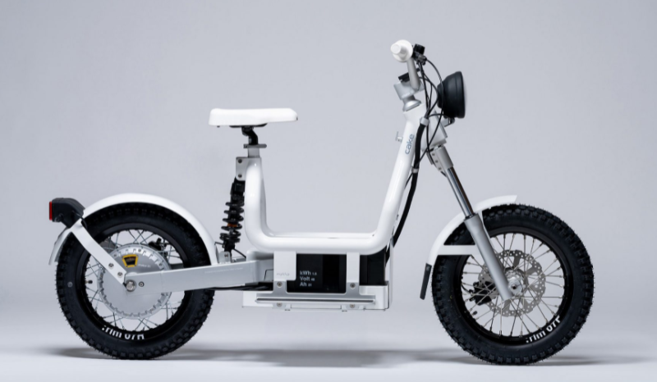

Micro mobility, mini elektric car, examples are BIRO (www.biro.nl , Microlino (https://microlino-car.com/en/microlino), Opel Rocks https://www.opel.nl/personenwagens/toekomstige-modellen/rocks-e/overzicht.html . you need to check which can be best used for Icon and represent this product category
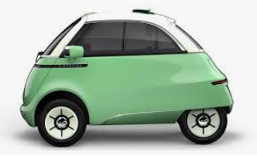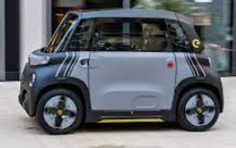
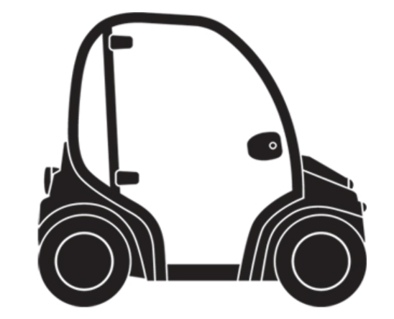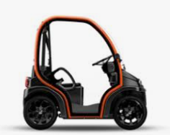

The name we use for our shop is E-lectrified, below our logo
these icons will be used as a tag line to our logo, to identify the meaning of our brand name:
