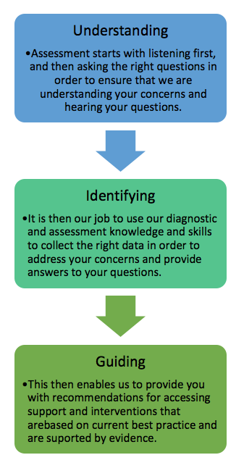
  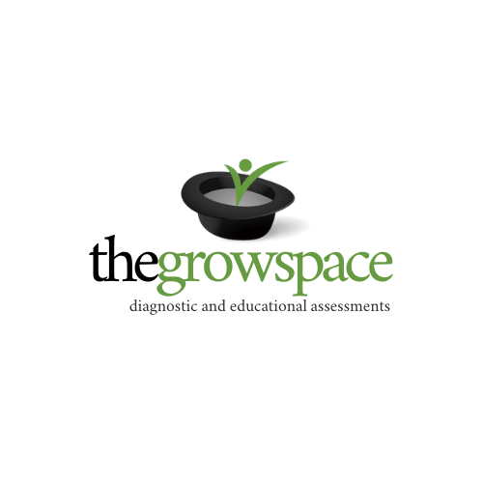
  Company Name
  43/90 Mona Vale Rd, Mona Vale NSW 2103
  info@thegrowspace.com.au
  www.thegrowspace.com.au
  ph: 02 8208 5958
  Understanding
  Identifying
  Guiding
  Who we are  thegrowspace is a team with a passion for helping people to thrive. We are a team of psychologists and teachers who have experience in both educational and clinical settings.  We understand the challenges parents face in wanting what is best for their children, trying to understand how and where to access the most relevant information and support. | We are passionate about wanting to help families navigate the diagnostic and assessment process.  We believe that quality and comprehensive assessment needs to happen before intervention begins. We work collaboratively with other professionals to ensure that recommendations and supports put in place are appropriate and evidence-based while also meeting the needs of the individual.  We are qualified to give formal diagnoses for mental health conditions and specific learning disorders. This includes:  Attention Deficit Hyperactivity Disorder  Autism Spectrum Disorder  Specific Learning Disorders  Language disorders  Anxiety Disorders  Mood Disorders  Communication Disorders  We are passionate about collaborating with your school or workplace, supporting you in applying for financial support if available (such as NDIS funding), and to feel more informed and confident in your decisions. | The process

