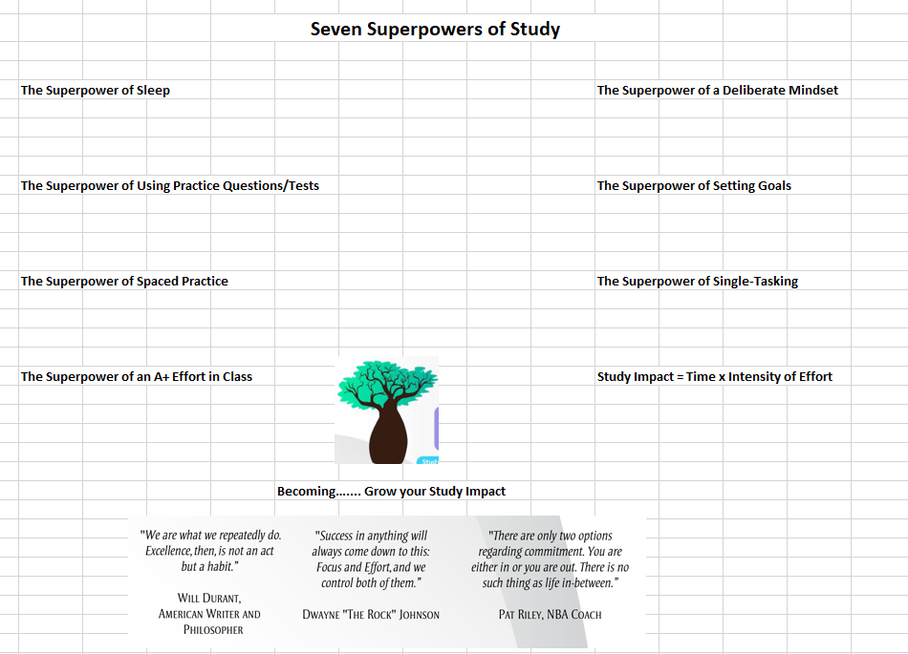

The image on the previous page is a rough mock-up of the elements that I would like.

The theme and title is, ‘The Seven Superpowers of Study’

In the middle is a Boab tree, an Australian tree that has the capacity to store water for long periods of time.

Around the outside I would like each of the ‘7 Superpowers’ that I have identified arranged. The 8th element is a formula that I like to use for study:
Study Impact = intensity of effort x time

At the bottom are some motivational quotes.

What I would like to add, is an academic superhero. This is an example of one from a previous poster design:


I would like the academic superhero to be either clearly non-gender specific – or perhaps to use a female form in 4 images and a male form in 3. I want to avoid any gender bias.

For each of the seven superpower, I would like the academic superhero to be in an appropriate pose – so effectively there are seven images, one for each of the study superpowers.

My thoughts on possible images are:
Superpower of Setting Goals: | Visible Clipboard with the words, 'my goal' at top, and 'my plan' underneath
Superpower of Practice Tests/Questions: | Picture doing a test, with the words, 'practice test' visible
Superpower of Spaced Practice: | Picture of a thought bubble, 'Let's Get Started Early'
Superpower of Sleep: | Picture of sleeping
Superpower of Deliberate Mindset: | Picture of thought bubble, 'I've Got This'
Superpower of an A+ Effort in Class: | Picture working hard at a classroom desk
Superpower of Setting Goals: | Picture holding a clipboard with 'Goal' at top, and 'Plan' underneath
Superpower of Single-Tasking: | Picture of focus on work - maybe cone from eyes showing focus just on work at desk

I would like each of these seven superpower images to be able to be used separately, for example as an image to introduce each superpower as part of a powerpoint presentation.

Finally, I’d love it if there was a way for each academic superhero to be aiming a watering can, and providing some water, to the boab tree. Perhaps if this can’t be done then just a watering can from each superpower watering the boab tree might be the option – linking the idea of academic growth to the superpower.

