LoGo Fishin logo design brief:

Company Name: “LoGo Fishin” and eventually the “LoGo Brand” (The capital “L” and “G” matter, as well as no “g” on the end of “Fishin”)

Industry: Graphic apparel company centered around logo spoofs, currently focused on the fishing market but with the ability to expand into almost any other market from Hunting and Camping, to Skating, Gaming, and even Cooking.

Slogan: “Don’t just go fishin, LoGo Fishin”, “Look Good Fishin”, “Love to Go Fishin”
(These would work with all the other markets we decide to go into, and could be animated nicely, as well as make some good apparel designs we could sell on our store)

Goal: Make a logo for “LoGo Fishin”

About Us and this project: “LoGo Fishin” and the “LoGo Brand” is a logo spoof apparel brand and eventually a group of brands specializing in the creation of themed logo spoofs based on popular logos from recognizable and emotion evoking brands, artists, events, etc specific to a certain market ( See sample designs below). We’re starting out with the fishing community so currently only need the “LoGo Fishin” logo, but we will eventually be expanding into other markets, creating “LoGo Huntin”, “LoGo Outdoors'', “LoGo Skatin”, etc.
With that being said, I would like to have a cohesive logo that stays consistent across all the brands we decide to make so I’m thinking the “LoGo” part of the logo will stay the same for every brand, and then the text under that for “Fishin”, “Huntin”, “Brand”, etc will change with each brand. So the only thing I would like to change from logo to logo (brand to brand) would be what the text actually says under “LoGo” (“Fishin”, “Huntin”, “Brand”, etc), and the color of that text. The “LoGo” part of the logo will stay the same color from brand to brand. I'm thinking black or maybe white, but the color of the text under will change accordingly, I’m thinking lime green for “Fishin”, neon orange for “Huntin”, forest green for “Campin”, etc. The only design that is needed right now though is “LoGo Fishin”, I would just like you to keep in mind that we will be expanding into other markets hopefully using the same logo from brand to brand.
We are a brand whose main focus is creative logo spoof designs so I feel the LoGo Fishin logo should be of the best quality as well, in order to reflect the quality and creativity of the designs in our catalog. I hope the “LoGo” part of the design will be able to radiate this first impression and somehow give off the vibe that we do logo spoofs or just a “general logo vibe” if that exists. Given the concept and the actual format of the brand name (the two lowercase “o’s” and capital “L” and “G”), I feel there is a lot of potential for this design to represent and give off the vibes we want as well as be a very creative and wearable design hopefully giving the idea our other designs are just as creative, witty, and fun to wear.
I am putting this project out there to get some solid ideas from creative designers that I might be able to build upon and eventually create a finished company logo out of, but if I’m lucky and find the perfect logo from the first batch of designers I will also be very happy. Either way I feel like a logo about logos is an interesting concept and I’m interested what a group of people whose careers revolve around logos can come up with.

Design Requirements:

- Color: Black for the “LoGo” part of the logo, lime green for the “Fishin” part
- Font: Use a font that can be used across all markets from fishing, hunting, and camping, to gaming, cooking, skating, etc. I’m ok with a custom font or premade fonts, whatever works best for the design.
- The “L” and “G” of “LoGo” need to be capitalized and no “g” at the end of “Fishin”
- The “LoGo” part of the logo should convey that we are an apparel company with an emphasis on logo spoofs, and stop there, it should not reflect fishing or hunting, that is all for the under text.
- I don’t think the under text needs to represent fishing (visually) past the color of it (Lime Green), since it will change from market to market, for every market we do (hunting, hiking, cooking, etc), so unless you can add an element that can be easily altered from brand to brand, to represent each of those markets, then the bottom text should just stay consistent, in a font that works well with the “LoGo” part of the logo, and for all the markets we could go into, which is pretty much any activity/hobby people enjoy being a part of (so very broad).
- I would like it to be a wearable logo that will look good on our apparel as a full chest print and also be simple enough to look good when it’s a part of small branding on the tags or sleeve of the apparel.
- Be as creative as possible please!

Design Possibilities/Would be nice to have:

- Some sort of simple cutout, medallion, imprint, etc within the logo to specify a little more between each brand like a simple fish outline for “LoGo Fishin”, deer head for “LoGo Huntin”,a tent for “LoGo Campin”, etc. But this would need to be able to work with every brand we decide to do, so it is not necessary.
- Ability to be animated in a cool way - Gifs, intros, etc
- The text should most likely be stacked, “LoGo” on top and “Fishin”, “Huntin”, “Brand” etc under that, I like the condensed logo that works well in social media profile pictures, since that will be where most of our traffic comes from, but if it works side by side too that’s cool. I just feel like the stacked orientation would be best for our uses though.
- I think the logo would be best as a text logo over an icon logo, but It’d also be really cool to make a brand mark out of the word “LoGo” (once again, I would like the Capital L and G in this design, but if a really good idea comes about where that’s not the case, it can be changed).
- Possible design elements: Arrows to symbolize the “go” part of the slogan, Lightbulb to symbolize good ideas, copyright or trademark symbol (© and/or ®) to symbolize logos (this could look good with the lower case “o’s”, T-shirt or some sort of clothing to symbolize we are an apparel company. These are all the design elements I could think of for this logo but I’m hoping there are more out there other people can think of.
- Im looking more for creative ideas on what could be illustrated out of the word “LoGo” with our brand concept in mind, versus cool fonts that might work well together, but I wouldn’t mind seeing a couple of the basic text logos within the 50+ designs

- Completed LoGo Fishin designs (we were previously named “Elite Catch Outdoors”):

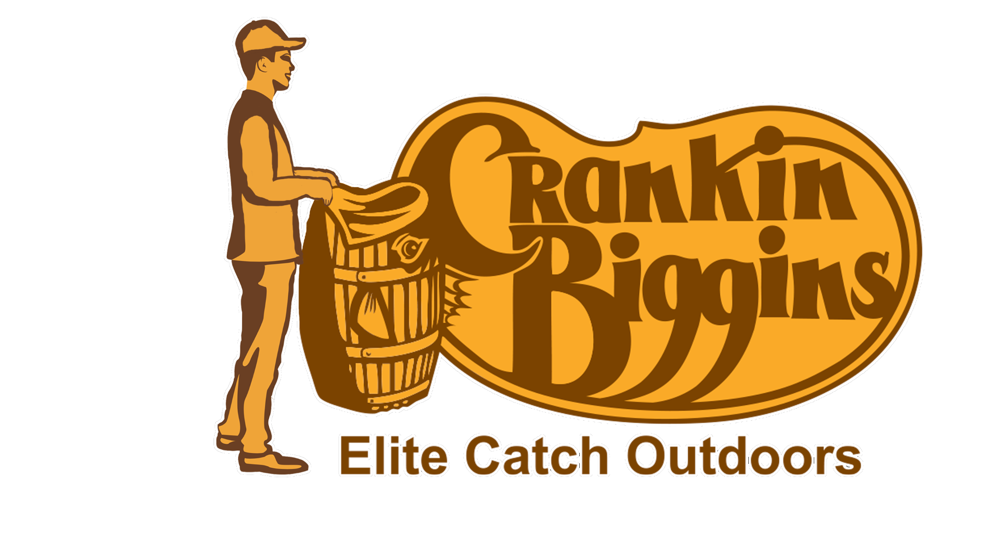
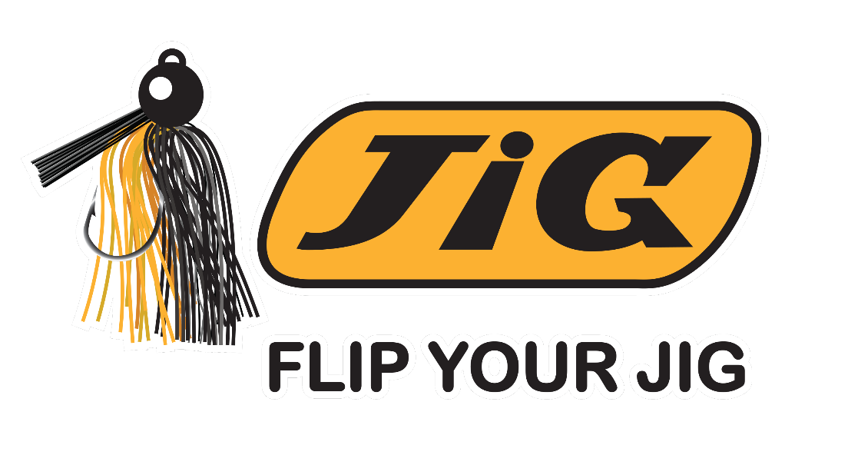

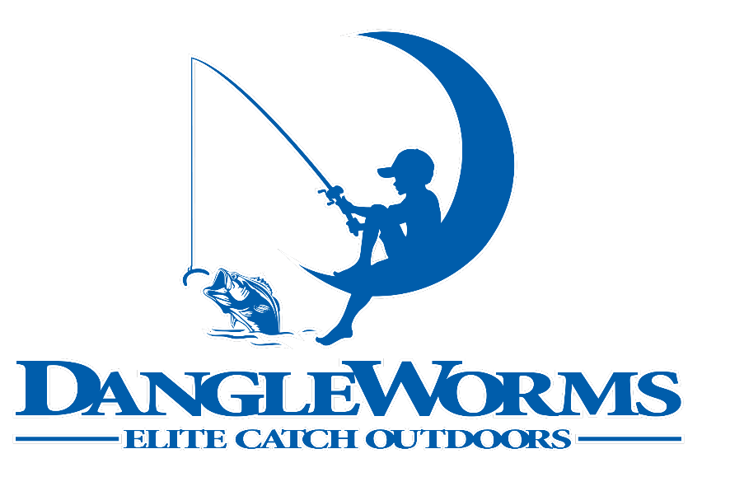

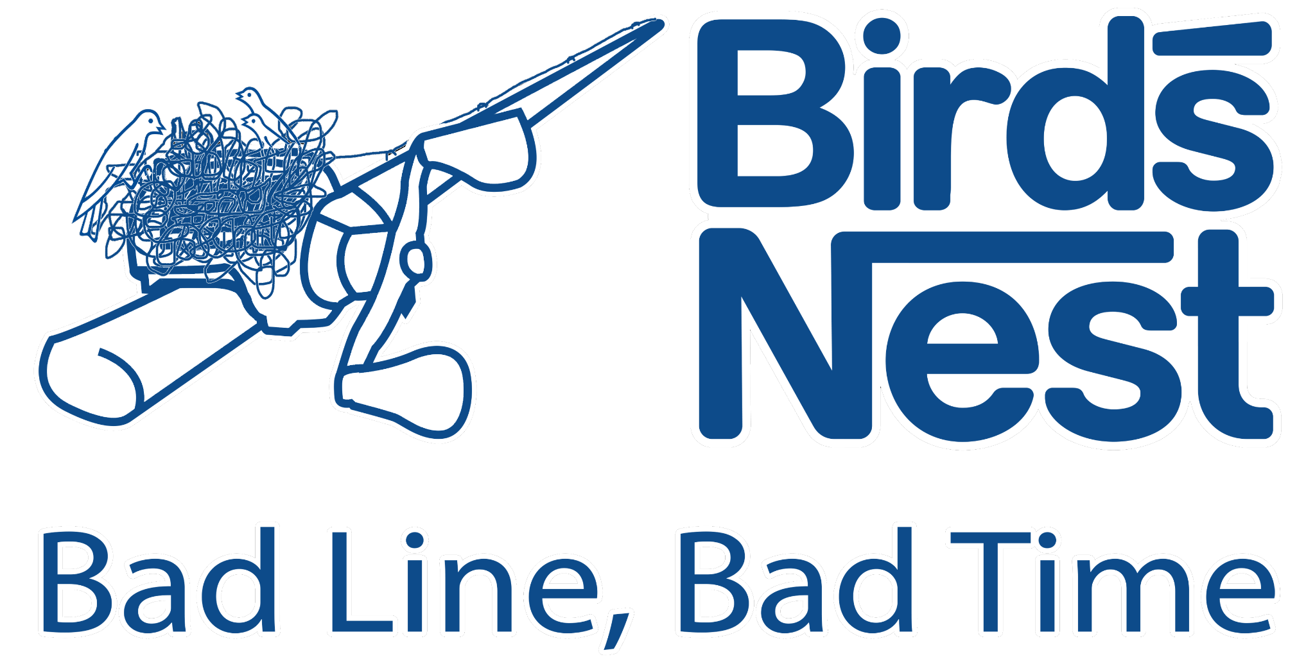

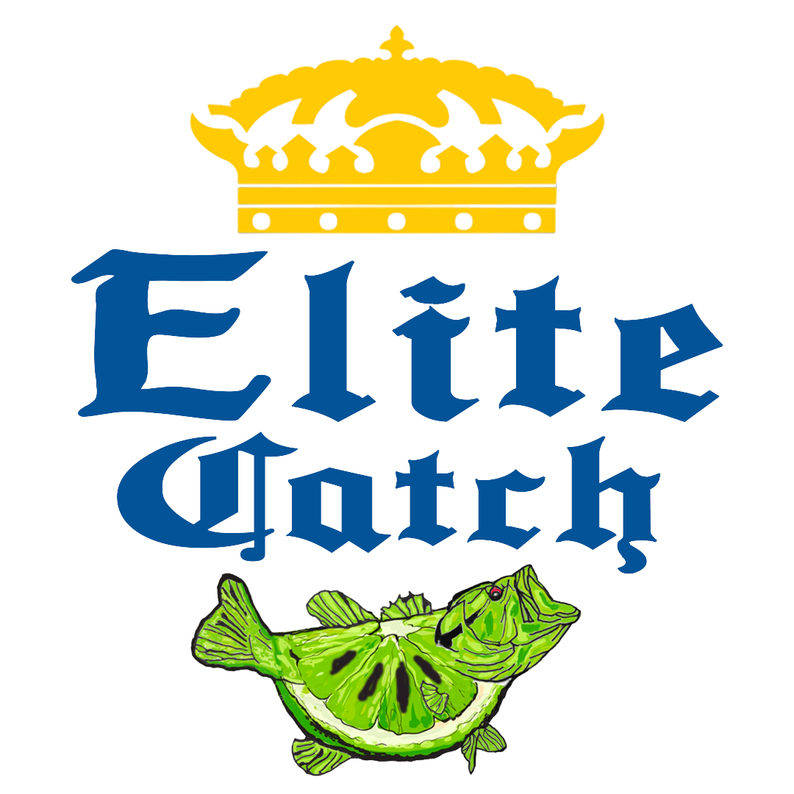
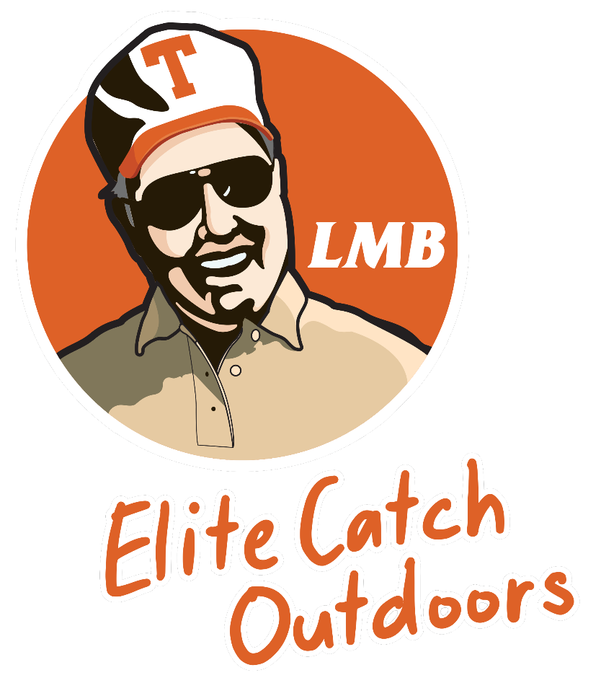
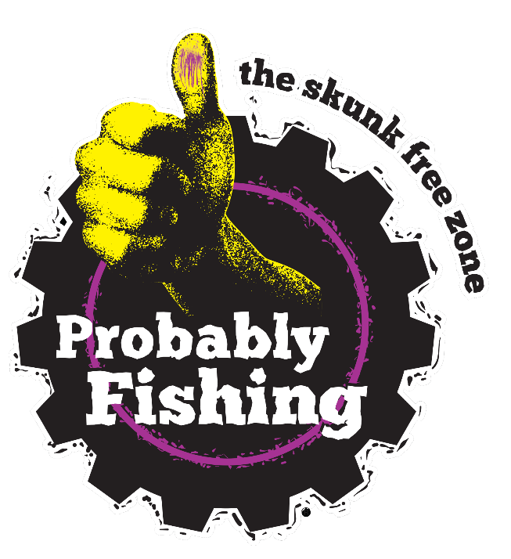

Design Inspiration:

- Color: Googan squad, woo tungsten, go fishcam
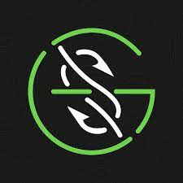
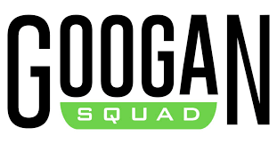

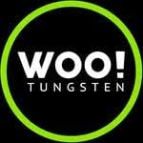
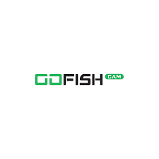
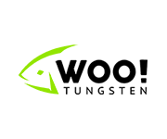
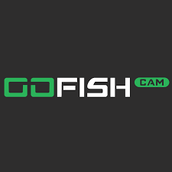

- Design element inspiration with the word LoGo:
I’m not super inspired by any of these designs, and I did quite a lot of research into designs with the word “logo” and didn’t find much ,but that excites me because I think there is a ton of room for originality, and this could be fun for some really creative people to create a really cool design with that word that people have never seen before.
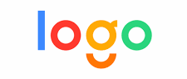
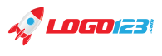

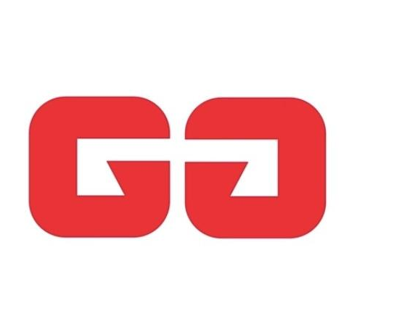
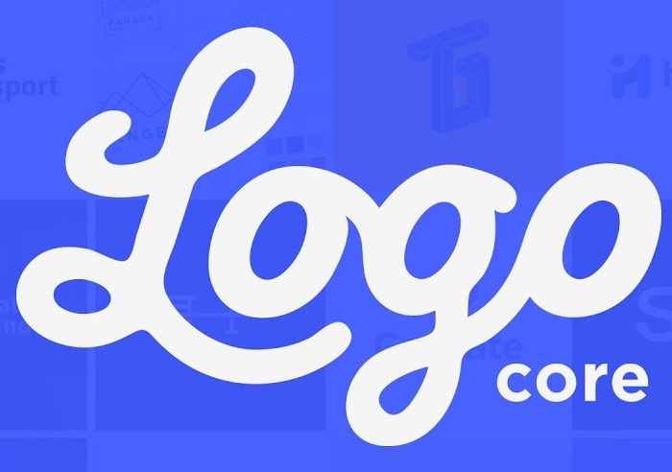

- Design Style/vibe Inspiration:
I like the general vibe of “daVinvi”, the blockiness of “H clothing”, the creative element embedded into the text of the logo in “Batman”, “FedEx” ,“Dig”, and “Shift”, I think “One Design” looks awesome. I love the way the “one” works on its own and you could change “design” to any other word and it would still work,

