List of emails banners

March 2022
NEEDS UPDATING – need click through our event?
Wording to be included:-
Carbon Profile are running a webinar as part of our webinar series on MEES, EPCs and ESG
BELOW IS A SAMPLE OF :
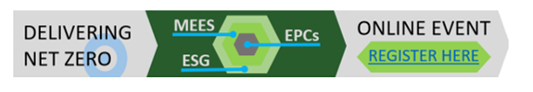
April 2022
Are you reading for EPC legislation changes in April 2023?
((( NEW FOOTER DESIGN ))))

May 2022
Carbon Profile have a maturity model to map out your EPC Compliance.
((NEW FOOTER DESIGN)))

June 2022
Carbon Profile are launching phase 2 of our Digital EPC analylsis platform

((New FOOTER DESIGN))))

SEE SAMPLE BELOW

xxxx
____________________________________________________
T: | +44 (0) 1865 865 403
E: | info@carbonprofile.co.uk
W: | www.carbonprofile.co.uk


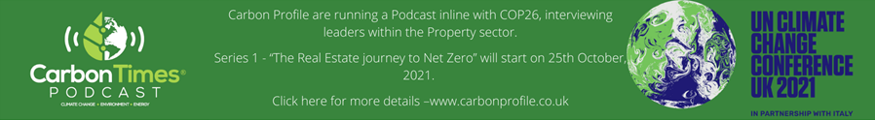
This email is sent to you by Carbon Profile Ltd. It is intended for the addressee only and any access by another person is unauthorised.
The information contained in this email and in all documents transmitted with it are private and confidential.
If this email is not intended for you, please remove it from your system without storing, disclosing or copying all or any part of it and notify us on the contact details above.

