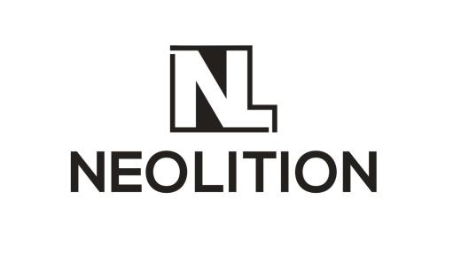
GAME CREATIVE BRIEF
THE ROLE OF A CREATIVE BRIEF

To create a connection with your audience by showing them how your game can fill a need.
This document is used by designers and—in conjunction with your Positioning Document—guides them as they create content

Project Context & Background: Why are we Advertising/Communicating?

We are a student project and our final delivery will be an about 20-min experience. We need some advertising methods to let our target audience know our game.

Who is the Consumer Target/Audience?

Players who like action-adventure games with traversal elements and innovative levels, especially those with some verticality. Also goals could be approached in different paths.

How do they normally hear about new games in your space?

As a student project, mostly on some student game expos like USC Game Expo.
Some subreddits or forums where most viewers were action-adventure fans who would also be willing to try some indie games.
Some websites dedicated to sharing indie games, like itch.io

What do they Like?

Fans of action-adventure games may expect an enormous world with verticality. Because these levels offer a new axis to explore which often makes players feel refreshed and inspired.

What do they Dislike?

Boring gameplay, gameplay elements are so plain and shallow that players quickly feel tired with it.
Too small levels or too straightforward level designs. Players just beat them without too much difficulty.

Consumer Insight

I am an action-adventure game fan and I love playing good action-adventure games because many games provide an enormous world full of mysteries, especially those with some sort of vertical designs. It’s always enjoyable to explore these worlds. I get annoyed when games in this genre fail to provide a world with challenging or inspiring levels. It will make the game less engaging and I can easily get bored.

When they hear about (not “play,” yet) your game for the first time, list 3 emotions/reactions you want them to experience, in order of importance

mysterious, adventurous, curious

When they’re exposed to your message, how do you want them to think/feel/act?

Think: I can feel the tension in the atmosphere as those islands look high and challenging.
Do: We want them to know that this game world has good verticality and is full of challenges.
Feel: We want them to be excited to face those challenges.

Key Rationale Benefit: what do consumers get for playing your game? What experience are they rewarded with? Are they better strategic thinkers? Do they feel more empathy towards people? Have they learned teamwork? Solved puzzles? Something else?

An engaging gameplay realized by a world designed with specific focus on verticality, where players can traverse freely among cliffs and forests with various tools. Players will feel the tension when they encounter monsters and go through dangerous terrains, but they can always use their cleverness to plan carefully and find a way through. When they reach the destination and discover mysteries, they should feel excited.

Key Emotional Benefit: how do you want the game to make them feel, after they’ve played it? Finish this sentence as the consumer: “I loved playing [game] because it gave/let me [what?]

I loved playing Skylost because it allows me to use tools to go to every corner of the world, which inspires me to reach goals in my way.

Why should they believe you can deliver?

We are from USC AGP, a program mentored by lots of experts from the game industry.
We have a talented team, many of our team members have professional experience in game development ranging from indies to AAA studios.
You can try our demo to see what we’ve made.
Restate Your Game’s Positioning Statement from the Positioning Document, below:

For players who enjoy action-adventure games with beautiful scenes and exciting stories,
Skylost will give them the ability to go vertical as they traverse across unique levels and
avoiding hazards and enemies, By utilizing the grappling hook, players can easily move
around: particularly vertically, as they explore multiple paths to advance, ascending their
way through floating islands while solving the mystery of the lost expedition that preceded
which includes someone really important to you.

Tone and Manner – give adjectives for how your audience should perceive you

mysterious, curious, inspiring

What is Your Key Consumer Message? What are the key 2-3 sentences you would tell the consumer to convince them to try your game?

We are Skylost, an action-adventure game featuring a beautiful skyworld. In our game you will explore sky islands with good verticality and dangers inside. You need to utilize the tools and find your own path to get through those dangers and reach your final destination.

Where do you anticipate delivering your message (types of advertising, communication, promotional venues)?

Influencers, e.g. streamers
Social network. We already have instagram and twitter accounts run by our producer. Hopefully we can gain followers and promote in this way.
Game expos, USC Game Expo next year.
Subreddits, indie game forums.

