Build Your Product
As startups are racing to build software as a product, they have stumbling blocks on building software from scratch. One of the reasons is stiff competition.
The competition to get the best resources, robust design, and scalable technology is overwhelming.
Startup owners must use the CEO mindset while building a software product. Think of the bigger picture. Focus on the outcome and set aside the tiny technical details. Focus on human resources and Process.
Software development needs experts. Thus, your team will include:
- Project Manager
- Team Lead
- Business analyst
- Developers
- Testers
- Technical/Content Writers
- UX Experts
You need a step-by-step process to achieve the result. This is essential for combining the people and technology to build the product. Here are the processes:
1. Brainstorm for a product that will solve a problem
2. Plan the entire process
3. Incorporate ideas from business partners or stakeholders
4. Design the product
5. Outsource the development team
6. Develop the product
7. Deploy the product
8. Sell the product to the target market
Building a product: Split concept development into iterations
It's worth remembering that each subsequent step of the product development process will be more expensive than the one before it. CrossTeams proposes breaking down the development of a product into multiple iterations:
- Identify the issue and conduct interviews with possible users to validate the concept.
- Discuss the findings with the rest of the team, and do more research.
- Make prototypes to ensure that the initial concept appears as 'attractive' on paper as it does in your imagination.
- Examine the design and put it to the test with representatives of your target audience.
- Review customer comments and feedback and make changes/amendments to the design/concept as a whole.
- Make iterations on the prototypes and collect feedback, then assess and make modifications based on the input (if necessary).
- Create a Minimum Viable Product (MVP) and show it to potential clients (early adopters).
- Repeat the iteration process until the MVP satisfies high market demand or is deemed a failure.
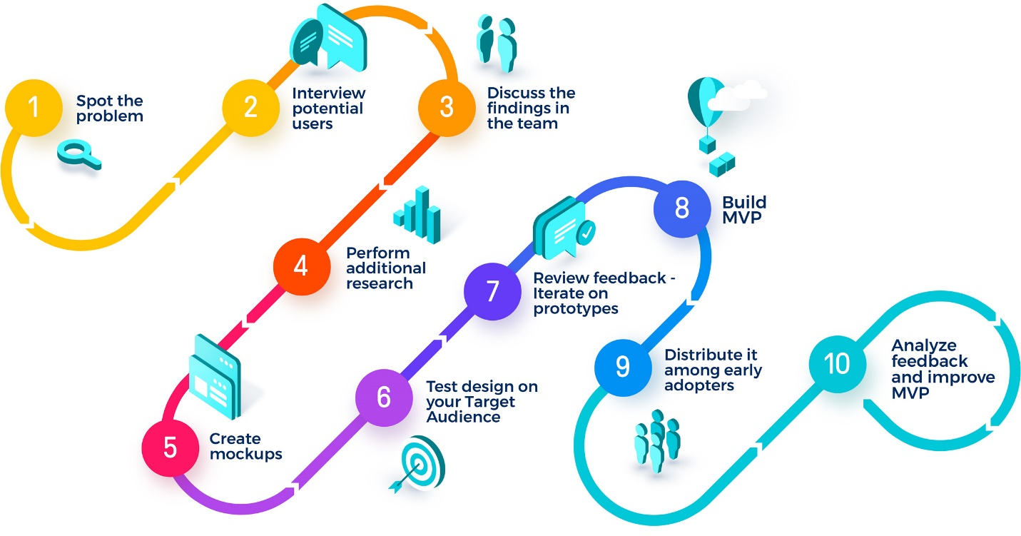
This approach gives more flexibility, allowing for the full-scale product concept review without spending your budget on something nobody will use.
In totality, the whole process goes smoothly to help you reach your goals. With expert CrossTeams, you are in the right hands and towards your goals. CrossTeams helps you take care of all business affairs and takes care of activities along the way. Uncover a whole new range of innovative ideas to take a step closer to your goals.
