This Google example is probably the closest. We could have all of the dots pop in like this, each pop out larger or we could get creative and have them show like little chemical compounds (similar to where google takes theirs and makes them sound bars). At the same time, the colors could then filter through all primary and secondary colors in the palette. It would only loop once as the hero this way. In the navigation, I like the idea of one of the dots simply expanding, or fading in/out to know you are on that page.


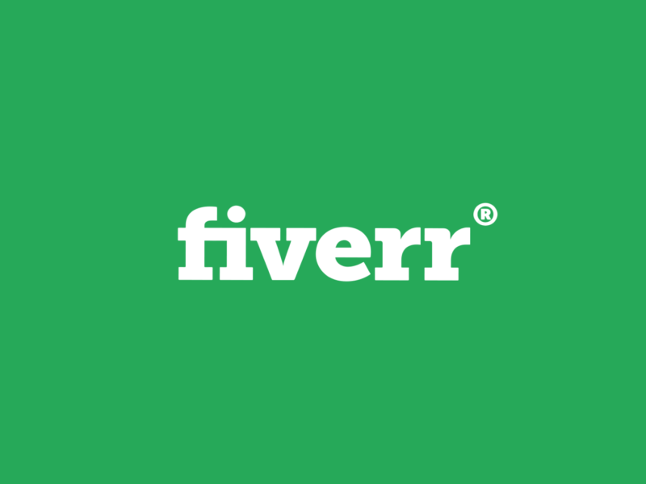

Another great example of how the name flies in and the dot in the I lags and comes to life. I could see us flying ours in from the opposite direction of this.

