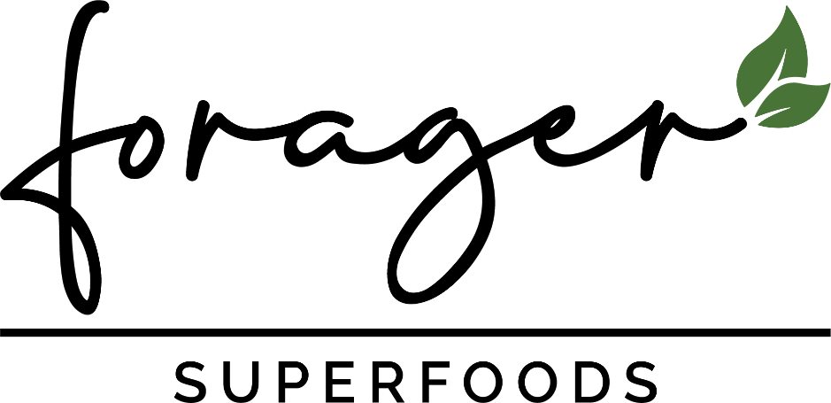
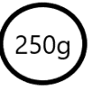
MORINGA LEAF

MORINGA, ALSO KNOWN AS ‘THE MIRACLE TREE’, HAS BEEN PRAISED FOR IT’S HEALTH BENEFITS FOR THOUSANDS OF YEARS. IT IS EXTREMELY RICH IN HEALTHY ANTIOXIDANTS AND BIOACTIVE COMPOUNDS. IF FACT IT HAS:

- 7x THE VITAMIN C OF ORANGES | - 4x THE CALCIUM OF MILK
- 3x THE POTASSIUM OF BANANAS | - 3x IRON OF SPINICH

THE LEAVES CONTAIN ALL NINE ESSENTIAL AMINO ACIDS AND TRADITIONALLY USED IN ASSISTING THE HEALING OF MANY AILMENTS. THE NUTIRITIONAL DIVERISTY IS ALSO KNOWN TO REDUCE BOTH CHOLESTEROL AND BLOOD SUGAR LEVELS WHILST AND HAVE SERIOUS ANTI-INFLAMMATORY BENEFITS. OUR 100% ORGANIC MORINGA IS GROWN AND HARVESTED IN IT’S NATIVE ENVIORNMENT, SUPPORTING PREMIUM SUPERFOOD NUTRITION.
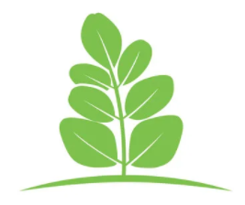
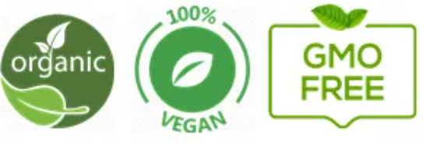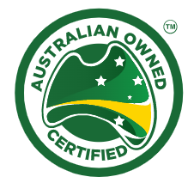
.COM.AU
Having studied the ancient learnings from traditional medicines spanning the centuries, Forager has used cutting edge science to substantiate what the old timers always knew, that these remarkable foods have the potential to improve our health, wellness, and performance.

“Let food be thy medicine”
- Hippocrates 440BC

Freeze dried to lock in nutrients Express Shipping Quality Guaranteed

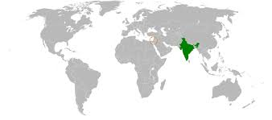

Ingredients: 100% Organic Moringa Powder

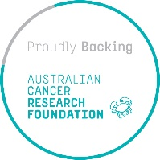
We donate $1 from every order to help fund Australian Cancer Research.
LET’S CURE
CANCER
Nutritional Information

Per serve: | 5g | 100g
Energy | 55kj | 1,103kj
Protein | 1.3g | 26g
Fat, total | 0.3g | 5.9g
-saturdated | <1g | 1.2g
Carbohydrate | 1.5g | 30g
Sugars | <1g | 0.75g
Sodium | 8.15mg | 163mg
Calcium | 1.5mg | 30mg
Iron | 17mg | 339mg
Potassium | 0.09g | 1.81g
Vitamin A | 0.94g | 1.88g
ORAC (umole Te/100g) 34,889g
GROWN IN: India

Forager Superfoods are proud to partner with the Australian Cancer Research Foundation. By backing Australian research, we hope to play our part in helping to prevent, detect and treat ALL cancers. We support ACRF’s vision of one day reaching a world without cancer.



Proudly Australian owned company.


DIETARY WARNING:
Certain information that relates to health and illness is offered for general
informational and educational purposes only. It is in no way meant to be a
substitute for professional medical care and attention by a qualified practitioner.
Always seek professional advice prior to making changes to your diet.
Not recommended for pregnant women.

