Aquamarine Digital Website Brief
February 7, 2022

Overview
- We are very small startup research organization focused on crypto / digital assets
  - First produce will be a crypto investment fund, will consider future consulting, speaking, other research projects
  - Currently 1 founder + 3 interns, scaling to ~5-6 people over next few years
- No current website; we need something to establish credibility with future investors, employees, partners, and companies we are researching
  - Investors: high net worth people with interest in technology, investment advisors who are more forward thinking vs typical (but still a relatively traditional group)
  - Companies we’re researching: typically younger, very tech savvy, a bit anarchist / independent
- This is basically an online brochure with functionality to collect email addresses for a newsletter
  - No need at this point for login/credentials, etc

Other
- I am OK using a website builder (WIX, etc)
- We would like to launch by March 4

Website Functionality / Structure
Home page <-borrow liberally from the structure of decentral park capital’s home page
-navigation bar across the top with logo on top left
-Tag phrase and lead image (see below)
-scroll down to copy describing the firm and our research process
-“News” section with links to us in articles/podcasts/etc (hide for now until we have something)
-links to most recent research reports and the Research page
-subscription form for the newsletter
-bottom of page has additional navigation and “follow us” links to Twitter and LinkedIn
About
-Copy on background of the firm, research philosophy
-Team photos
Research
-blog posts with our investment thesis on various crypto assets (see decentral park’s site)
-Include subscription form for newsletter
News
-Links to articles, podcasts, blog posts where we’re quoted
-Notices of upcoming appearances etc
->hide this section for now
Careers
-hide this for now but will want it later
Contact
-Include subscription form
-Media appearances / podcast links (hide this section for now until I have some)

Visual Aesthetic
- I do *not* want a black background like so many crypto websites
- Keep with the “urban” / “street” art theme of the logo
  - Edgy and creative but modern
  - Not a generic finance look
- On the home page, I’d love to incorporate a version of this image (you can search for a high resolution version of it—it’s Banksy’s graffiti wall
  - Behind the curtain, instead of the graffiti can we do something with a lot of web3/crypto logos or ideas?
  - This might be something we save for v2 of the website so let’s not burn a lot of time/money on it at this point

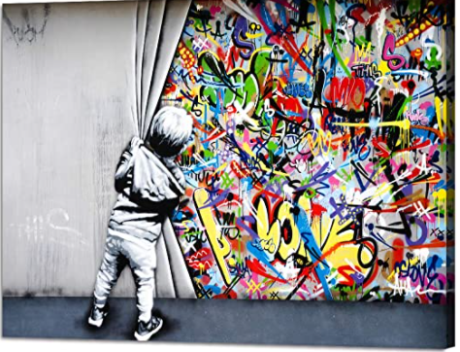

Disclaimer copy
We need to include the legal copy at the bottom of the main page and research page regarding not offering a security, not financial advice, etc

Sample websites
https://www.decentralpark.io/ <- I love the structure of this site, let’s copy most of it
https://www.starkiller.capital/ <- very basic site, but most of what I need

