Notes for the template: Owasys is a Tech Allie of InfoPortal, please include the logo of Owasys in the tittle, you can check the way we included that before in our webpage, here is an example of another tech allie: https://infoportal-mx.com/highbyte/
The logo and the images are in this document at the bottom.
We want that this landing page be in terms of design the mix of InfoPortal web design with the Owasys web design, but the InfoPortal web design has to prevail, here are the links:
https://infoportal-mx.com/
https://www.owasys.com/en
Please include a contact form with name, email, company, comments, phone number and location at the bottom of landing page.
In all the template please include repetitive time these two buttons:
- Make an Appointment
- I’m interested
—

Text: Owasys supports customers in making industrial vehicles and machines smart, safe and productive Operational excellence and engineering expertise, we are a trusted partner for OEMs
and System Suppliers globally.

- 19 Years of activity (Established July 2002) ISO 9001:2015 y 14001:2015 certified.
- Over 200.000 Units installed in the field since 2003.
- Compact, coordinated, balanced and effective team of persons.
- “Core” Competences and Knoledge (R+D+i, Clients and Suppliers,
- Home designed production processes deployed in an ISO 9001 certified Center.

—

Title of the section: Owasys Market Proposal
Text: The owa platforms are designed by taking into account the technical requirements of more than 200 System Integrators and Service Providers working in the M2M/Iot industry.

- Wireless Embedeed Computer
- Linux OS
- System Integrator has Complete Control of the application
- Just need to maintain 1 Piece of SW for different projects.
- Easy to addapt the applicaton for a new project. Short TTM.
- Standard Product
- Certified Product
- Wide variety of Versions

Notes for these section: Please include the 3 images of the products, here is an example of the way our Tech Allie put the information, all the characteristics name before
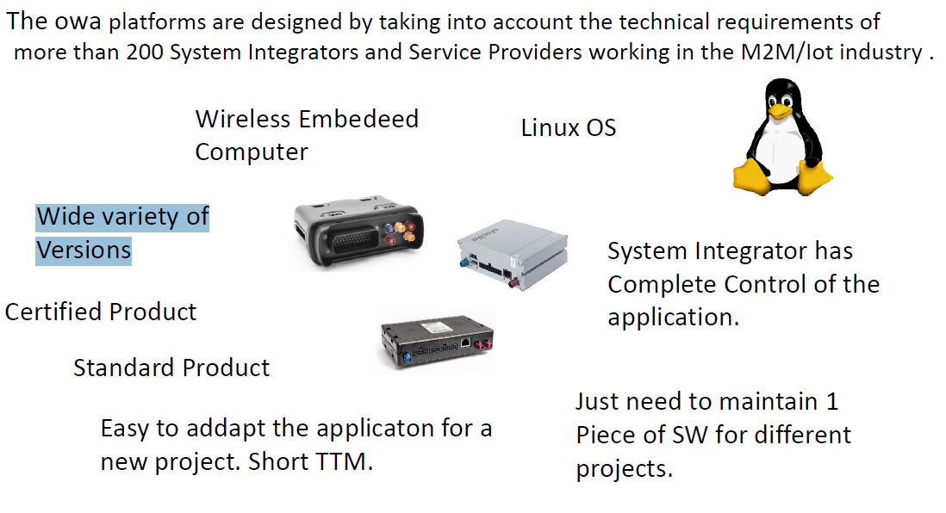

— PRODUCT SECTION
Notes for the section: In this section, we want to show the products that Owasys can offer, you will find the images and the description, please make it in a way that the images form part of a carousel next to the description.

Title of the section: owa3X Platform
Text of the section:
ARM9 CPU 32bit @400MIPS
- 32MB/64MB RAM
- 64MB Flash, +16GB in uSD
- Industry standard architecture
Powerful: Linux and C/C++
- Open platform: 2.6.36 Linux Kernel
- Programmable in C/C++. Shell scripting
- Extensive libraries and a well documented API to make the most of the owa3x hardware
- Open source tools and Sofware packages available
PSU:
- Robust for Automotive
- Very Low Power consumption

Images for this product:
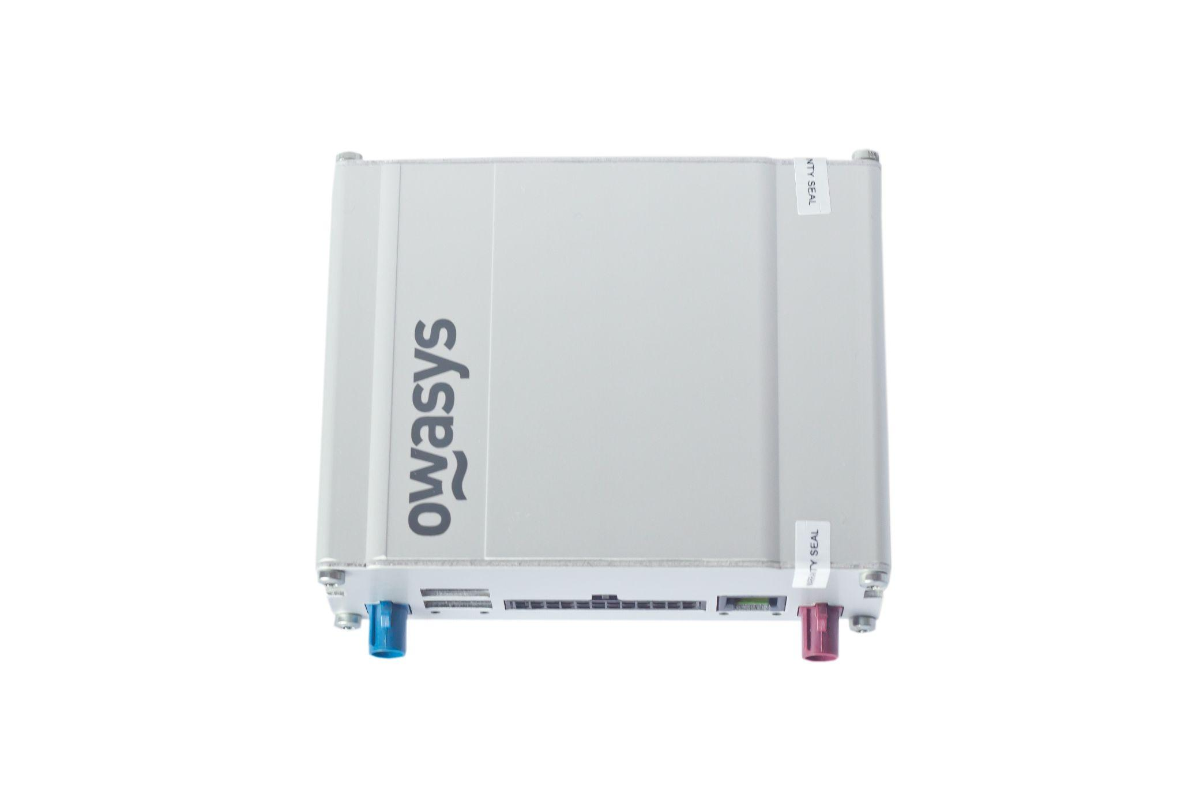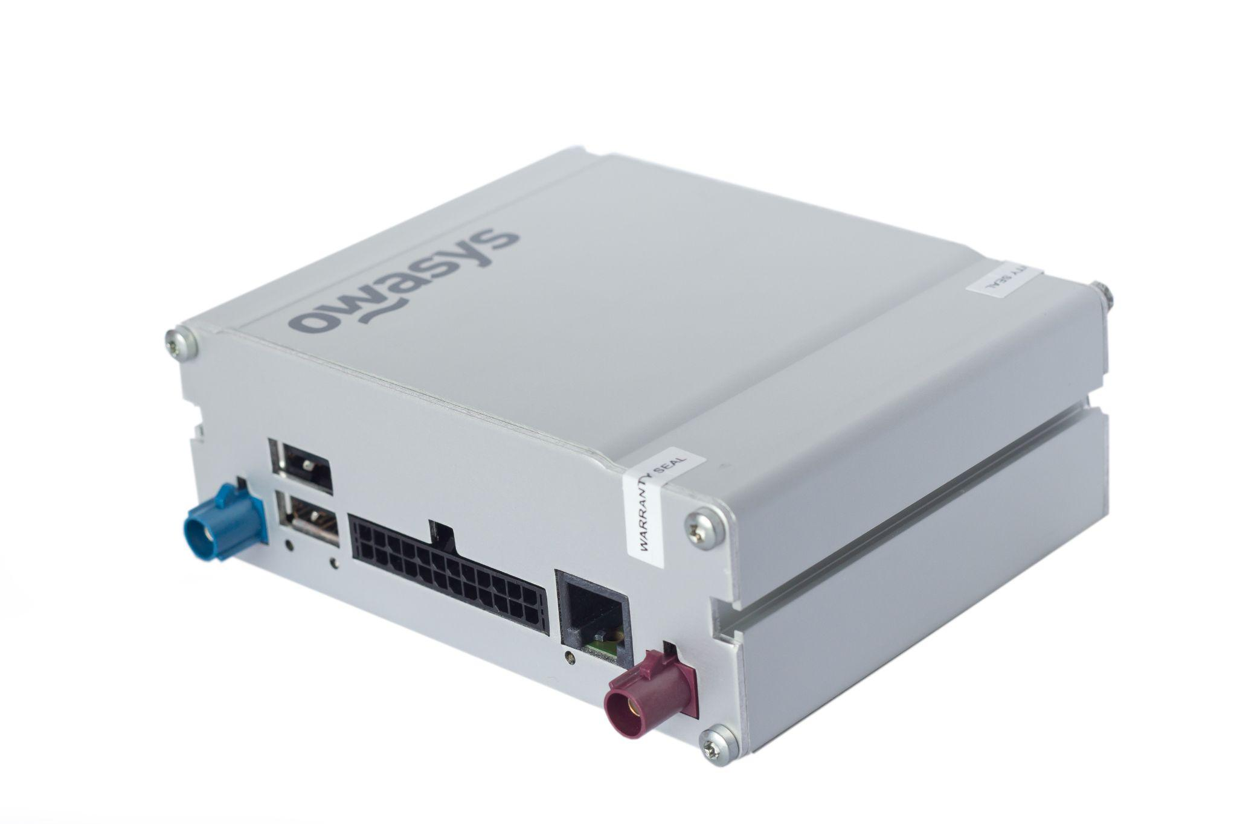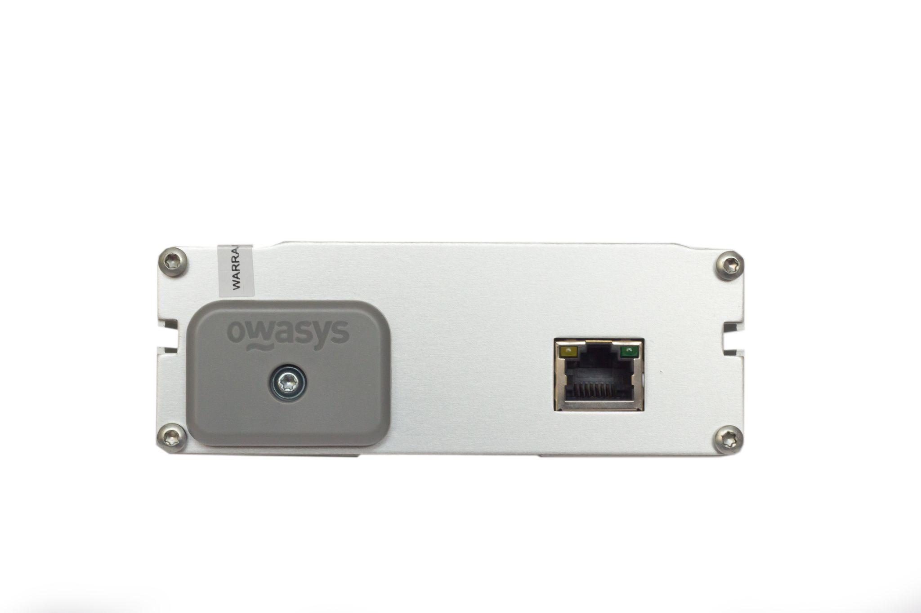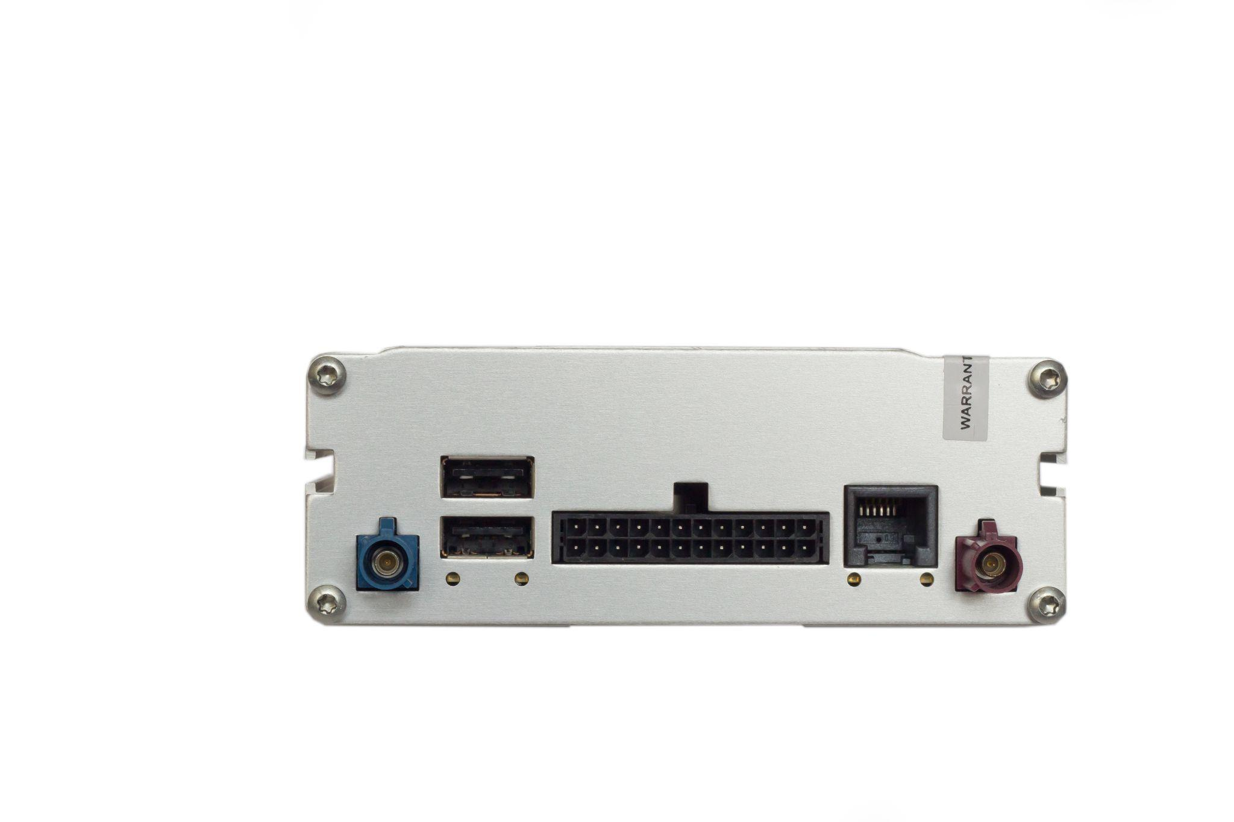

Title of the section: owa4X
Text of the section:

ARM Cortex A8 CPU 32bit @800MHz
- 512MB RAM DDR3
- 1GB NAND Flash, +32GB using uSD card
- Industry standard architecture
Very Powerful: Linux Kernel and Debian OS
- Open M2M/IoT platform: 4.19.94 Linux Kernel
Debian 10 Buster Filesystem
- Programmable in C/C++, Shell scripting, Python, Java, NodeJS, Golang and Lua
- Extensive libraries and a well documented API to make the most of the owa4x hardware
- Open source tools and Sofware packages available. Access to the official Debian repositories for ARM.
- Backwards compatible with existing owa3x applications
PSU:
- Robust for Automotive
- Very Low Power consumption & power saving modes
Images for this product:

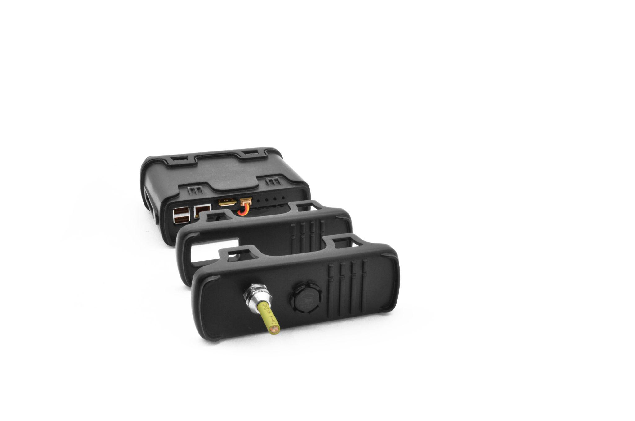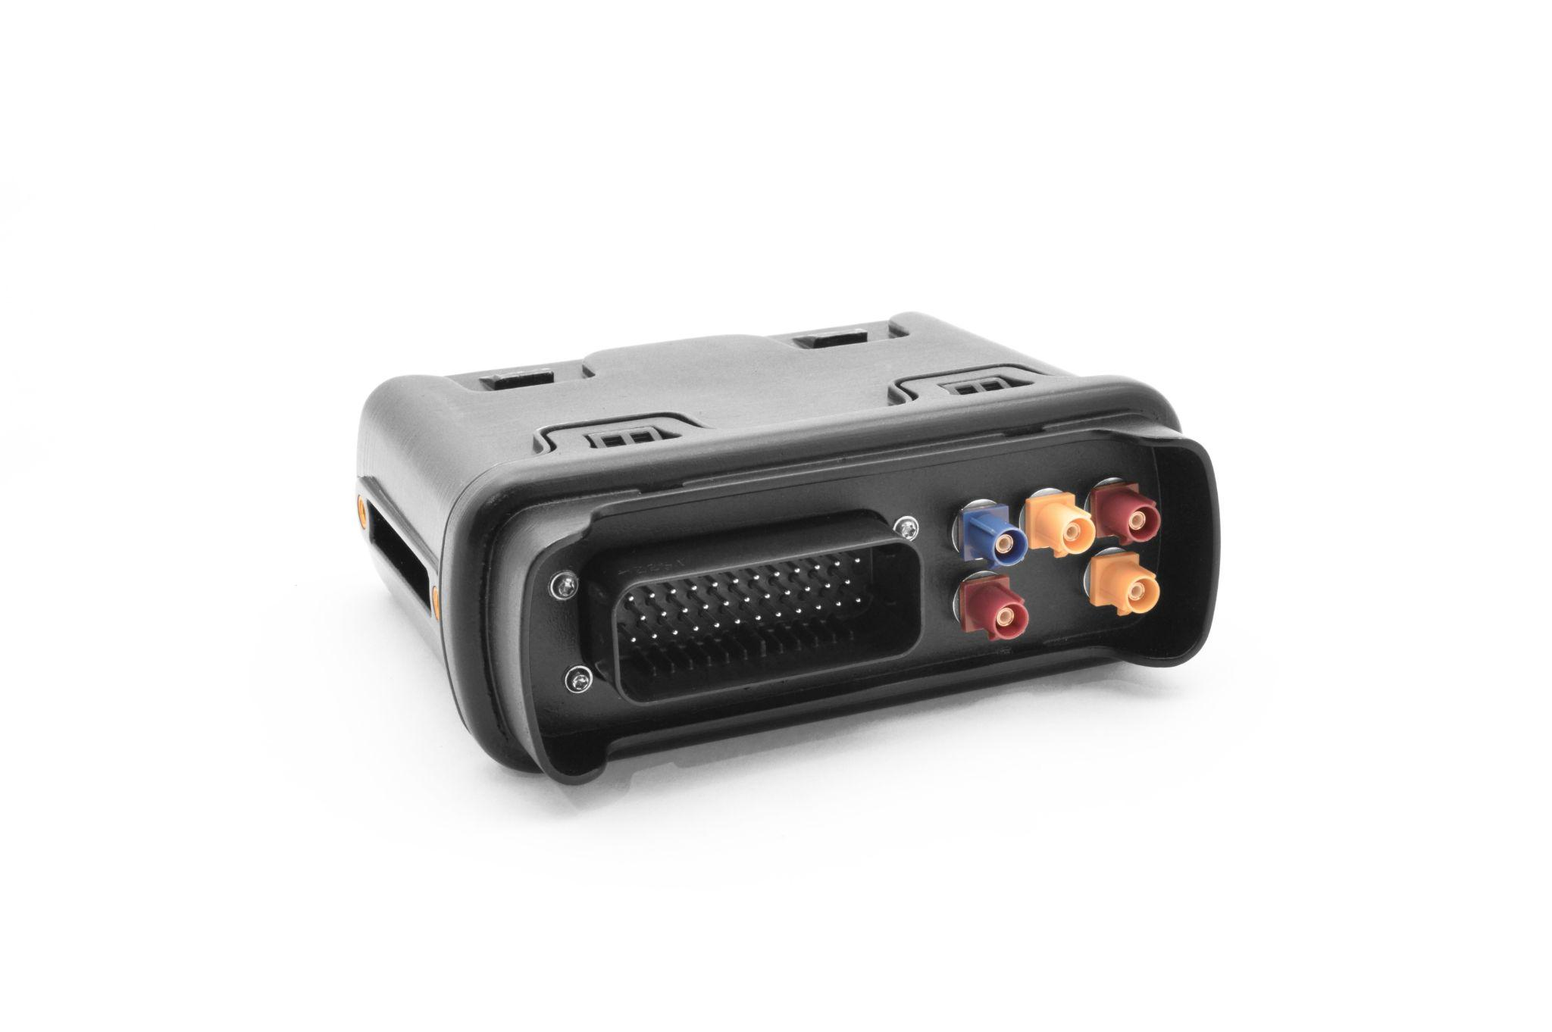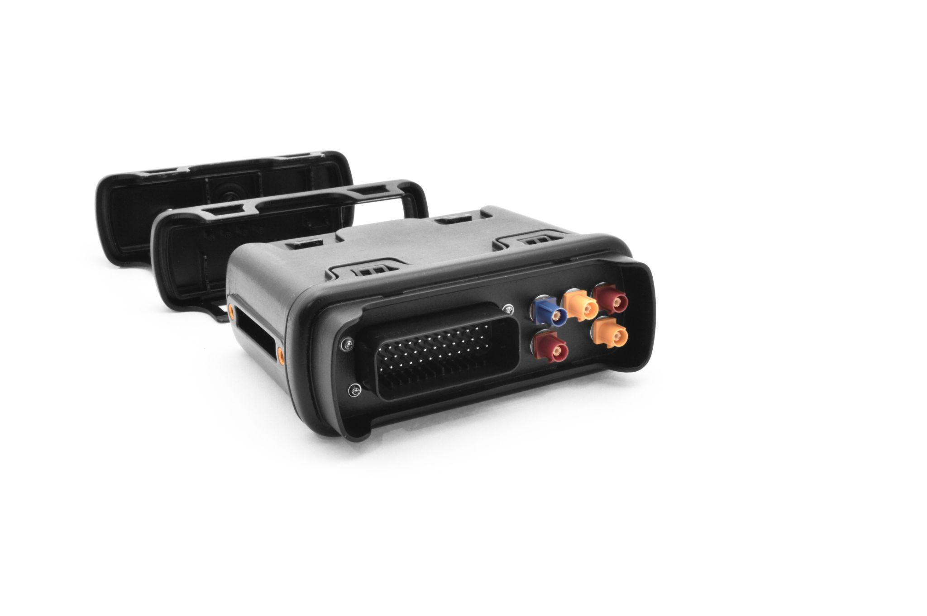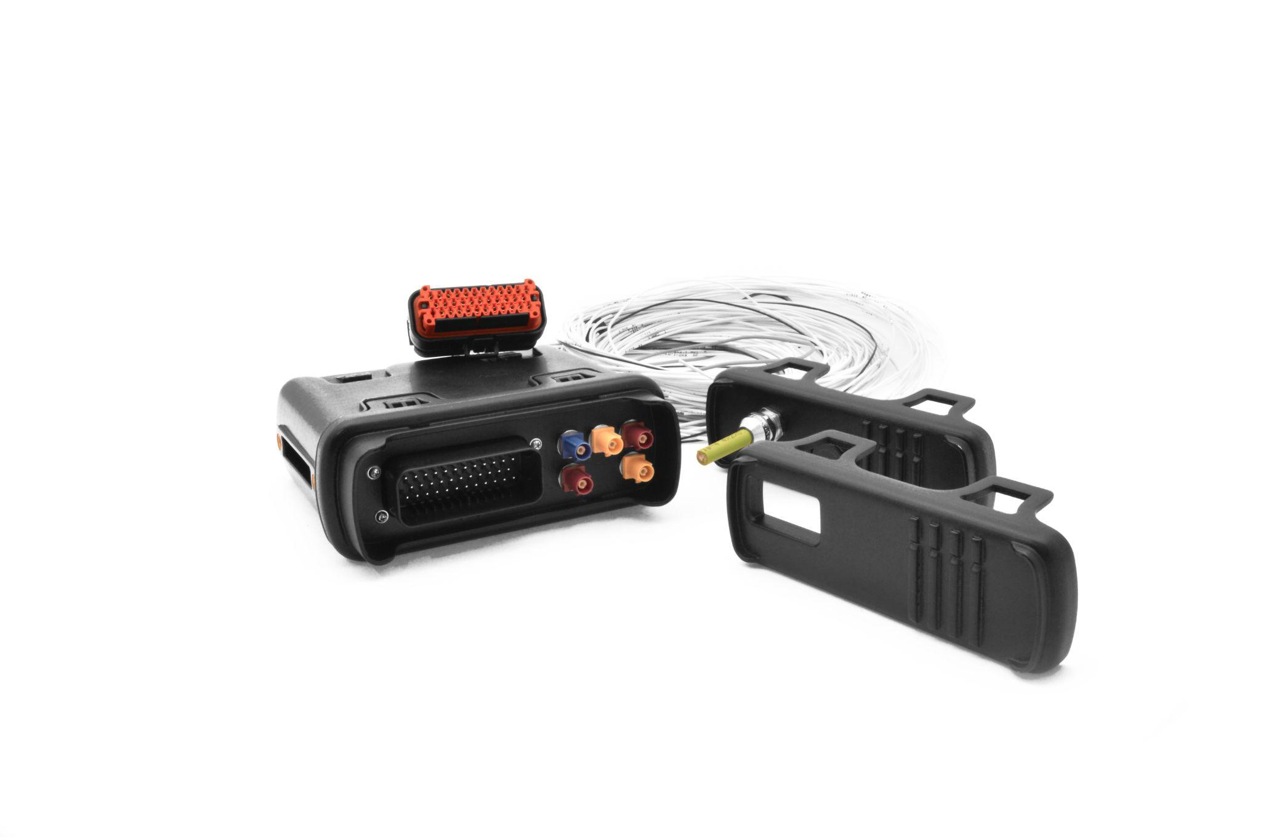

Title of the section: owa450
Text of the section:
ARM Cortex A8 CPU 32bit @800MHz
- 512MB RAM DDR3
- 1GB NAND Flash, +32GB using uSD card
- Industry standard architecture
Very Powerful: Linux Kernel and Debian OS
- Open M2M/IoT platform: 4.19.94 Linux Kernel
Debian 10 buster Filesystem
- Programmable in C/C++, Shell scripting, Python, Java, NodeJS, Golang and Lua
- Extensive libraries and a well documented API to make the most of the owa4x hardware
- Open source tools and Sofware packages available. Access to the official Debian repositories for ARM.
- Standard and complete set of tools and development environment, code examples and Application Notes
- Backwards compatible with existing owa3x applications
Industrial-grade Cybersecurity: TPM 2.0

PSU:
- Robust for Automotive
- Very Low Power consumption & power saving modes
Images for this product:

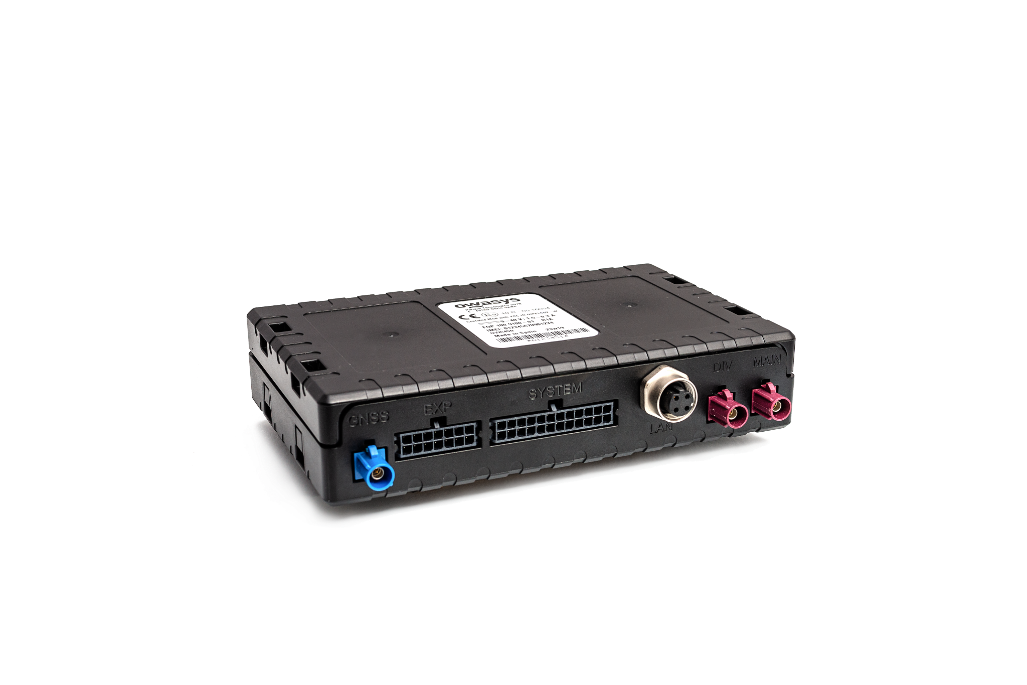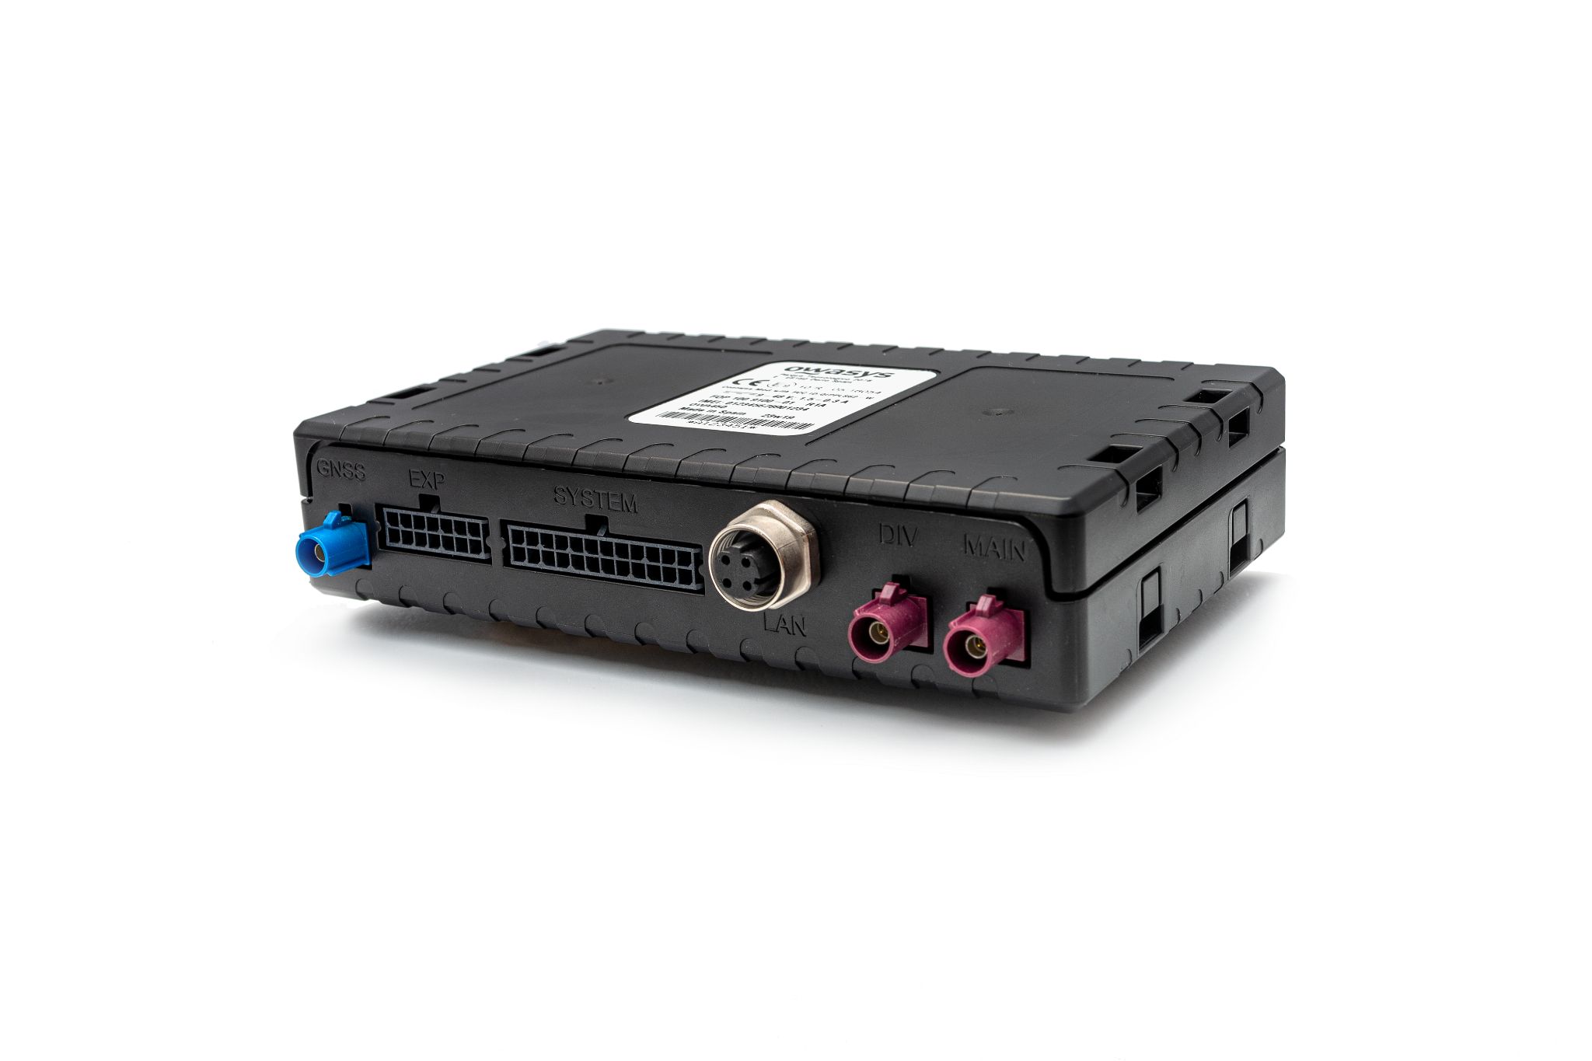
—--
Logo:



