BARNARD’S CRUNCHY DIP
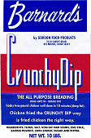
UPC: 78653-12121
PACK: 4/10 LBS
CASE COST: $54.25 FOB
CASE: 16’ WIDE – 11” DEEP – 10” HIGH
CASE CUBE: 1.018
PALLET: TIE-10 / HIGH-5
PALLET CUBE: 54.87
PALLET WEIGHT: 2000 lbs

