Design brief. Journey Connect.

Journey Connect
Tagline: Support & Therapy Specialists

Logo construct – iconography and typography
The ICON will include a QUOKKA, a native Australian animal that is known as the happiest animal on earth.
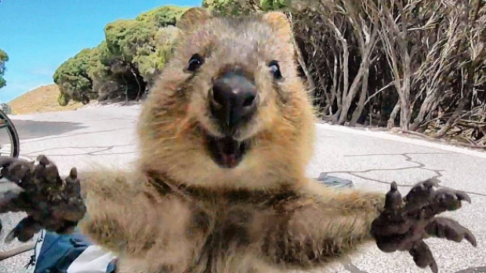
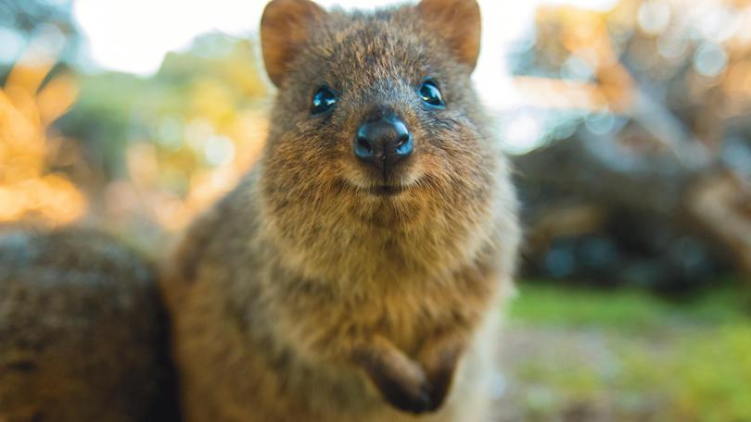
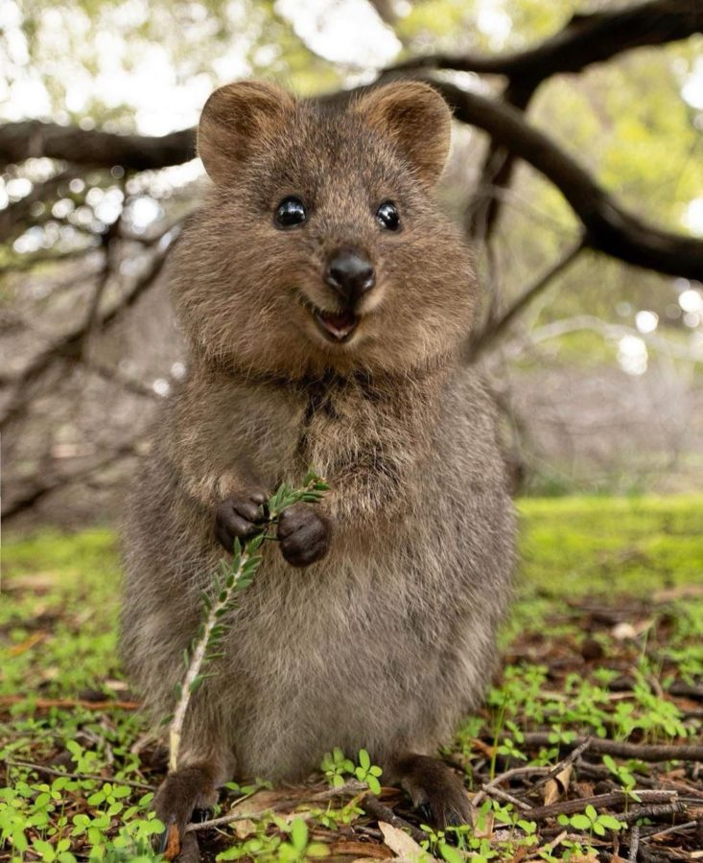
Structure of logo
Quokka as a separate icon that incorporates and creates the brand feeling of Journey Connect.
Icon to the left and typography to the right.
The simple line art of the icon below is what we are aiming for. (Below is a koala, not a quokka) Minimal line art that captures the essence of the Quokka but can easily be used for embroidery.


The icon
The Quokka: Known as the ‘happiest animal in the world’ with the feel of the icon ‘be happy’. Trying something new, skilling or support for change or fulfillment in life.
THOUGHT BUBBLE: The icon could incorporate brand elements such as a tricky use of the JC (would want to be subtle and clever use of letters) with some form of nature. Eg. The quokka sitting in the branch shaped like a ‘JC’


LOOK AND FEEL OF THE QUOKKA
Line art without too much detail. The Quokka should be awake and happy. (the below is illustrative, this was is too cartoonish)
We think that the quokka looks most NOT like a mouse or rodent when it is face on, smiling.
The tail should be incorporated – potentially with a love heart?
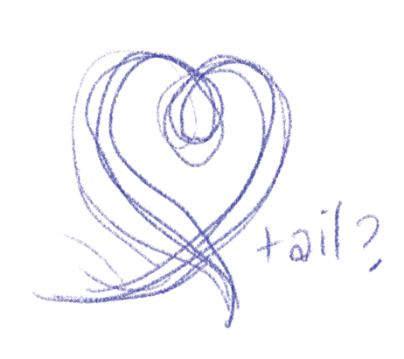

We liked this version of a piece of quokka line art. However it is too side on, needs to be more front on.
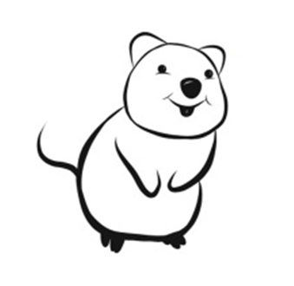


When you play with it with the typography it seems it would need to be more ‘front on’ as it looks like it’s facing away But this is the look at feel we like.

Typography
Font families to play with would be San Serif and Modern. Below are just examples and not the fonts I think would work.

San Serif example:

Modern Font example
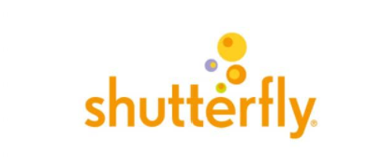
We think play with the use of case. Whether the J and C are upper and the rest lower, or all Upper case, or all lower case.

Colours
We are still wanting to stick with strong but subtle earthy tones.
The logo would need to e able to be converted into black and white easily.

