The McCrillis Homestead History c. 1826
Peterborough, New Hampshire

In 1826, George S. McCrillis and his wife, Jane (Smith) McCrillis purchased 26 acres from Robert White on the Contoocock River, north of Noone’s Woolen Mill in South Peterborough, NH. This parcel was carved out lot #32 which was comprised of 268 acres that were deeded to John White (Robert White’s grandfather) by Jeremiah Gridley and John Hill on May 5, 1762. It is believed that McCrillis, who was blacksmith, built the house that currently stands at 181 Grove Street in Peterborough, NH. He also built his forge on the site down by the river. It is likely that much of the forged hardware in the home was crafted by him. Feeling the need to leave Peterborough for a new frontier, McCrillis left town with his brother, Bowden, to purchase land in the emerging communities of Orleans County, NY. Before doing so, McCrillis sold the home, shop and buildings to Thomas Wilson and his wife Alice (Foster) Wilson in 1828.

By trade, Thomas Wilson was a cloth dresser and wool-carder. He was also a deeply religious man and served as deacon in the emerging, but still quite small, Baptist community. In those days, small groups of the Baptists and Methodists met in the Cheney Home for bible study, prayers and singing. The Cheneys were well known abolitionists and their house served as a stop on the Underground Railroad. Deacon Wilson died in 1839 and his estate was managed by Samuel Foster—very likely a relative of Alice—who protected Alice’s dower. The property was then sold to Elijah Brown Kimball and his wife Achsah (Buss) Kimball.

Elijah was quite industrious and continued to expand the wool mill. He was an early investor in the Monadnock Railroad and ceded a right of way to the railroad on the homestead. The mill eventually came under the control of his son, Henry A. Kimball, and operated until it burned down on April 20, 1874. Elijah passed away in 1877 and left the home to Mary Ellen Kimball who was most commonly known as “Ellen.”

Ellen Kimball was approached in 1891 by Allie Noone, the owner of the Noone’s Mill Complex, to ask if she would be willing to rent out the home to a couple from Boston. This turned out to be Marian and Edward MacDowell, the founders of the MacDowell Colony, who ended up spending their first summer in Peterborough, NH in the home. Marian recalls in her writings: “You can't fail to remember the two-story farmhouse almost across from the road from the iron bridge, now occupied by the Waite Family. It had never been painted and was a lovely soft gray in color. There were really only four rooms and a kitchen, spotlessly clean and adequately furnished, which really didn't mean much but some chairs, tables and beds. Then in the kitchen was something that fascinated me, a stone bowl into which the clearest of water was all the time pouring and then running off into a a drain...."

The Waites lived in this home for the longest time of any owner--and some refer to this area before the bridge, as Waites Corner. This moment of stewardship began under Fred Parker Waite and his wife Grace E. (Herrick) Waite around 1904 and lasted until 2015 when a descendant sold the home. The house is now under the stewardship of Edward M. Cardoza and Albert A. Cummings, Jr. and will be undergoing a significant restoration.

(FACEBOOK LOGO) They invite you to join their Facebook Group

McCrillis Homestead c. 1826, Waites Corner, Peterborough, New Hampshire

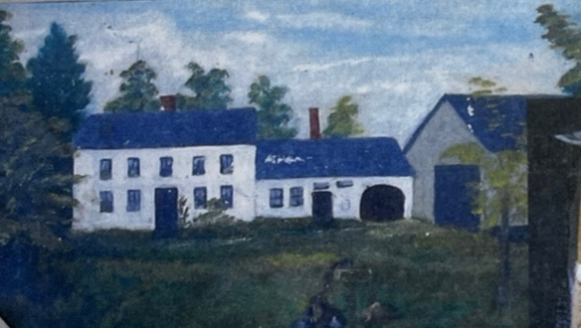

Owners of 181 Grove Street
Peterborough, New Hampshire

Robert White (grandson of John White) owned the land 1826
George S. McCrillis and Jane (Smith) McCrillis 1826-1828
Deacon Thomas Wilson and Alice (Foster) Wilson (Baptist) 1828-1839
Elijah Brown Kimball and Achsah (Buss) Kimball 1839-1877
(mortgage between Samuel Foster and Kimball is 1845)

Mary Ellen Kimball 1877-1898

James Condon 1898-1904

Fred Parker Waite and Grace E. (Herrick) Waite 1904-1956

Elinor (Waite) Beverstock and Frank O Beverstock 1955-1998
(Elinor was born in house on July 29, 1911)

James H. Dichtelmiller and Maria Ruiz Dichtelmiller 1998-2015
(James was nephew of Elinor (Waite) Beverstock)

RiverMead 2015-2022

Edward M. Cardoza and Albert A. Cummings, Jr. 2022

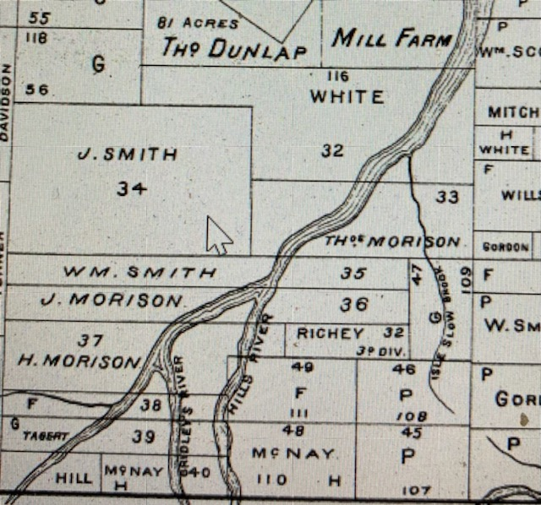

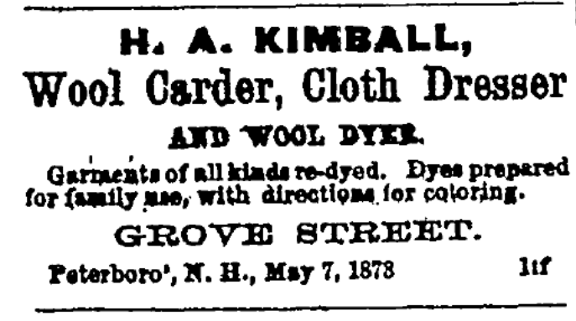

Advertising for the Kimball Mill

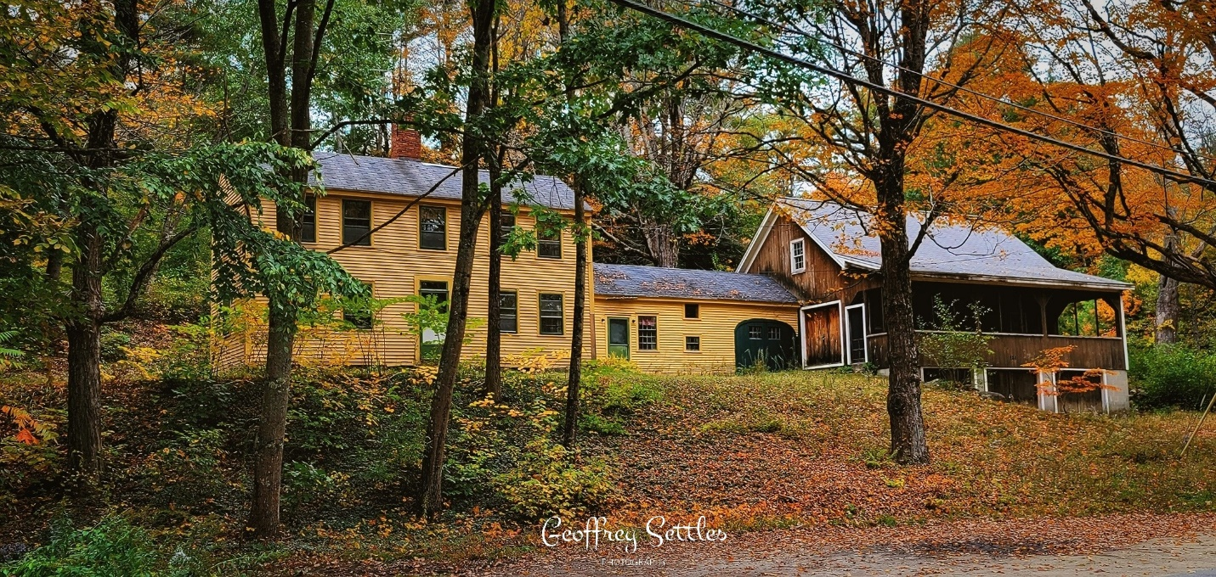

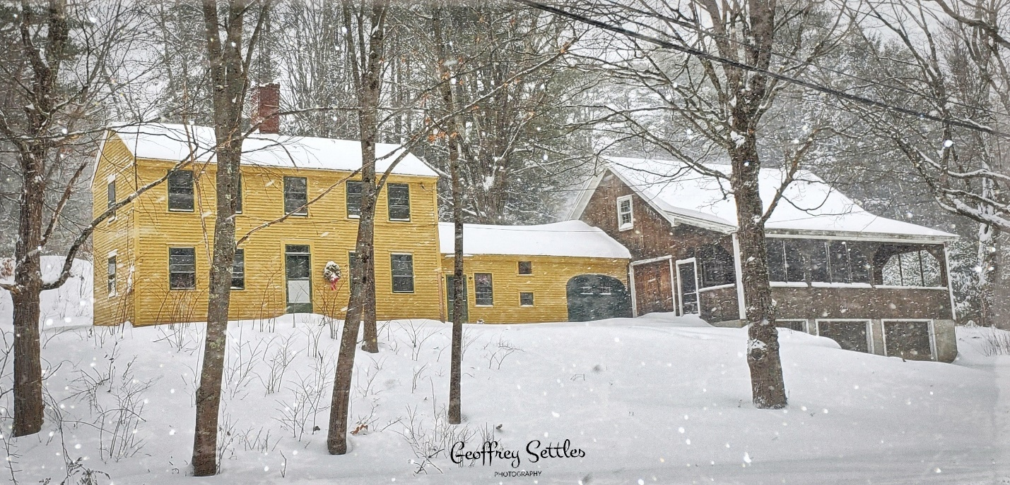
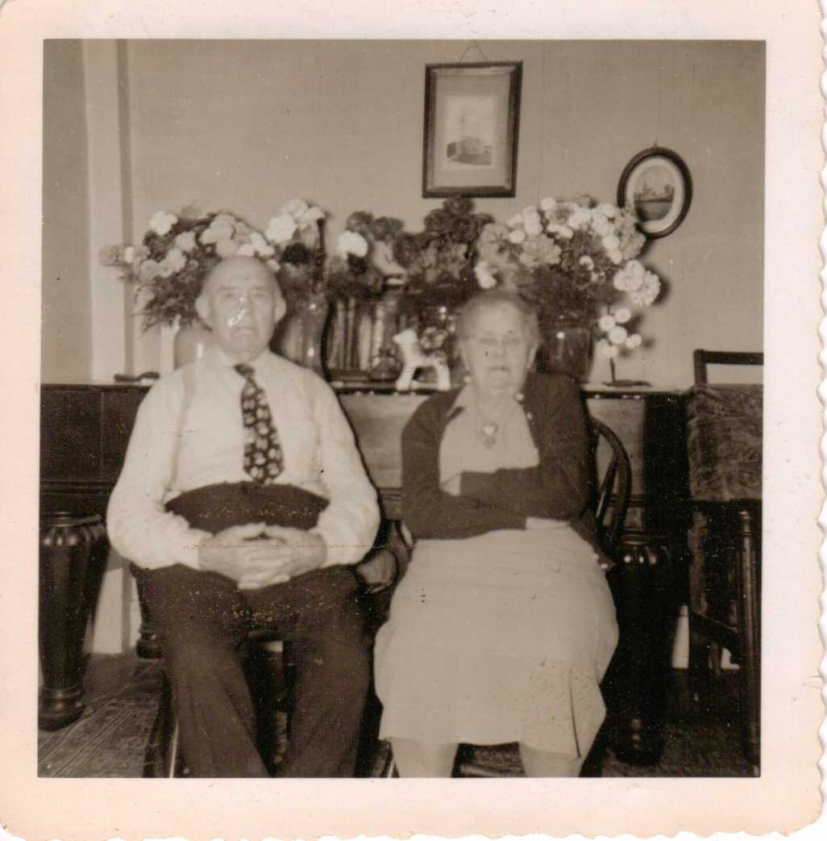

Fred and Grace Waite

