

Southwest Probiotics: Homepage (links to other pages should be made)

Show video of a beach with palm trees
Title:
Southwest Probiotics
The Probiotics Expert!

Scientifically Advanced Probiotic Blends
for Food and Supplement Manufacturers
Please Contact Us for ALL Your Probiotic Needs

And at the Request of So Many Friends!
BRAND NEW!
Dr. Tom’s Probiotics!
Featuring:
Dr. Tom’s Healthy Weight Probiotic Formula
Order your individual 60-day supply today!
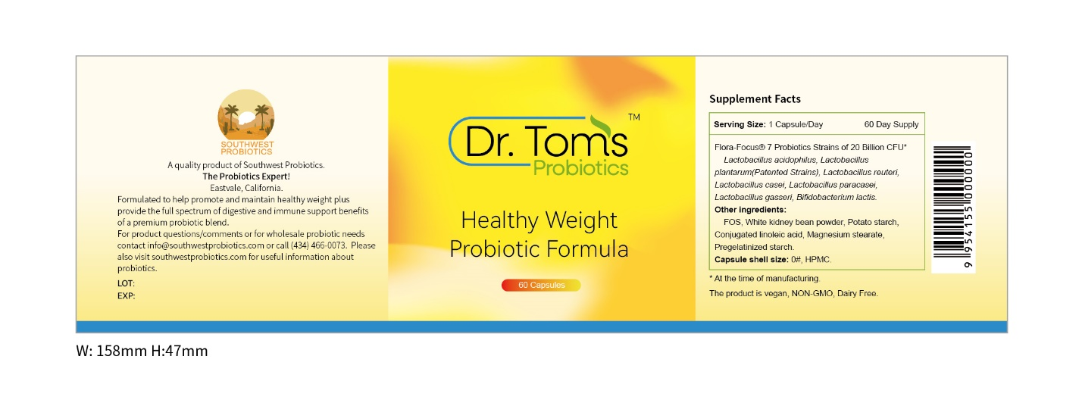

Please Note:
Always, at least 20% of all our total wholesale and retail sales minus cost of goods sold goes to support the needy, especially for food and health assistance. We welcome your suggestions on worthy organizations for our funds.

And to assist your health further we will soon simplify this entire complex, promising, and greatly expanding world of probiotics with the publication of the first ever truly practical and informative guide:
Dr. Tom’s Probiotics Primer
Scientific, relevant, fully up to date, and understandable. It will show you how probiotics can help your health in many ways now and will give you our own personal vision of the exciting future probiotics will have to bring new levels of health and vitality to humankind.
We are also starting a new blog series that will cover in bite size portions key issues from the world of probiotics. Please visit our blogs regularly.

WE WANT TO HEAR FROM YOU!
- Wholesale Probiotics for supplements or foods. We can supply anything you need at very competitive pricing and provide expert guidance on probiotic selection and blending. We can provide probiotics in drums all the way to finished capsules in labeled bottles, ready to sell. Please visit our wholesale probiotics page for more information and contact us today!
- Questions about our retail products or just want to talk about probiotics please contact us.
- Finally, please contact us with worthy organizations to fund with the 20+% of our sales dollars we always allocate to help others

PHONE OR TEXT: (434) 466-0073
Email: info@southwestprobiotics.com

WEB PAGE ONE
Southwest Probiotics Website About Section:

Hi! Thank-you for visiting our website. Southwest Probiotics rests on two premises that define who and what we are.

Premise One: We are all joined together as members of the global human family. As people, the love and compassion we feel for all people, and not just for our family and friends, is perhaps the most wonderful thing about being alive. As a company and as individuals that comprise this company the connection and concern we feel for our fellow human beings and the bonds we form by connecting with those whom we benefit in some way with our products, education, or simply encouragement and relationship, means everything to us, and empowers all we do.

Premise Two: We are absolutely committed to the highest excellence in probiotics science and technology to be able to honor our commitment to you, our followers, to provide you in a continuing way the products, education, and encouragement that most will transform and sustain your health and wellness to new heights. Probiotics is our field and probiotics hold many of the keys to a new level of wellness and health. We intend to be a force to help get the people of the world there. Our human family needs a new level of health and wellness, globally.

Among the ways we seek to live out the two premises are:

- We seek to hear from you and get your perspectives on health and wellness issues and how probiotics might help. Please contact us by email (info@southwestprobiotics.com) or phone/text ((434) 466-0073).
- Southwest Probiotics always donates at least 20% of our sales revenue minus cost of goods sold to help with food and health needs throughout the world, especially to countries that have the biggest needs. We contribute that 20% before we pay ourselves, our taxes, our expenses, or pay for R&D and clinical trials. We feel like donating to help those who have the greatest needs should take precedence over everything else. Please see our charitable contributions page for more details and we are open to specific charities that you would suggest to add to our list.
- Please see our educational blogs that will eventually cover all key topics related probiotics and health and wellness.
- We will soon be publishing the first ever complete practical guide for probiotics health: Dr.Tom’s Probiotic Primer, A Complete and Understandable Guide to Better Health.
- We seek to place our retail probiotics for easy access to anyone. We always offer completely free shipping because it is not fair to you if a store near you does not currently carry our line.
- Our knowledge of biochemistry (a key field to everything), microbiology, probiotics, the anatomy and physiology of the entire digestion and absorption process, the human microbiome, is unsurpassed in this industry.
- Our knowledge of probiotic strains research and development, probiotic manufacturing, probiotic quality testing and assurance, and probiotic stability and storage is state of the art.
- Our knowledge and creativity in R&D in the probiotics arena, clinical trials for probiotics, and innovative ideas in prebiotics, probiotics, and postbiotics is top notch.
- We do not simply seek to create our own top retails brands and products but also premium wholesale probiotic products and blends for other companies that market probiotics because they also have loyal customer bases that we want to also ensure receive superior products.

The cofounder and Managing Partner for the Americas for Southwest Probiotics is Dr. Tom Laaman. Dr. Tom’s education includes a B.S. from Cornell University, M.S. from The Ohio State University and a Ph.D. in Protein Biochemistry from Texas A&M University. While at Texas A&M he earned a 4.0/4.0 GPA for all courses and was selected for a prestigious Fellowship given to the top four Ph.D. students in his college. He subsequently was a Postdoctoral Fellow in Protein Biochemistry at The University of Texas Medical School in Houston in the world-renowned lab of Dr. Finn Wold.

Dr. Tom has devoted his entire career to providing products that can really help people. He has held senior technical positions with Merck, FMC Corporation, Pronova Corporation, and the probiotic companies Bio-Cat and Specialty Enzymes & Probiotics. In late 2019 he cofounded Southwest Probiotics to provide superior help to companies seeking to market top notch probiotic blends. At the beginning of 2022 Southwest Probiotics also launched the first entry into what will be a line of probiotics for the consumer that will provide individualized probiotic solutions for a wide range of specialized needs.

The first product in the Dr. Tom’s Probiotics line is the Healthy Weight Probiotic Formula, designed to help promote and maintain healthy weight. For more information on this product please visit the Dr. Tom’s Probiotics page. For more information on how we can help you with your own probiotic products please visit our wholesale probiotics page.

Probiotics are in our humble opinion a major key to not only assisting people overcome various health issues, especially related to digestion, while providing critical immune support, but also to eventually extending the horizons of health and wellness to new heights. But to develop the best probiotics of today and tomorrow requires intensive cross functional knowledge in many fields and the goal should be for top experts to have a wide, working knowledge of all these fields. Having a team with ten people from ten disciplines has been shown again and again not to work.

Again, the fields that are necessary to individually master to provide superior probiotics to needy consumers include biochemistry, microbiology, human nutrition, human anatomy and physiology, the human microbiome, biochemical engineering, conducting clinical trials, and quality assurance and testing. And creativity, especially to see analogies with other branches of science, are a significant key to bringing probiotics to new levels of effectiveness for human health. We invite you interact with us to learn how our expertise and products can enhance the health of you and those you love, and if you are a marketer of probiotics, those who trust you for superior, cutting-edge probiotics.

For more about probiotics and our approach to them please see our informative blogs. Again, please contact us by phone/text at (434) 466-0073 or email at info@SouthwestProbiotics.com. We would love to hear from you with any questions, requests, or comments.

WEB PAGE TWO

Southwest Probiotics Website: Wholesale Probiotics
Southwest Probiotics, the Probiotics Expert!
Please allow us to be your probiotics expert for your wholesale probiotics needs or we can help design your retail products containing probiotics.
Southwest Probiotics provides a full selection of the finest probiotics combined with prebiotics and postbiotics at competitive prices. These are available individually and in blends. They can be purchased in quantity in drums or in finished capsule form in bottles for immediate retail sales. We can ship these products worldwide and they are available for rapid delivery with minimal wait periods. Maximum potencies are up to 500 Billion/g for many of the strains.
Each of these probiotics are from established and in some cases patented strains to ensure our customers get probiotics that second to none in the industry.
Below is a representative list of the probiotcs we offer but we can also provide other choices upon request:
Lactobacillus acidophilus
Lactobacillus buchneri
Lactobacillus casei
Lactobacillus crispatus
Lactobacillus delbrueckii subsp. lactis
Lactobacillus delbrueckii subsp. bulgaricus
Lactobacillus fermentum
Lactobacillus gasserii
Lactobacillus helveticus
Lactobacillus johnsonii
Lactobacillus paracasei
Lactobacillus plantarum
Lactobacillus reuteri
Lactobacillus rhamnosis
Lactobacillus salivarius
Bifidobacterium adolescentis
Bifidobacterium animalis subsp. lactis
Bifidobacterium bifidus
Bifidobacterium breve
Bifidobacterium longum subsp. infantis
Bifidobacterium longum subsp. longum
Bacillus clausii
Bacillus coagulans
Bacillus licheniformis
Bacillus megaterium
Bacillus subtilis
Enterococcus faecalis
Enterococcus faecium
Lactococcus lactis subsp. cremoris
Lactococcus lactis subsp. lactis
Clostridium butyricum
Leuconostoc mesenteroides subsp. mesenteroides
Pediococcus acidilactici
Saccharomyces boulardii
Streptococcus thermophilus

WEB PAGE THREE
Southwest Probiotics: Retail Products

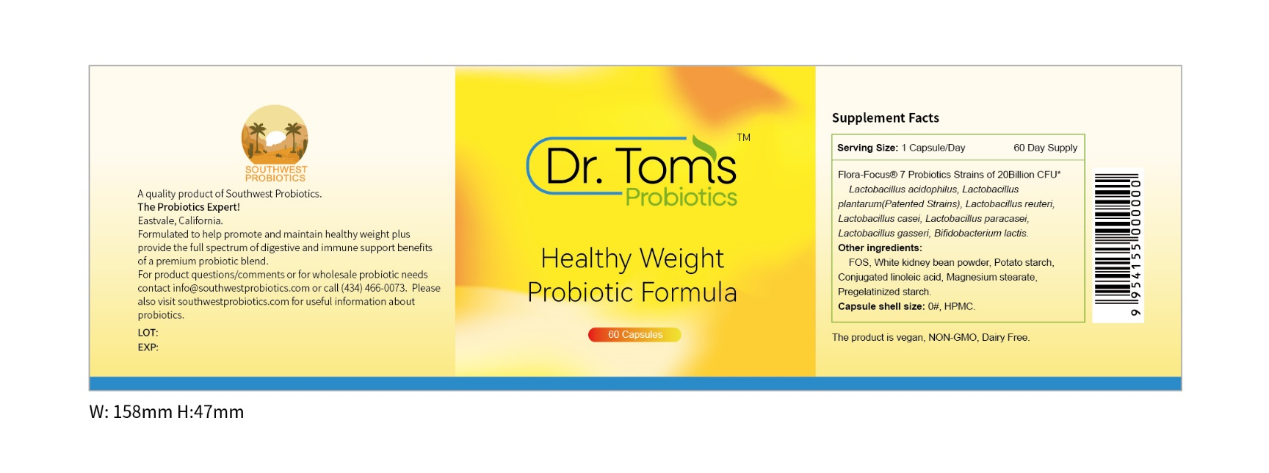
Click to purchase

Dr. Tom’s Probiotics Healthy Weight Probiotic Formula!
- Provides full digestive and immune support benefits of a top notch probiotic blend.
- Helps to promote and maintain healthy weight.
- Special Blend of 7 Key Probiotics Strains, including patented strains.
- Full 60 Day supply!
- $31.99 per bottle and always free 1st class shipping throughout the USA.

WEB PAGE FOUR

Southwest Probiotics Shopping Cart

Healthy Weight Probiotic Blend Price $31.99
60 Day Supply

California Residents add Sales Tax of $2.48 per bottle

Number of Bottles: 1

Grand Total $31.99

Shipping is always free in the USA!

Credit Card Payment

Address for shipment

WEB PAGE FIVE

Southwest Probiotics: Charitable Giving
Southwest Probiotics is a company formed to help people. We endeavor to make the best products to assist the health our fellow people. We also seek to help with food and health issues those who most need help.
We therefore contribute at least 20% of our total sales minus our cost of goods sold to various organizations that help with food and health issues throughout the world. We give away this money before we pay ourselves, our taxes, our expenses, or do our research and clinical trials. All that comes from what is left.
A special concern we have is for central Africa where there are perennial issues with food and health security. These members of our human family need and will continue to receive expanding support from us at Southwest Probiotics. We have a special understanding and concern because relatives of Southwest Probiotics personnel have done medical work in this region and seen the suffering first hand.
An organization we have begun to support recently in the USA is myfreedoctor.com. This organization does accept donations for their services but will give completely free medical care to those in need. Among the services they provide is early treatment of positive Covid 19 patients for those with advanced age or comorbidities who could be under risk for serious complications or even death, but with early treatment are able to gain much better outcomes.
We are open to your suggestions on organizations to support, especially those that operate as much as possible with volunteers and where there are no high salaries at the top. Please call us at 434-466-0073 or email us at info@southwestprobiotics.com.
WEB PAGE SIX

Southwest Probiotics Website:
Blog One: The Health Benefits of Probiotics, Part One: Lactic Acid Production
This is the first in an extended series that will cover in detail all the major benefits that probiotics provide for our health. The goal is to explain the science so that you are able to understand the why and not just have a laundry list of supposed probiotics benefits such as those written by non-experts that are all over the internet. Since most readers are not Ph.D. scientists, I will endeavor to make this understandable for a wide audience. Please let me know how I do. Call or text me us (434) 466-0073 or send us an email info@southwestprobiotics.com. Also, send us requests for other topics on probiotics you would like us to address in these blogs.
So, what is lactic acid and why is it called lactic acid? Well, in the earlier days of scientific discovery over the few centuries past, in the western world, all educated people knew Latin, but they did not share a common language. So, in order for French, German, British, etc. scientists to have a common language for naming living organisms they adopted Latin as the language to be used to scientifically classify all living things. But as we go more in depth with understanding probiotic organisms specifically, and how they were named it will become clear that the classical Greek language is actually the fountainhead for many names. Classical Greek learning transferred to the Roman Empire and Greek words were the source of many words related to probiotic names. More on that in future blogs.
The name lactic is derived from the Latin word for milk, which is lac in Latin. But the genitive form of lac is lactis, hence “of milk”. It was given this name by the Swedish scientist Carl Wilhelm Scheele who first identified it, back in 1780, because he isolated this molecule from sour milk. He considered it an acid of milk.
Before we discuss the significance of sour milk and how that relates to probiotics let’s take a brief minute to review the chemistry of lactic acid. I promise to try to make this as understandable as possible for those that haven’t seriously learned organic chemistry. But you can handle it!
Organic chemistry is one of the four main branches of chemistry and it deals with the chemistry of molecules that are carbon based. These molecules are made by living organisms and also products such as petroleum are organic molecules derived from life that existed in the past. And, of course, scientists can synthesize in laboratories many organic molecules that are not found in living things or nature.
Lactic acid is a small 3 carbon molecule which has the chemical structure of CH3-CHOH-COOH. The COOH is what is called an acid group, and what makes this molecule an acid. Acids make things taste sour. Anyway, please see the three-dimensional model I just put together on my desk while I am writing this blog. The three black balls represent the carbon backbone of the molecule. The white balls are hydrogen and the red one’s are oxygen. Towards the front you see the black carbon with two red ones attached. This is the acid group. Anyway, a little fun with chemistry! You will slowly understand more and more as you read these blogs.
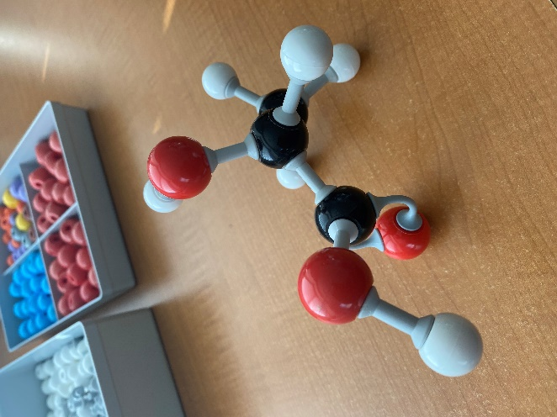
Moving on, what’s so great about lactic acid? To understand that let’s travel back to the dairy farms of northern Europe of yesteryears. Like where Scheele made his discovery. Before refrigeration, before Pasteurization, cows would be milked and this milk was an important food source. If you drank it immediately it would be warm and sweet. But even by later that day, for dinner time, the milk would still be nutritious, but it would be sour.
It was made sour by what are now known as lactic acid bacteria, which are now also considered the most significant “probiotics”. These bacteria fermented some of the milk sugar, lactose, to lactic acid and this made the milk sour. The bacteria carry out fermentation because from it they derive the energy they need to grow and reproduce. This fermentation on farms was a good thing because, if anything, the sour milk was now more nutritious than when fresh. The farmer didn’t have to add any “culture” to the fresh milk. The lactic acid bacteria were naturally all over the farm, even right on the udders of the cows. The milk came out sterile but was quickly inundated with lactic bacteria which dominated any other bacteria around.
When milk was shipped further distances to bigger cities however, problems sometimes arose. Not healthy for humans bacteria somewhere during transport sometimes contaminated the milk. This caused some serious digestive illnesses and occasionally even death. Laws were eventually enacted requiring milk to be heat treated (Pasteurized) to kill off any bacteria, good or bad.
How does this farm and milk distribution story relate to lactic acid, probiotics, and our health? Very closely, actually. You see, when you ingest lactic acid bacteria, it eventually starts to grow on some of the food you have eaten as it is being digested. This is especially true starting in the ileum, the third and final section of the small intestines. I will do entire blogs in the future explaining the actions of various probiotics during the stages of digestion (mouth, esophagus, stomach, three sections of the small intestines, and large intestines).
In the ileum the oxygen level starts to get very low and fermentation (which doesn’t need oxygen) begins to dominate for microorganisms trying to thrive and grow. If you have lactic acid probiotics in quantity, they start to produce lactic acid. The largely digested food at this point, known as chyme, then passes into the large intestine in a slightly acidified state due to the lactic acid. This is very good because it inhibits “bad” bacteria and encourages the growth of “good” bacteria. And there are tens of trillions of bacteria in the large intestines, so there are plenty of both good and bad bacteria naturally at all times. You just have to keep the right balance for health. I will do a whole series of blogs on the human microbiome. It is a complex topic but I think it can be clarified for you with careful explanations. Anything I see on the internet currently does not really capture correctly how the microbiome operates. It is an amazing synergy between tens of trillions of individual single cell bacteria, many in colonies along the walls of the large intestines, and a single organism (human) composed of tens of trillions of gigantic (to the bacteria) cells!
If you don’t have enough probiotics and beneficial production of lactic acid, bad bacteria may begin to become too active. This can cause various digestive and other illnesses and infections. These types of bacteria can also produce toxic compounds from what are called putrification reactions, breaking down proteins to harmful substances.
When this happens it is the same idea of milk being transported and harmful bacteria getting in that make the milk unwholesome and disease causing for those who drink it. In the case of probiotics and digestion this happens internally while for the milk it happens externally. So, the goal for digestion is the same goal as for milk, let the good lactic acid producing bacteria dominate and give us good milk or a good digestive environment.
Does that mean if I forget to take my probiotics I will get sick? No, hopefully not. There are many factors and conditions that keep the good and bad bacteria that naturally are found in your intestines in a reasonable balance. Probiotics just help tilt the scale in a favorable direction. That is the number one reason I consume probiotics, personally. I want to tip the scales in a favorable direction and I am overall just a fan of organisms that make lactic acid! They help keep me healthy and they look pretty cool under a microscope!
Thanks for reading! May your health prosper!
Tom Laaman, Ph.D.
(Dr. Tom)

