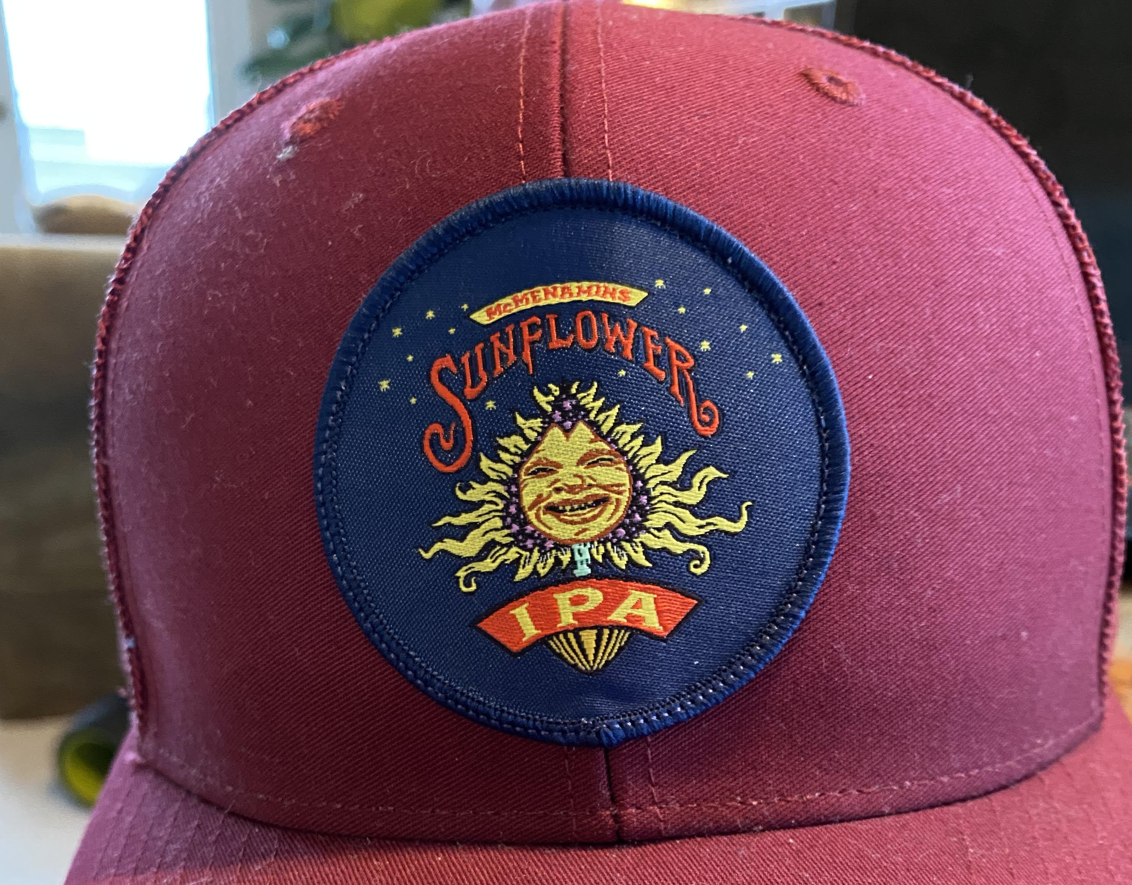
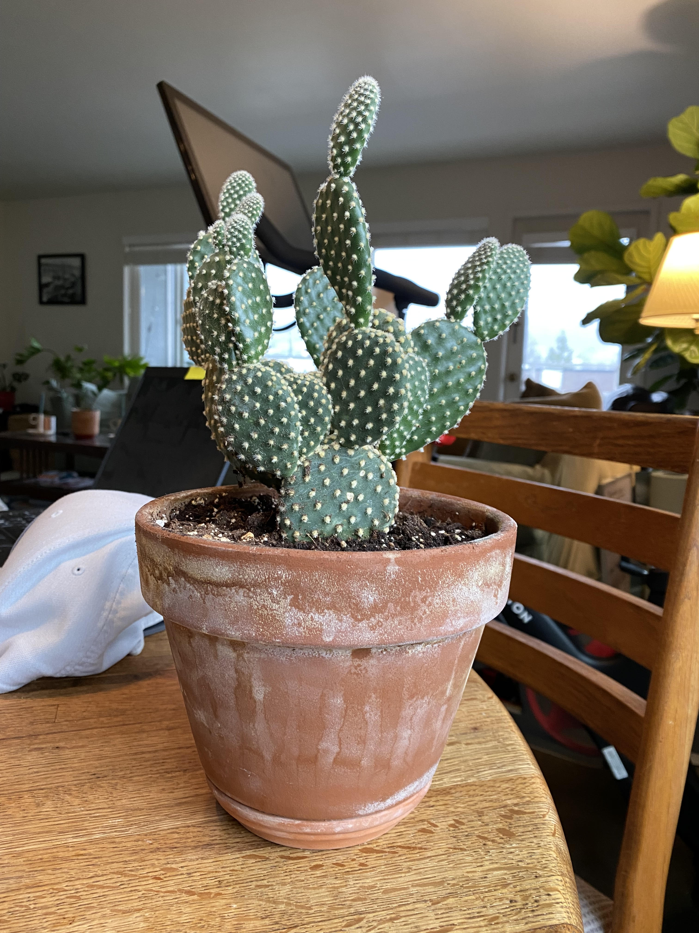

This is the terracotta pot shape that will replace the IPA font at the bottom of the hat

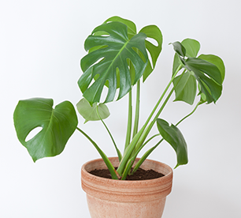
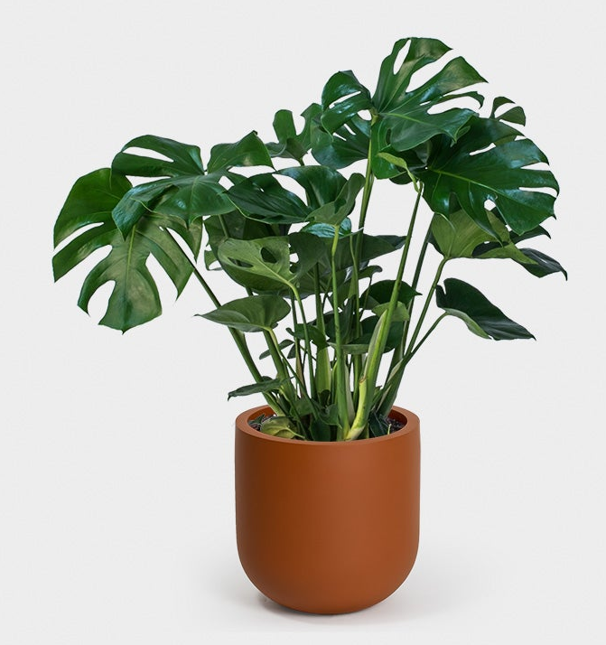
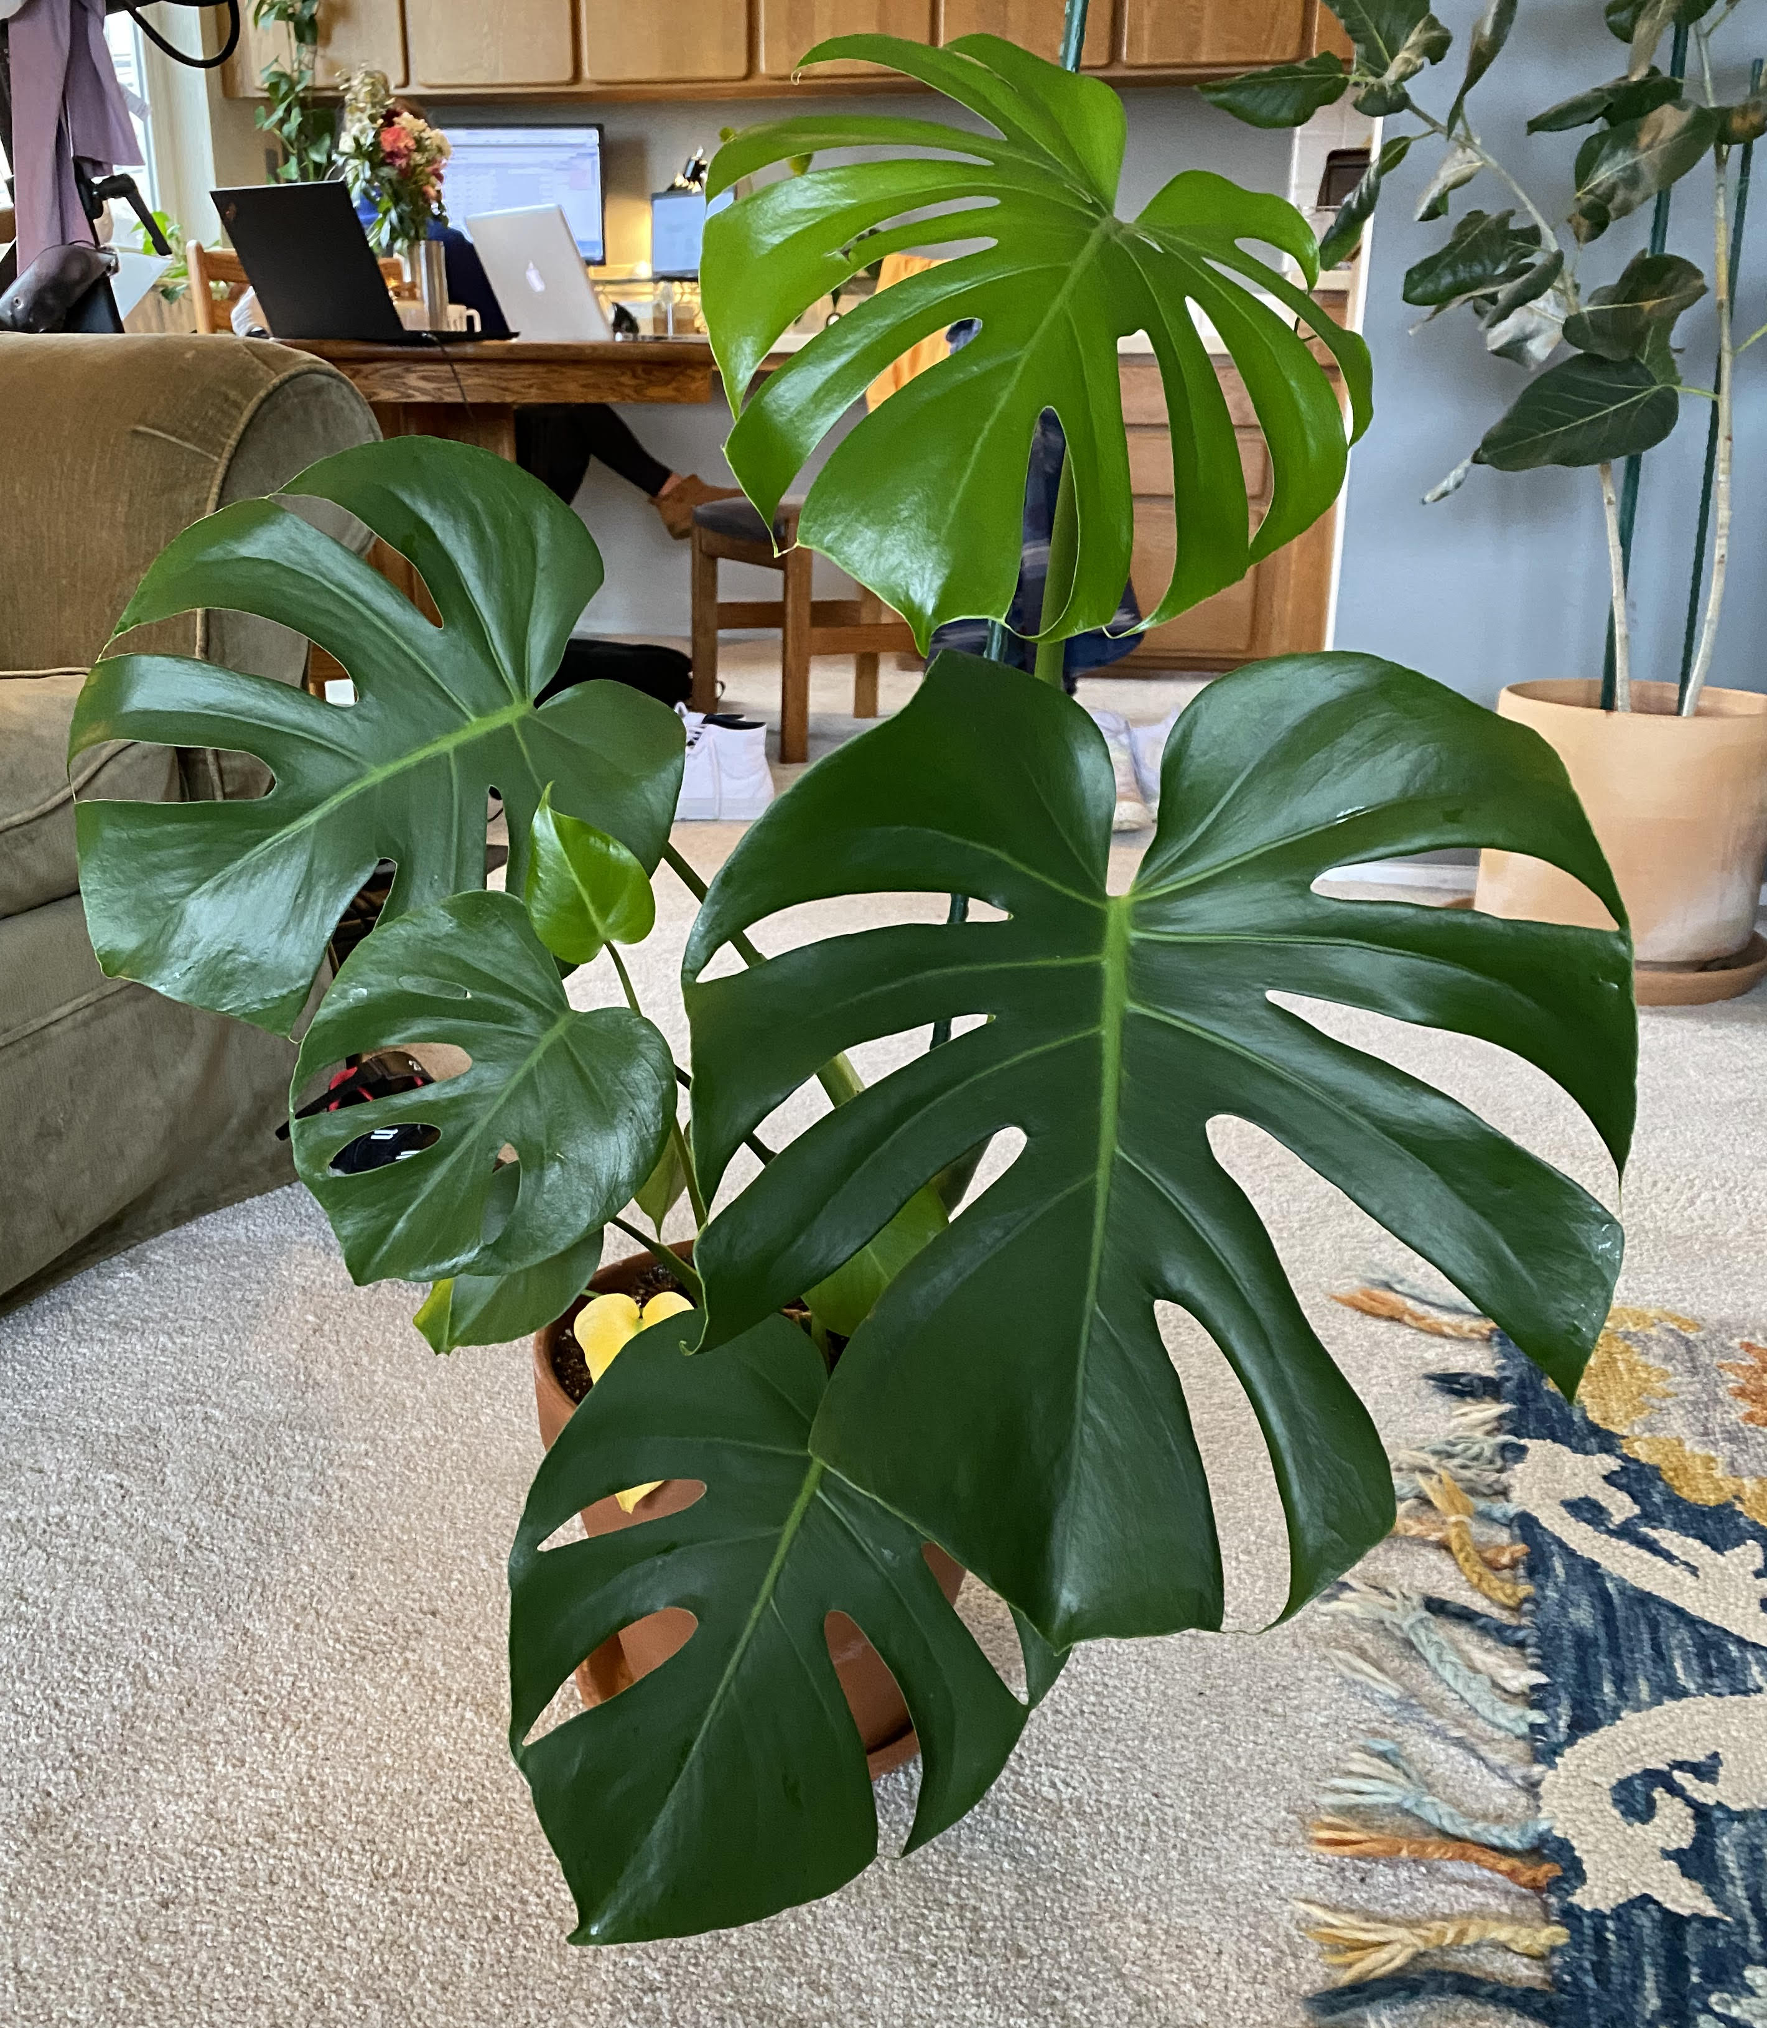
-Monstera plant-
This is to be middle of the patch
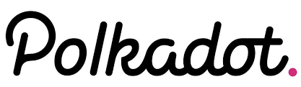

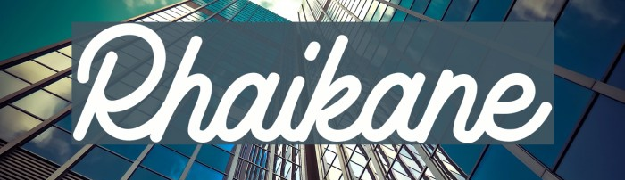

I would like to use the font Rhaikane… I have found it is the most similar to my favorite font, which is used by the crypto currency Polkadot. I found the font here

https://www.ffonts.net

Light gray colored patch
Replace the word sunflower with Monstera and make the font Rhaikane

