

Meet the Team

STACEY
PAUL
BEK


Senior Team Leader
Stacey@candisplans.com.au
Support Worker
Support Worker

CANDI

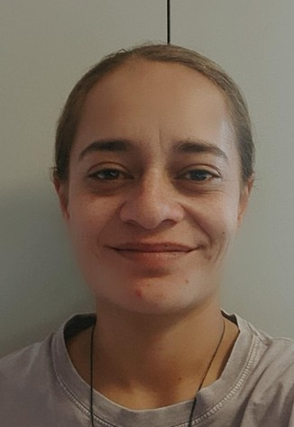
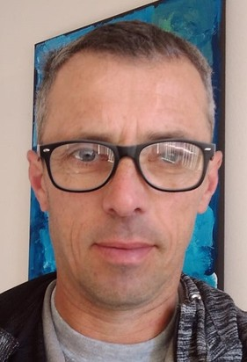
Director
candi@candisplans.com.au
JOE
KIMI
CHAD

Support Worker
Support Worker
Support Worker


WAYNE
SIU
JESS
ATONG
TEGAN

Support worker
Maintenance Manager
Support worker
Support Worker
Support Worker

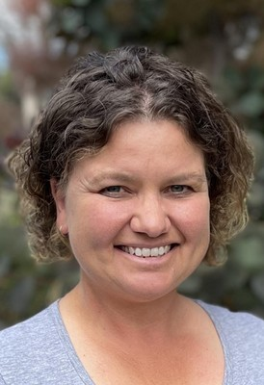
BERNICE
PAT
ADELE
ANNA
SAMANTHA

Support worker
Support worker
Support Worker
Support Worker
Support Worker

