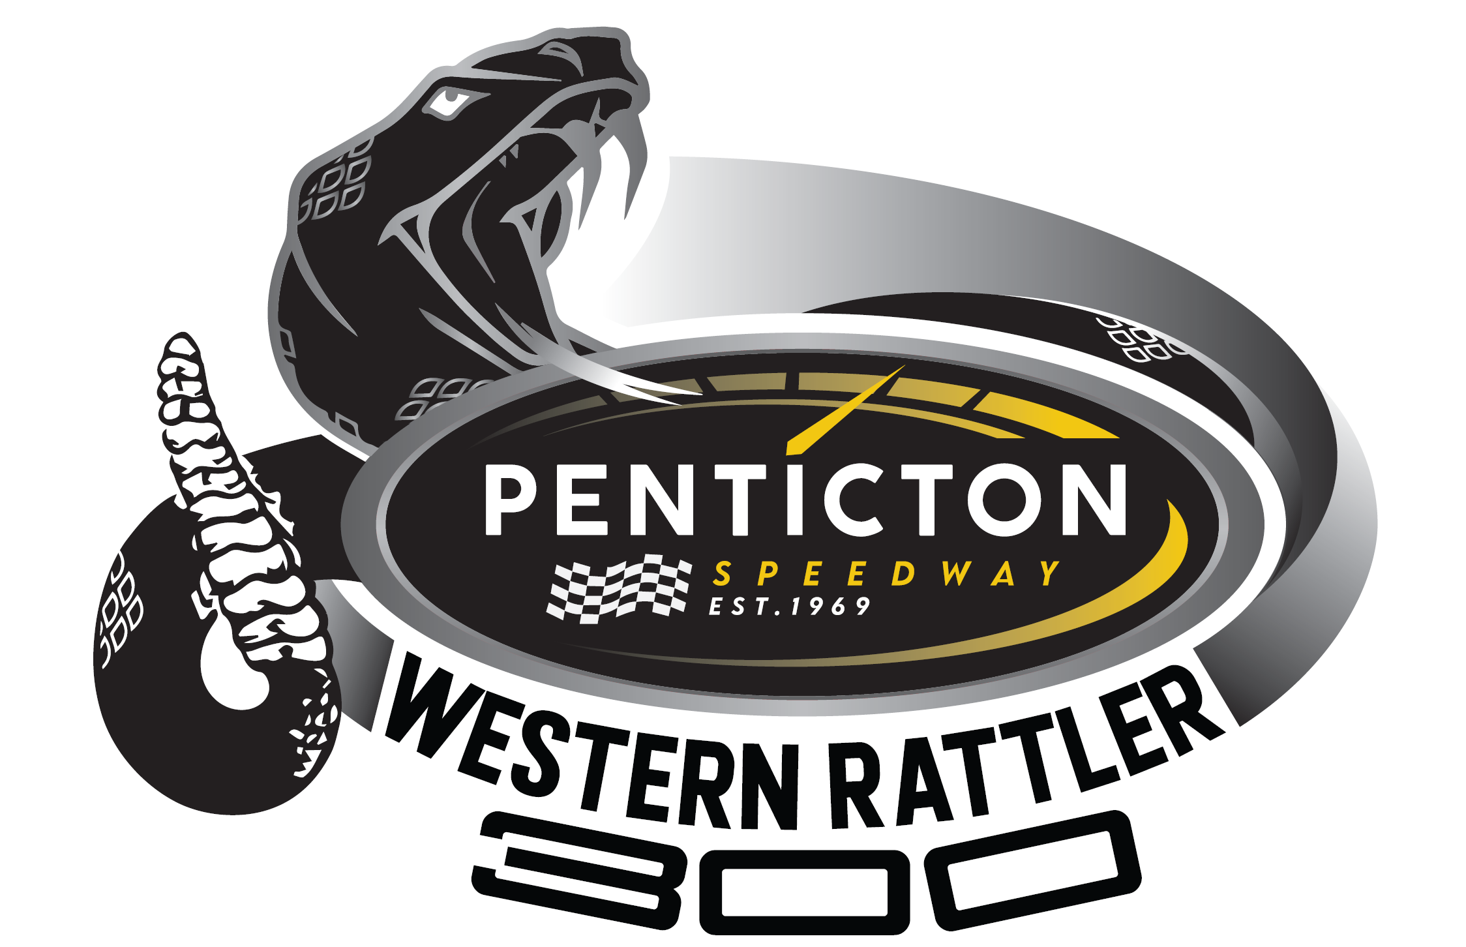
April 29th & 30th
$65,000 Purse!
$55,000 Late Models, $10,000 Street Stocks
$10,000 to Win!
$700 to Start
Pole Position The Western Rattler 300 The Bakers Dozen The 300 Three
$1,000 1st $10,000 6th $2,250 1st $2,500 1st $1,500
2nd $5,000 7th $2,000 2nd $1,250 2nd $1,000
3rd $3,500 8th $1,700 3rd $500 3rd $250
4th $2,750 9th $1,500
5th $2,500 10th $1,200

Open to All Super Late, Pro-Late & Limited Late Models following WESCAR or APC Rule Books in conjunction with Penticton Weight and Engine Supplemental Parity Rules.
Late Model Format: Friday Night Qualifying by Time Trials, the top 12 advance to “The Western Rattler 300” (300 Laps – Saturday Night), positions 13 to 28 advance to “The Baker’s Dozen” (100 Laps – Friday Night), the top 13 advance to the “Western Rattler 300”. All remaining cars race “The Three Hundred 3” (50 Laps Saturday Night), the top 3 advance to “The Western Rattler 300”.
Street Stock Format: Friday Night Qualifying by Time Trials, A & B Heats, “The Venom 100” (100 Lap Race Friday Night), “The Western Rattler 100” (100 Lap Race Saturday Night). Points gained by Qualifying, Passing and Finishing positions on Friday night determines starting position for “The Western Rattler 100”. Friday high points car starts on pole Saturday night, all other races are full invert. ($2,000 to Win, $200 to Start The Western Rattler 100)
Rules, Schedule, and Format on pentictonspeedway.com or click HERE.
Penticton Speedway 2020 Carmi
For Information e-mail karilee@pentictonspeedway.com
1-250-488-2540

