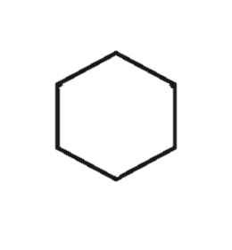




1)

We would like to see something similar to this one with the full name KAGE with the K as shown. We would like to try more cursive font and orange or blue flames.






2)

We would like to see this design with blue flames with the K a contrasted dark blue fire, we would also like to add AGE to the and of this to make it the Complete KAGE logo. The rest of the font we would like to do a clean, standard font style. Similar to the one shown below.

