THE NUMBERS  BEHIND THE NEIGHBORS  #1 Auto Insurer #1 Homeowners Insurer  #1 Life Insurer A Leading  Small Business Insurer  State Farm received the highest score among large insurers in tie in the J.D. Power 2021 Insurance Shopping Satisfaction Study of Customer’s Satisfaction among recent purchasers with their auto insurance company.  39th Ranked Company  On the 2021 Fortune 500  The Holland Agency has served customers in  Georgia and South Carolina since January 2012.  The success it has experienced stems from the  company’s unwavering commitment to help customers  manage the risks and challenges life brings  their way.  We’ve been present for them from the get-go.  Like a good neighbor, State Farm is there.® | STATE FARM IS  An 100+ year old company.  State Farm is a business based on a promise. We’ve made it a century because we take that promise seriously in everything we do.  STATE FARM OFFERS  100 Products  About 60% of State Farm households have more than one product.  *We offer 3 Driver Discounts  - Drive Safe & Save  - The Bundle  - Steer Clear for Young  *Small Business Insurance  STATE FARM HAS  85M+ policies and accounts in force in the U.S. as of 12/31/21.  2.8 M+ Small Business Customers  43.7 Million Auto Policy Holders  (Including Small Businesses)  19200 agents  55,000+ employees | In 2021, Fire and Auto Claims reached more than 8 million.  That is about 22,000 claims per day.  That is more than the Chicago Metro Population.  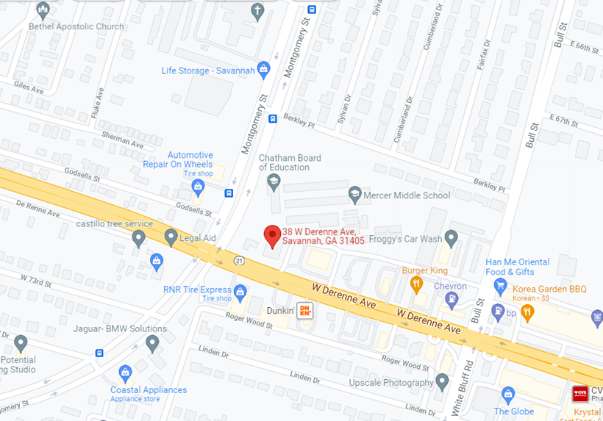  (Located in between Auto Zone and Auto Glass Now)  Nothing feels better than home. Especially when you know it’s protected.  We’re happy to help you choose the amount of coverage that suits your needs and budget. That’s just one reason State Farm is ranked NO. 1 in homeowners insurance.  If you need flood insurance we can help with that too.  .  Holland Insurance Agency, Inc.  WE HAVE THE PEOPLE TO HELP YOU PLAN  Like A Good Neighbor State Farm is There
About Mike  Your life changes. As your State Farm agent, Mike Holland helps you manage your changing needs, from starting a family, to buying a home or planning for retirement.  Mike designs strategies to protect you today, while planning for tomorrow, and managing the everyday risk in between.  Mike started the Holland Insurance Agency in 2011 after more than a decade of success in the corporate sector and after 14 years as a small business owner. He holds a bachelor’s degree in engineering from NC A&T State University.  When Mike is not helping his clients, he is spending time with his wife, Teisha and two boys, Michael (7) and Miles (4).  The Holland Agency Team  Our agency has 7 team members in addition to Mike. Our Team will arrange to meet you anywhere, at anytime to accomplish your plan. Your needs will determine our path. Shared values will guide us. | The State Farm mission  is to help people manage the risks of everyday life, recover from the unexpected and realize their dreams. | 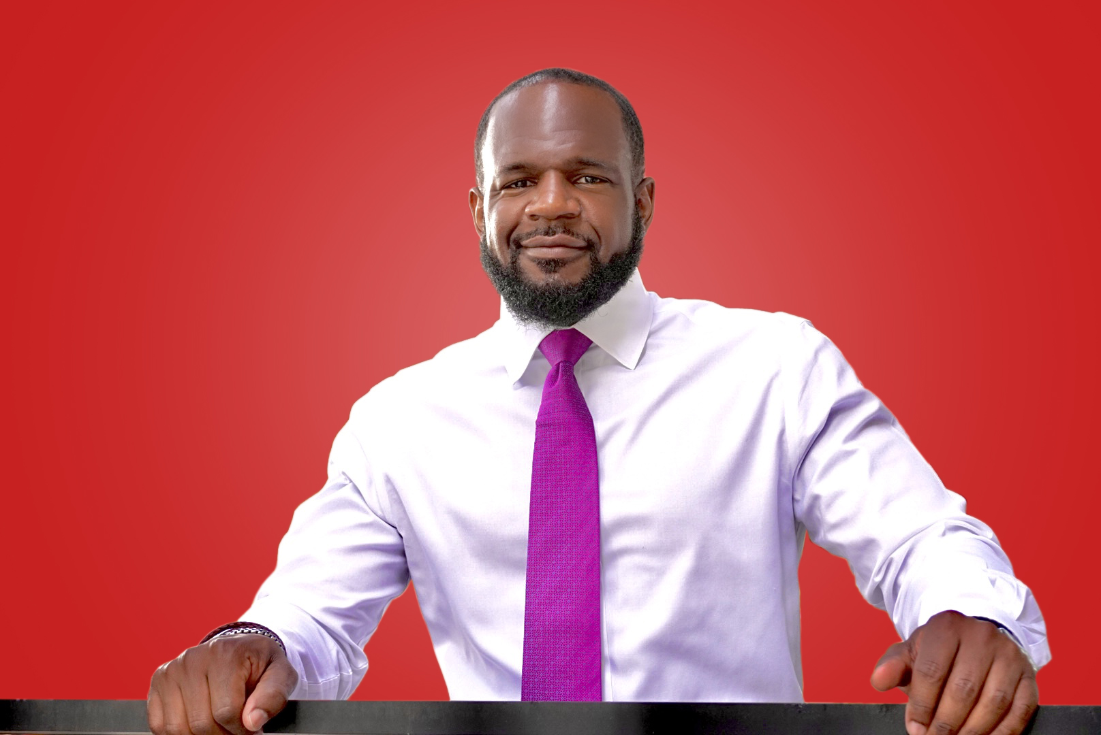  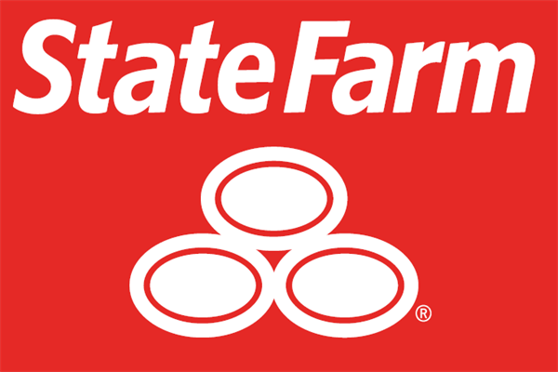  AUTO – HOME – LIFE- BUSINESS  38 W. Derenne Ave.  Suite 1  Savannah, GA 31405  912-358-0093
 |  | www.MIKEINSURES.com

