My Business is a brand new Psychology company. We work with acute mental health diagnosis, think personality disorders, psychosis, trauma, schizophrenia etc. Work in Melbourne Australia, Company name Neurogenesis Clinical Psychology.
The design should encompass wealth and large business, it is a considerable cost to engage in therapy and we work with psychiatry and hospitals direct so majority of clients are mid-upper or high socioeconomic brackets. At the same time I don't want the feel to be old and stuffy, we are vibrant and new and forefront of psychiatric/psychological treatment and research.
I am sick of blues. I'm not against them but people tend to over use them in psych. I was thinking maybe some orange tones
I was wanting a few things. A logo, and also a short hand. for example NCP on the front of the business card perhaps and the full name on the back.
The final product should be able product should be able to work with business cards, emails, marketing information, websites, etc
I'm uncertain about a graphic. Probably good to have a logo mark. Potentially incorporate 'psi' symbol.

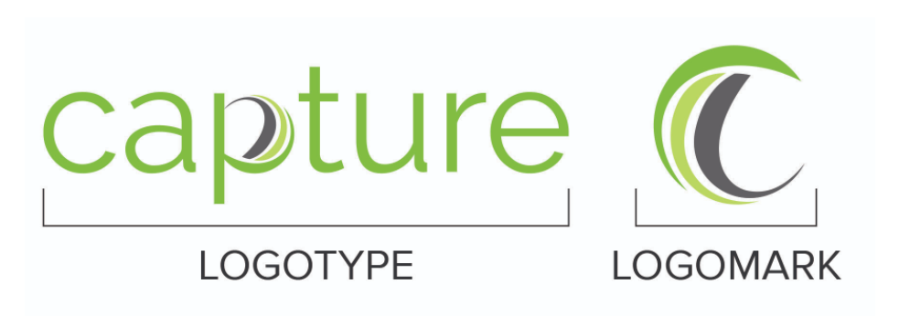
Examples below:







