Brief for Santegis Logo

We have some developed thoughts on what we would like. Image one below is the font type we prefer. Modern, easy to read and strong.
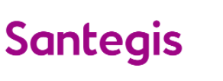

The corporate colours will be fairly French flag like with the red being a softer tone. If you think we need two different colours feel free to experiment.
Below is an example of our thoughts. Feel free to change this if a better mix looks more appealing. (Note not this font, we do like these colours)
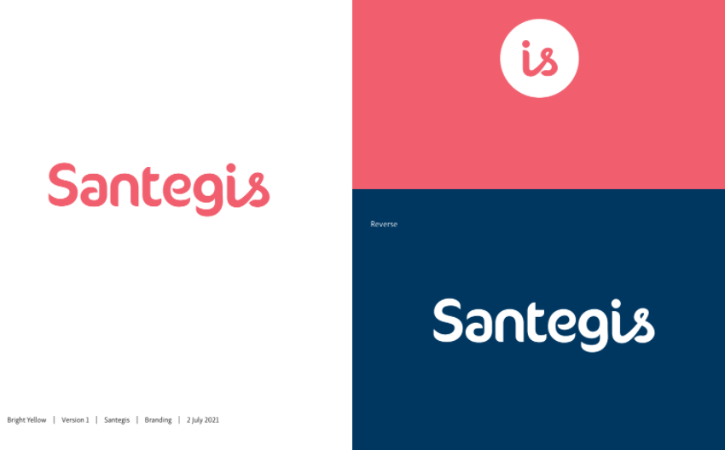
We like the circular representation type logo but remain open, using the navy and soft red/salmon but try to get a human feel with a hand or similar indicating improved health.

We like this positioning. A logo on the left (abstract type, and then the name on the right). We don’t like the look of look and feel of the logo though.



We really like the simplicity of this one. Can you do this in the Navy and see what it looks like ?


We like the one on the left without the cross and potentially replace the arrow with the a stylised hand like the one on the right. Albeit the hand must be subtle not too prominent.



