Following are some examples of logos that could represent my company, but I do think they all look out-dated/ not modern:
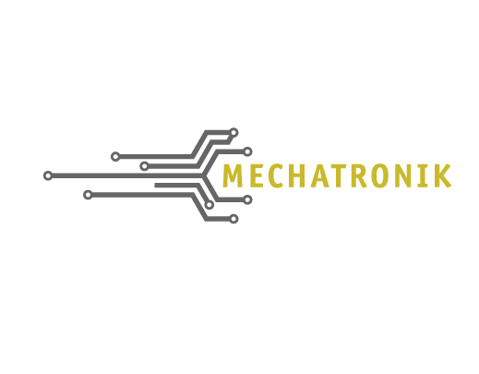



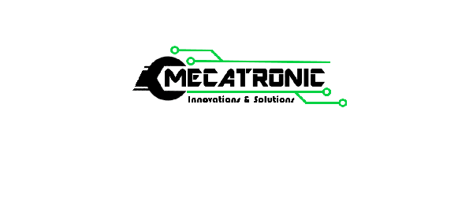
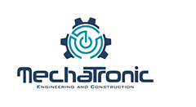
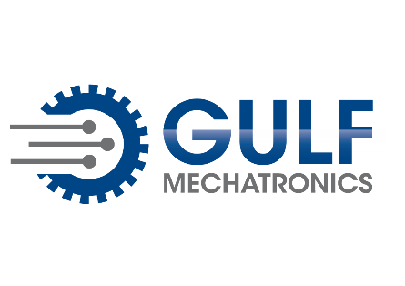
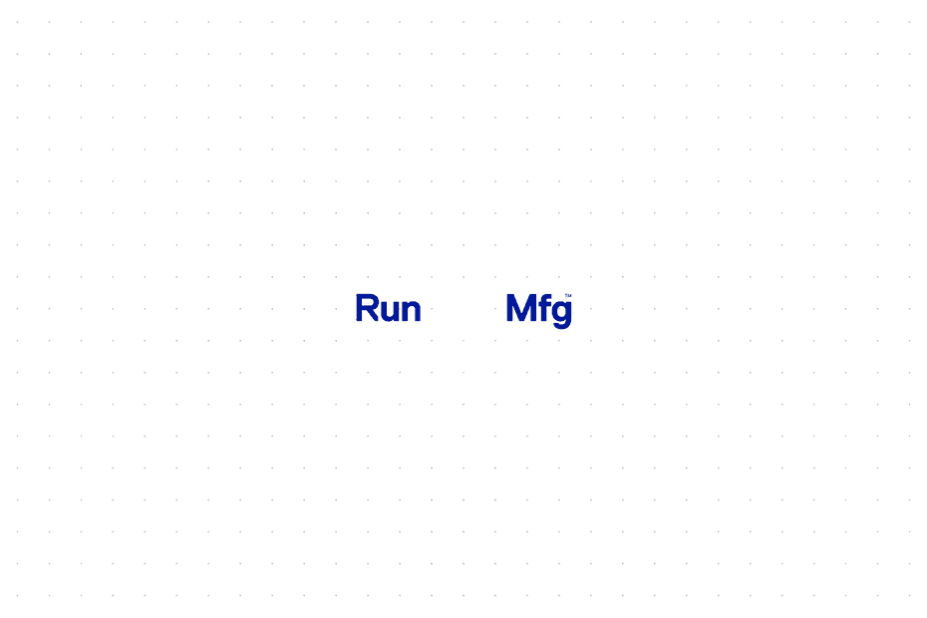
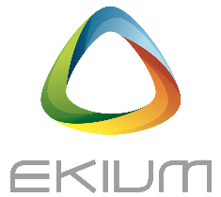

Last but not least, could be great to have an animated version of the logo, the company is not in the same field at all, but I like this one:
I’m also open to any other design that could represent my company. For example, I like the one below (logo of one of my competitors in France) because the various colors are interconnected, and the triangular shape is interesting.

