B2B label for cleaning/lubrication/conservation and disinfection product company.
All product information is just an example, we don’t need a label specifically for a Stainless Steel Polish, but for a professional cleaning/lubrication/conservation and disinfection product company that will fit all segments of products.

- Professional look not focused on this product particularly, but in general for our brand
- Functional, with image of where the product’s used for (stainless steel industrial surfaces)
- Logo: use the ‘VOSSEN’ logo, add ‘GREENER CHEMICALS’ in a creative way + change color of ‘VOSSEN’ logo, preferable only use the ‘VOSSEN’ part as the actual logo of the label
- Subtle ‘eco’ look (icon?)
- It should be very clear for a consumer where to product’s for in one look
- Stand out from competition by premium look
- Use clean, premium and professional looking fonts

Product name: Stainless Steel Polish

Product slogan: Restore steel surfaces hologram free

Use numbers (rounds) to express which step of the process this product is:
- Clean
- Disinfect
- Protect
- Preserve

Product description: Staporex is a mildly abrasive cleansing cream with preservative properties. For removing stubborn dirt, water stains and deposits on stainless steel with a hologram free finish. Staporex is non-tox and safe to use.

User instructions:
o Shake before use.
o Apply with a damp brush, sponge or pad.
o Adjust rubbing pressure and duration to the persistence of the soiling.
o Add water as needed while rubbing, rub in the direction of the structure.
o Rinse with clean water.

Expiring dates:
Batch number: see packaging.
Net volume: see packaging.

Company information:
Produced by Vossen Laboratories Int. B.V.
Postbus 10053 - 6000 GB Weert (NL)
Phone NL: +31 495 58 34 00
H van veldekesingel 150 bus 72 – 3500 Hasselt (B)
Phone B: +32 11 23 16 00
www.vossenchemicals.com
hello@vossenchemicals.com

Label number: 23092021

Danger symbols (should be placed on white background and be at least 1cm large):

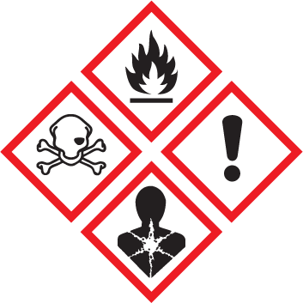

Danger: Causes severe skin burns and eye damage. Wear protective gloves, protective clothing, eye protection, face protection. IF SWALLOWED: rinse mouth — DO NOT induce vomiting. Immediately call a POISON CENTER, a physician. IF ON SKIN (or hair): Take off immediately all contaminated clothing.

