2022 Line Card Information

Z-CHECK LOGO:

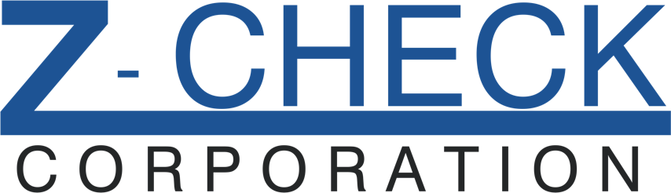

Z-CHECK COMPANY INFORMATION FOR LINE CARD:

NON-DESTRUCTIVE & MATERIALS TESTING EQUIPMENT

Z-CHECK CORPORATION
35560 GRAND RIVER AVE, #420
FARMINGTON HILLS, MI 48335

EMAIL: SALES@Z-CHECKCORP.COM
PHONE: 248-676-1007
WEBSITE: WWW.Z-CHECKCORP.COM

EDDY CURRENT FLAW & SORTING SYSTEMS

ULTRASONIC FLAW & THICKNESS GAUGES

MAGNETIC PARTICLE SYSTEMS

LIQUID PENETRANT SYSTEMS

X-RAY SYSTEMS

LEAK AND FLOW TEST SYSTEMS

RESONANT FREQUENCY SYSTEMS

ACOUSTIC EMISSION SYSTEMS

VIDEOSCOPES, BORESCOPES, MICROSCOPES

VISION AND INFRARED CAMERAS

DIMENTIONAL GAUGING SYSTEMS

XRF & LIBS ANALYZERS

HARDNESS TESTERS

OES ANALYZERS

RENTAL EQUIPMENT

CONTRACT TESTING

NDT TRAINING CLASSES

MANUFACTURERS AND PRINCIPALS REPRESENTED:

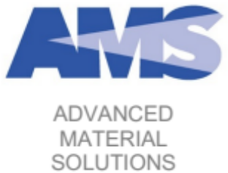

Advanced Material Solutions
- Resonant Frequency Technology
- Manual & Automated Solutions



Baugh & Weedon NDE
- UV & WL Meters
- Field Strength Meters



Chi NDT
- Magnetic Particle Benches / Lines
- Liquid Penetrant Lines
- Portable & Overhead Blacklights



Danatronics
- Hall Effect Thickness Gauges
- Hall Effect Accessories



DeFelsko
- Coating Thickness Gauges
- Surface Profile Gauges
- Adhesion Testers



Echo Ultrasonics
- Ambient Temperature Couplants
- High Temperature Couplants
- Fluid Couplants for AUT and Robotic Inspections

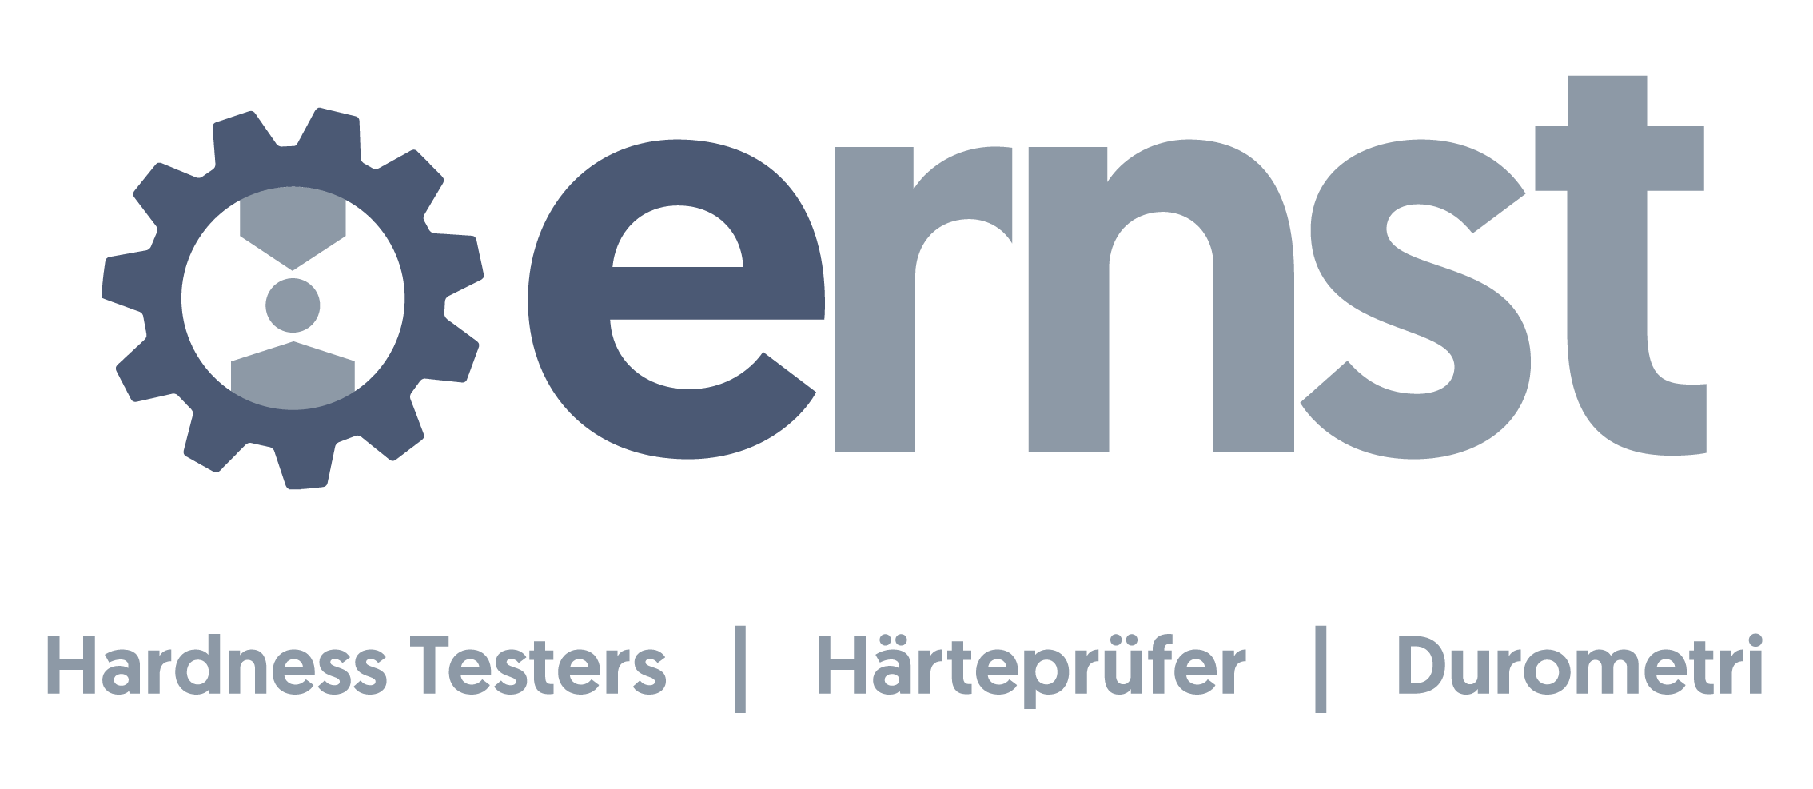

Ernst
- Portable Hardness Testers
- Bench Rockwell and Brinell Testers
- Automated Hardness Systems



Ether NDE
- Conductivity Meters
- Conductivity Standards & Accessories

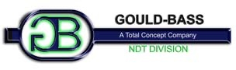

Gould Bass
- Magnetic Particle Benches / Lines
- Liquid Penetrant Lines
- Mobile MPI Units & Accessories

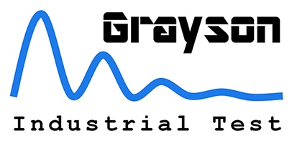

Grayson Industrial Test
- Leak and Flow Testing Systems
- Dimensional Gauging Systems
- Automated Inspection Systems



ibg NDT Systems
- Crack Detection Instruments
- Material Sorting Instruments
- Multi-Channel Instruments
- Custom Automated Systems

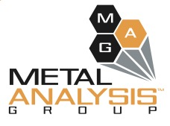

Metal Analysis Group
- Portable and Bench XRF Analyzers
- Portable and Bench LIBS Analyzers
- OES Systems



Newage
- Portable Hardness Testers
- Bench Rockwell and Brinell Machines
- Micro Hardness Testing Systems
- Automated Hardness Testing


Next NDT
- Phased Array Spotweld Test Systems
- Transducers & Accessories



Parker Research Corporation
- Portable Contour Probes
- Hi-Amp Portables
- Black Lights, Meters & Accessories



Proceq
- Portable Leeb Hardness Testers
- Portable UCI Hardness Testers
- Portable Rockwell Hardness Testers



Resonic
- Single Channel EMAR Systems
- Multi-Channel EMAR Systems
- EMAT Transducers & Accessories

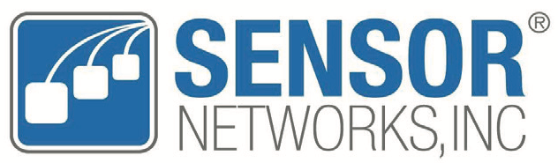

Sensor Networks
- Installed Corrosion Monitoring Sensors
- RVI Systems
- Retrieval & Sampling Tools

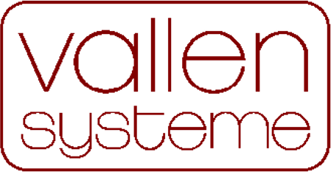

Vallen Systeme
- Acoustic Emission Systems
- Multi-Channel Systems
- Sensors & Accessories



Waygate Technologies
- Ultrasonic Thickness Gauges
- Ultrasonic Flaw Detectors
- Eddy Current Instruments
- Multi-Channel Systems



Zetec
- Phased Array UT Instruments
- Phased Array ET Instruments
- Multi-Channel Systems
- Scanners & Accessories

