Book Title: “Holding It All Together When You’re Hypermobile”
Subtitle: Achieve a Better Life Experience with EDS, POTS, and Joint Instability
Author Name: Christie Cox
Back Cover:
The Ultimate License to Deal and Heal with Rare Chronic Illness
Start healing yourself today with simple daily habits. You too can be jumping for joy, and not overextending yourself. This is not false hope but a remedy to cure your Zebra soul. Turn pain into possibility with this life-changing guide to help you navigate the complexities of hEDS, especially for those new to the disease. It's a journey, but you're not alone.
In “Holding It All Together When You’re Hypermobile,” Christie Cox explores hypermobile Ehlers Danlos Syndrome (hEDS) and the effects it can have on you not only physically, but emotionally as well, as you learn to deal and heal. Designed to teach you coping skills to better enable you to recover from the difficult and life-altering disease. You’ll also discover…
- Personal Q&A interviews with expert doctors, support and advocacy groups
- Lessons, questions, and quotes to inspire your search for answers
- A healing prescription for the miracle of the modern mindset
- Her inspiring story of how she came to live her best life possible with hEDS

“Holding It All Together When You’re Hypermobile'' will make you believe you can overcome any incurable painful chronic illness despite the challenges. You’ll also feel more empowered to support your loved ones who may struggle with hEDS as you experience compassionate understanding.

“A chronic illness sufferer's hopeful best friend”

The book explores the basic of hEDS and offers practical advice on how to live a more meaningful and fulfilling life with the rare, incurable chronic condition. It also peeks into the future of scientists’ medical research and the future of potential hypermobility care.

This book will provide you with the tools needed to get back to work or school, build confidence with medical insights from specialists, and empower yourself with knowledge that will change your life - for the better.

Christie Cox was always flexible and sometimes witty. But it wasn’t until she was properly diagnosed with Ehlers Danlos Syndrome at 48 years old that she understood her quirkiness. Following decades of unrecognizable health issues, she has gone from dismissed and disbelieved - to determined. She turned her passion into healing and the support of others facing a similar fate. She graciously thanks the EDS community for their ongoing support. They actually voted to select the book cover! To learn more about her and how she supports the Zebra community with coaching, and patient advocacy, visit www.journey2joyous.com.

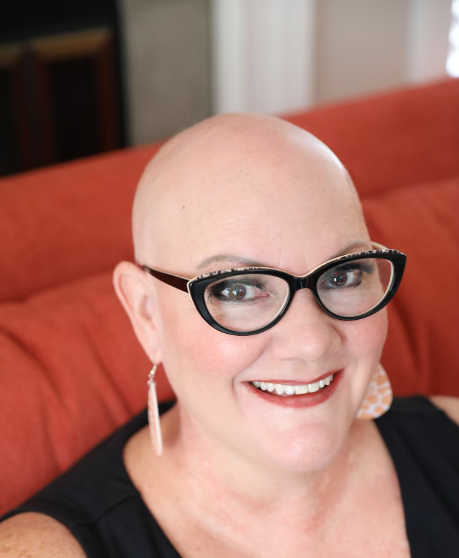
-----------------------------------------
This book enables invisible chronic illness sufferers to move from pain to possibility through a patient perspective of learning effective mindful habits to enhance happiness and health by following simple, accessible healing tips.

Copy not yet finalized:
1-2 Reviews/Endorsements Pending to be added

