8290-10 Clip on nose glasses - fishing
Text A pair of reading glasses that you clip on the nose. Easy to put on when you should thread your hook with just one hand. A pair of reading glasses that are the most common way to use when you thread the fishing line demands two hands. With a pair of clip-on nose glasses you will able to hold your rod as well. Single hand use. The unique design makes the glasses stay any type of noses. The glasses are equipped with a carabiner to clip on to your fishing west and clip (easy to use / open). With a strength of +2,5 makes it possible to see the eye of the hook. The ultimate fly fishing tool. Works with all fly fishing west on the market. Easy to change fly fishing fly = more fishing time and safer knotting.

BULLET POINTS
- SEE THE LINE. With a pair of reading glasses, it will be easier to see the fly and the line when tying knots. With a strength of +2,5 magnifying, the Clip on nose glasses will work for the most fishermen. Call them magnifying glasses or reading glasses, they do the work. You will be able to see treading the line / eyelet. If you don’t see it will take very long time tying the knot and it could also be terrible knot scaring the fish or even worse, it will not hold. Think of you dream trout getting away due to a bad knot.

- ALWAYS WITHIN ARM’S REACH – With a pair of glasses hanging in your vest. They are always in the reach. You can of course also stuff them in a pocket. Since they are slim some millimeter thick. You will not feel them as a pair of bulky reading glasses. The weight is also very low so will barley feel some extra gram.

- SINGLE HAND USE - Many fishermen use regular reading glasses carried in a pocket and they work fine but you need two hands to put them on your nose. Standing in the river you need to hold the fly rod with one hand, one hand to open the tackle box and two hands to put on you reading glasses. With a pair of Clip on nose glasses it can easily be done with one hand. Reach the glasses, hanging on the vest or sling pack, release the plastic buckle and put on the nose.

- CLIP ON NOSE – With only one hand you put them on your nose. The glasses will are flexibale and fit almost any nose. They will be fixed on your nose. Compeable with all kind of flyfishing vest and sling pack. Clip the carabiner in the D-ring NO FUSS - GET MORE FISH. Since the glasses will help to change the fly in no-time you will probably change fly more often and the knots will probably be better. It will also be easier since you don’t need to worry about the fly rod Since you don’t have to worry about your rod fastened / squeezed under an arm.

- WORKS WITH ALL KIND OF FISHING. The Clip-on nose glasses are also useful when fishing from the kayak, rowboat, motorboat, pier or a beach. Thin and very light weighted you can bring them anywhere. A magnifying glass is always help full. Buy some extra pair to always with you. It’s perfect gift for a fisherman

Key words

Stream, White water, rapid water, fishing, waders, woman fishing, fishing gear, hunting gear, fly fishing, Fishing Vest, chest pack. Fly Fishing Vest Pack, fishing gifts for men, fishing gear
fishing accessories, Vest for men, Fishing back pack, Orvis, Simms, loop, Scott, Sling pack, Vest, D-ring gear attachment, D ring, ice fishing gear, Fly fishing holder, threading eyelets, tying knots, Eyelet funnel, Tie clinch, loop Polomar knot, hook, flies, west, fishing not, tie-a-knot, Knot Tying Tools, Lures, Trout, salmon, brown trout, rainbow trout, retractor, Sage,G Loomis, Patagonia, fishpond, tibor

Facts Strength +2,5 dipoter
Size 40 x 105 mm / 1,5” x 4,1”
Thickness 2 mm
Weight 10 gram / 0,35oz
Material polycarbonate and felt storage bag
Package 1 pcs (1 pair)
Color Transparent

Image 1 Glasses
Image 2 glasses on fly fishing woman
Image 3 Infographics, Image with towel and holder
Icons: fish, fly fish hook, glasses, +2,5, nose
Image 4 Fisherman with glasses
Image 5 Magnifie +2,5
Image 6 Flyfishing woman
Image 7 Fisherman with glasses
Image 8 Fly fishing woman
Image 9 Fisherman without glasses
Image 10 One hand use
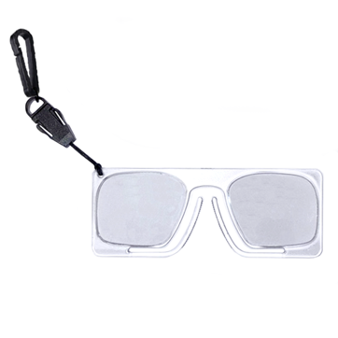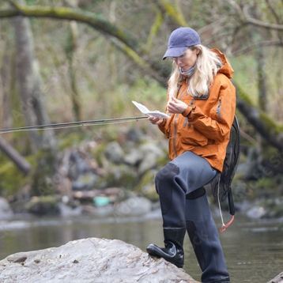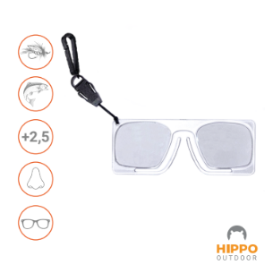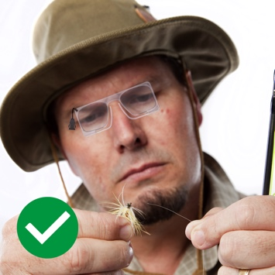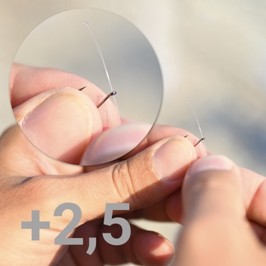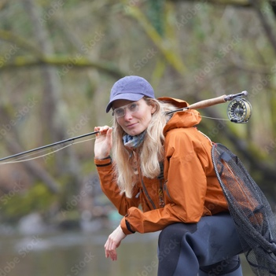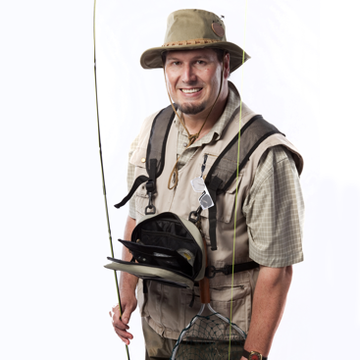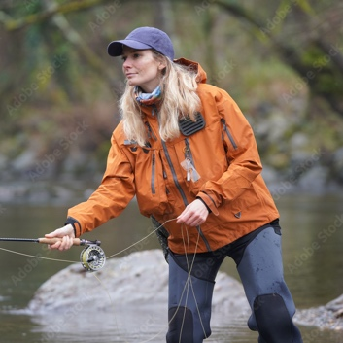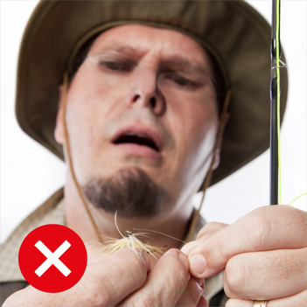

Movie
- Fly fisherman stand in the river changing the fly. Close up when he grabs the glasses with one hand and put back on nose.

A+ content
Fishing knots

