6636 Jerk Reducer tarpaulin rope 6 mm
Text
Most common problem with tarpaulins is that they break when the wind jerks in the tarpaulins. It’s the sharp jerk that make the break. It’s therefore important to always keep all lines / ropes tight. With bungee cord jerk reducer, you will not have the distinct jerk in the tarp. The shock cord will allow some flexibility and keeps the lines straight and tight. To tie a line to a tarp or to a tent you need good skills to have 100% good. If some of the lines starts to move, soon more of the others will follow.

The Jerk reducer is attached to the tarp line or guy line with two aluminum pieces connected with a ø 6 mm bungee cord. You can put wherever you want on the rope. You don’t need to get anything through the line. It’s good to have some slack when you attach the jerk reducer.
Pull a few times in the line to make sure the bungee cord does flex as you fit best, and that the aluminum is sitting tight on the rope.
Comes in three sizes:
#6634 Guylines ø 4 mm
#6636 Tarpaulin lines ø 6 mm
#6638 Tarpaulin lines ø 8 mm

Bullet points
• Protect your tarpaulin. The jerk reducer prevents one of the most common things that breaks a tarpaulin: the sharp jerk.
• Reduce the jerk
• Keep all tarp lines and guy lines tensed. With all lines to a tarp or tent tight the risk minimizes.
• xx
• Comes in three sizes: for guy lines on tents #6634, for tarpaulin ropes ø 6 mm #6636 and for tarpaulin ropes ø 8 mm.

Facts Size For tarpaulin ropes ø 6 mm
Material Aluminum and rubber cord ø 6 mm
Package 8 pcs, for 8 lines
Color Orange aluminum and grey rubber cord.

Image 1 Sticker paper
Image 2 Image with sticker for fire extinguisher
Image 3 Infographics
Image 4 Toilet door with overview page
Image 5 Sticker paper boat layout + sticker page
Image 6 Indoor environment with sticker
Image 7 Outdoor environment with sticker
Image 8 Indoor environment with sticker

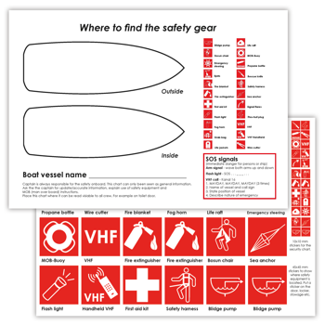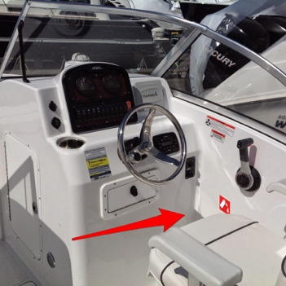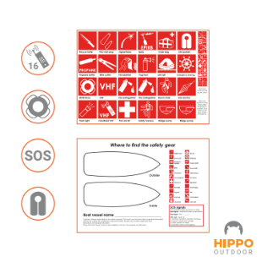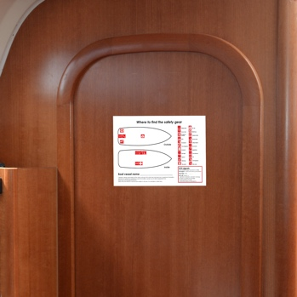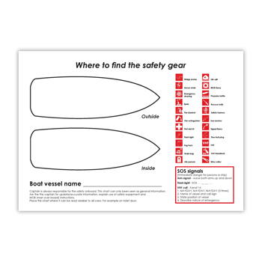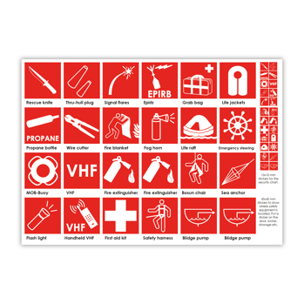

Movie
- Still picture of toilet door with sticker
- Still image with stickers inside and outside
- Man or woman applying sticker on the boat and on the security chart
- Apply the security chart on the toilet door

SEO duct tape, tarp, tarp repair tape, Tarp tape

Amazon title

Security chart with stickers for boats. Tape to toilet door- safety first #7140

Bullet points for Amazon
- Visual icons – international icons

- Crew security

- Pricy safety gear -

- xxxx

- Long lasting

