8170 Golf towel holder
Text A towel holder with removable towel. With a clean club and golf ball, you will have a higher possibility to have better score. People say with clean equipment, the difference is the same as a birdie or a boogie. Golf professionals always clean their ball before the putt a ball on green. A traditional towel sitting in a eyelet on the golf bag it just not possible. You need at removable towel. A towel that is easy to remove and easy accessable + easy to pack. With Hippo Outdoors towel holder, it’s possible. If you have a favorite towel, it can also be used. The towel holder works with any normal microfiber, cotton or terry towel. The included towel is made of microfiber and is fast drying, easy to wash in machine or by hand. Included 1 pcs towel 40x60 cm / 16”x 23” and 1 pcs towel holder with carabiner.

Facts Size 40x60 cm / 16”x 23”
Material Microfiber 80% polyester & 20% polyamide, 300 gsm
Washing -40oC – 100oC / 20oF - 140oF
Package 1 pcs towel holder
1 pcs towel

Image 1 Towel with holder (cover 80% of image)
Image 2 Golf bag with towel
Image 3 Infographics, Image with towel and holder
- Size towel
- Microfiber Waffle for easy cleaning
- Easy to wash
- Fast drying
- For golf balls
- For clubs

Icons: size, cloth material, washing machine, fast dry, golf ball, golf club
Image 4 Cleaning golf ball
Image 5 Cleaning golf club
Image 6 Close up on golf bag
Image 7 Hand pulling the towel
Image 8 Cleaning instruction

Amazon removable golf Towel.
Lower your handicap by keeping clubs and ball clean. People say that a clean is the difference between birdie and boogie. Don’t think you can save 36 strokes on a 18 hole round but you will definitely save some strokes. You may already have a towel on your bag but it’s connected to your bag. You can’t bring that towel up on the green. It’s no surprise professional golf player cleans their ball before they put. A small sand corn can give you a three put. No one wants to have a three put.
- Easy to clean your golf clubs with a removable towel
- Easy to clean/wash your towel without an eyelet
- Clean clubs and balls lower your score.
- Easy to bring your towel to green.
- Fast drying microfiber material.
- Bring your favorite towel with

Towel with holder
Towel grey orange border.
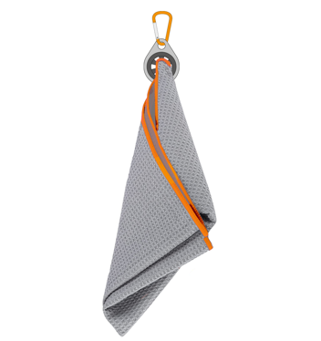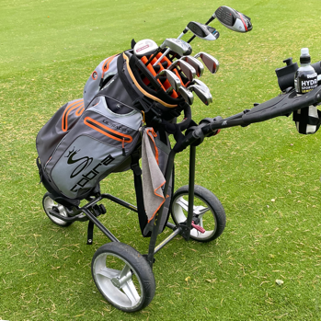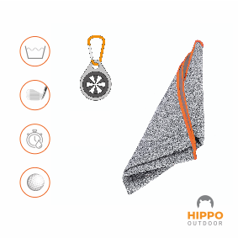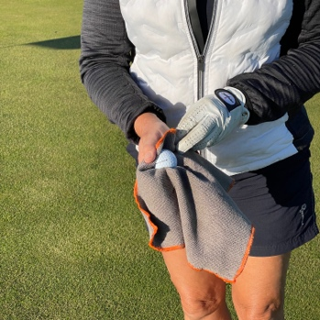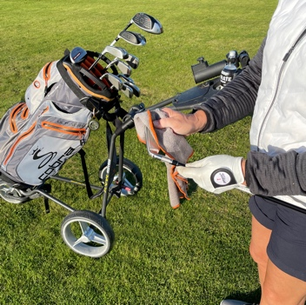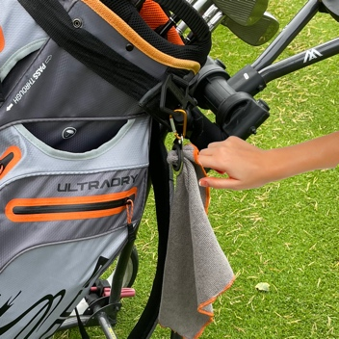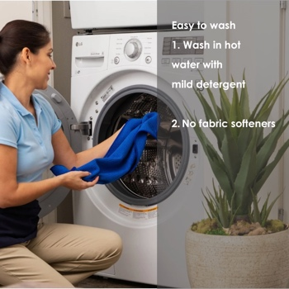

Movie
- Man cleaning the club. Perfect swing, ball landing on green with 3 bunches and roll into the hole
- Man cleaning the ball. Perfect putt in the hole.
- Text lower your score by clean clubs and ball.

SEO Golf, golf ball, gold club, easy cleaning, golf towel, removable towel, washable,
lower score, birdie, better score. Soak up, swab cloth, wipe clean, clean off,
sweeper, sheet, napkin, wiper, rag, drier, linen

Instructions For Washing At Home:
- Wash in warm or hot water with mild detergent
- No fabric softeners – they clog the open spaces in the microfiber, making the fabric useless
- Be careful what you wash with your microfiber. Avoid anything made with cotton because the microfiber will grab on to the lint
- Ideally wash microfiber with only microfiber but if you must mix loads, wash with other non-linting synthetics. Like anything you wash, be sure to separate your white or light colored microfiber from your dark colored microfiber.
- If you hand wash, wash in hot water with mild detergent and use a soft bristled brush if necessary – rinse thoroughly

Drying Microfiber At Home
- To ensure the longest lasting microfiber, air dry is best
- Microfiber dries relatively quickly
- If you use a dryer, set it on low heat or no heat

Amazon title

Removable Golf Towel Holder from Hippo Outdoor, GRAB-N-GO holder. Premium Microfiber Waffle for clean ball and golf clubs with easy access for golf bags. Lower your score. #8170.

Bullet points for Amazon
- ALWAYS WITHIN ARM’S REACH – The Towel is the ultimate GRAB-N-GO Golf towel. The powerful holder / clip offers ultimate convenience. Hang it on your Golf Bag or Golf Cart. It is the perfect gift for every golfer. Easy to remove and bring to the green to clean the ball. Easy to put back with a finger punch.

- COMPATIBLE WITH ANY TOWEL: The Hippo Outdoor Towel Holder Is unique due to it’s design that make the towel Easily Removable. Just use your finger to put it back in place. You can use the Clip with any Towel If You Choose to Change Towels and then you Wash It. FITS ALL TOWELS: Microfiber, Cotton, Polyester and Nylon, or Others.

- PERFECT SIZE & WEIGHT - (16" x 23") NOT TOO BIG OR SMALL - Oversize golf towels are too bulky to keep handy. Hippo Outdoor Towels is designed to be aconvenient CLEANING Towel that can be kept with you but not weigh you down. AMAZING CLEANING RESULTS - Super absorbent, lightweight waffle microfiber that remove dirt mud, sand, debris and grass better than cotton. Durable, fabric that dries fast, and reduces odors found in cotton. Wash and reuse often. HIGH QUALITY - provides superior water absorption and quicker dry time.

- GREEN TOWEL Use always before you putt. Even a small piece of dirt or sand can make you miss the important put. Play like a professional the always clean the ball. CLUB TOWEL Use after every stroke and clean the clubs before you hit the ball again. Keep clubs and balls clean for optimum results to lower your score. Play like a professional the always clean the ball.

- AMAZING CLEANING RESULTS - Super absorbent, lightweight microfiber with lint-free yarns that remove dirt, from golf grooves quickly. Durable, fabric that dries fast, and reduces odors found in cotton. Soaks up water, Sweeps off dirt, a sheet of linen to keep your gear clean, Wash the cloth and reuse often.

