7140 Security chart & stickers
Text The captain is always responsible for the safety
on board. The crew should have common knowledge how use and where to find the safety equipment. Place a sticker on door, locker, stowage where you keep the boat safety equipment. It’s supposed to be easy to find everything. Place a sticker for each safety
equipment on the overview safety chart. Place it visible for all crew. For example, tape it on the inside of the toilet door. A safety chart is often a demand for off shore sail races.

• Place a large sticker “Where to find”
on the boat
• Place small sticker on the overview chart
• Place the overview chart visible for all
crew

Facts Size 45 x 45 / 1,8” x 1,8”mm and 10 x 10 mm /0,4” x 0,4”
Thickness 2 mm
Material Outdoor vinyl sticker
Package 1 page stickers
1 page Security boat layout page
Color Red stickers
Package 1 pcs Safety chart for toilet door 210 x 297 mm
24 pcs large adhesive stickers
24 pcs small adhesive stickers

Image 1 Sticker paper
Image 2 Image with sticker for fire extinguisher
Image 3 Infographics
- Sticker paper
- Safety chart
Icons: MOB-Buoy, life jacket, SOS, VHF canal 16
Image 4 Toilet door with overview page
Image 5 Sticker paper boat layout + sticker page
Image 6 Indoor environment with sticker
Image 7 Outdoor environment with sticker
Image 8 Indoor environment with sticker

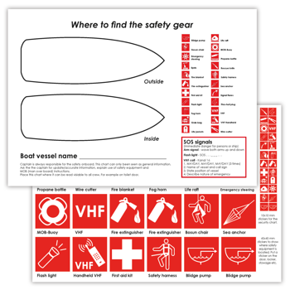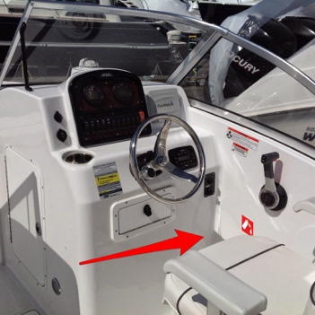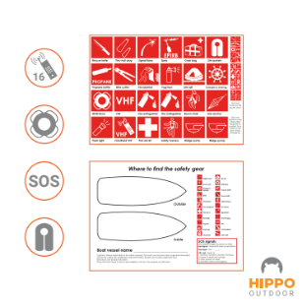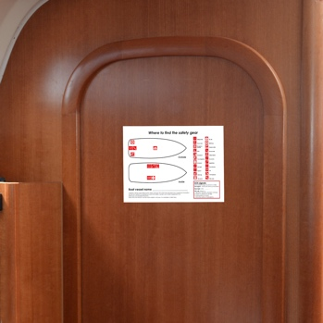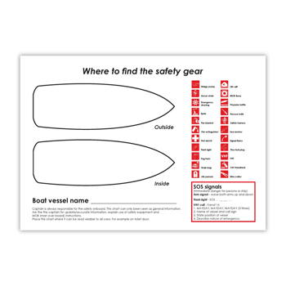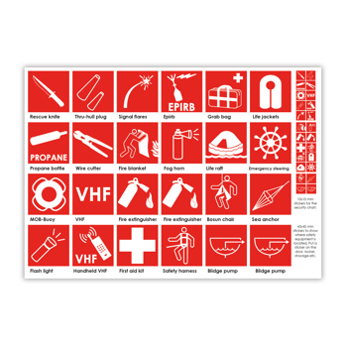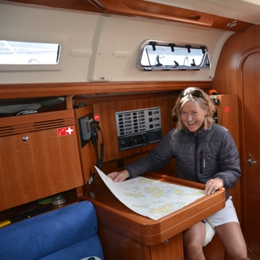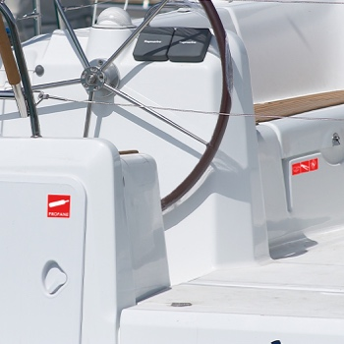

Movie
- Still picture of toilet door with sticker
- Still image with stickers inside and outside
- Man or woman applying sticker on the boat and on the security chart
- Apply the security chart on the toilet door

SEO Sailing boat, motor boat, security, Rescue knife, Thru-hull plug, Signal flares, Epirb, Grab bag, Life jackets, Propane bottle, Wire cutter, Fire blanket, Fog horn, Life raft, Emergency steering, MOB-Buoy, VHF, Fire extinguisher, Bosun chair, Sea anchor, Flash light, Handheld VHF, First aid kit, Safety, harness, Blidge pump,

Amazon title

Security chart with stickers for boats. Tape to toilet door- safety first #7140

Bullet points for Amazon
- Visual icons – international icons

- Crew security

- Pricy safety gear -

- xxxx

- Long lasting

