Gift Box for Naillak Bottles

Description: We need to make packaging for our new bottle that follows the design from our bottles, which means we need to use the same font(POPPINS), pattern with leaves/animals and Vegan/EU icon from the bottle.

For the packaging, we want to use our brand colour -> CMYK(22,40,35,8)

Download link for diecut of the packaging size -> https://we.tl/t-hS1Cx7LuR1

We want to give you free rein to be creative, but we have some ideas and content that we want to include on the packaging design. So please just take inspiration from our notes and try to use the content that we have included below.
My idea is to make the top and bottom clean with our brand color, and use the pattern on the sides of the packaging in a clean way with high opacity like we have done on the label for the bottle.

You can also get inspiration from our previous packaging designs->
6W UV/LED Lamp -> https://we.tl/t-0ISUeVDDEX
48W UV/LED Lamp -> https://we.tl/t-KkMcMJubue

Structure and content ideas from us:

If you have any design ideas or content you think is important and you need some content to put in, please let us know. We will figure out something cool.

Top | Front
Clen white logo like we have on the UV lamp packaging design  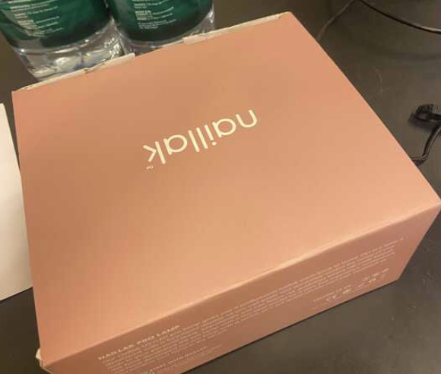 | Made in EU and Vegan formula icons like we have in the bottom of the bottle designs
Right side | Left side
Round SoMe Icons like we have on our UV lamp | Round SoMe Icons like we have on our UV lamp. Maybe with no pattern inside of the icon and a small egde around with no icon.
Back side | Bottom
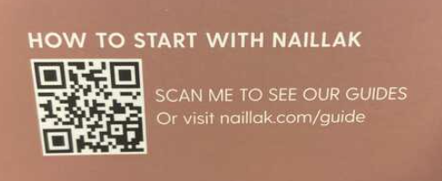 | Business information like we have on backside of the bottle design  Brand Partners A/S - Valby Langgade 86A, 2500 Valby - Denmark

The same packaging from one of our competitors:

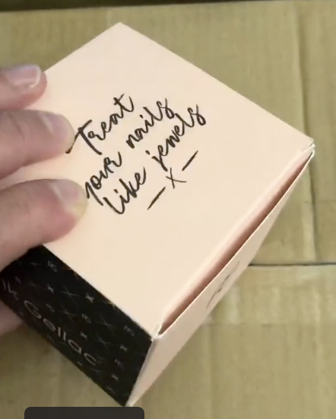 | 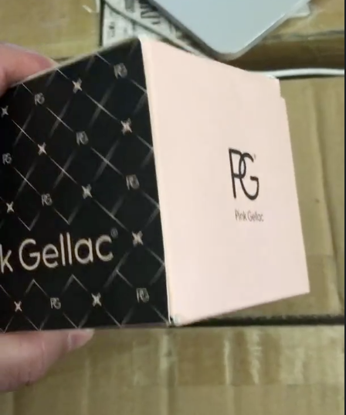 | 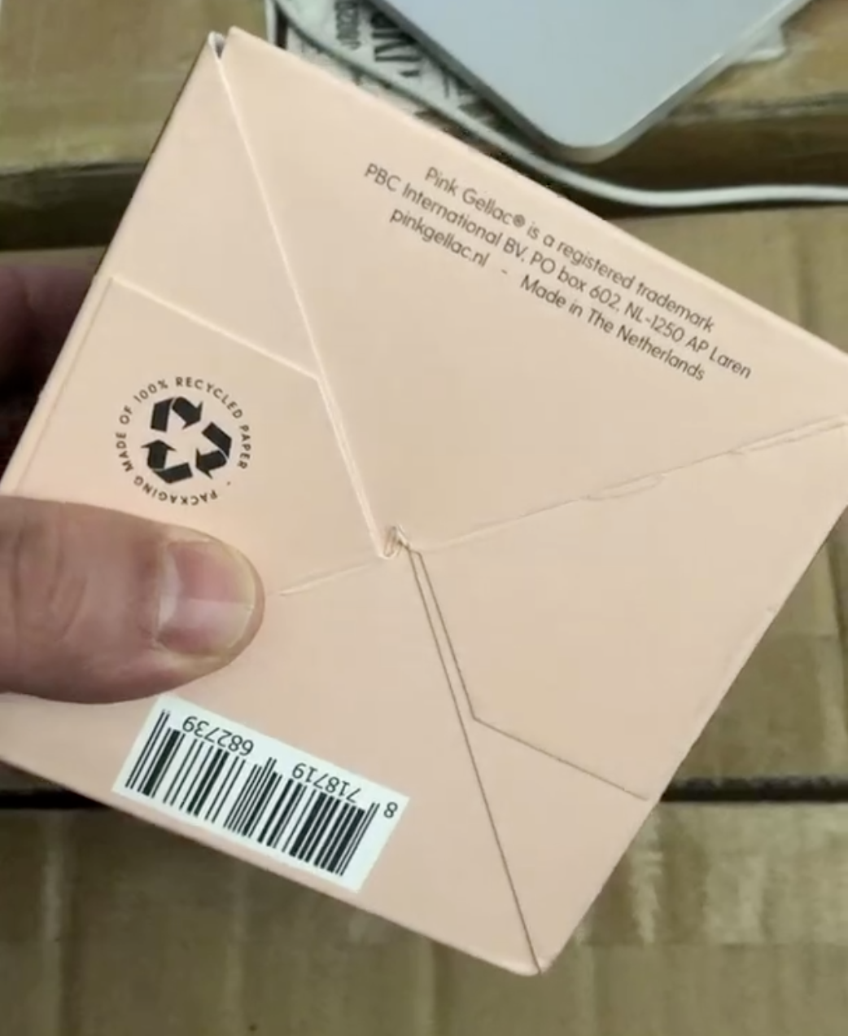
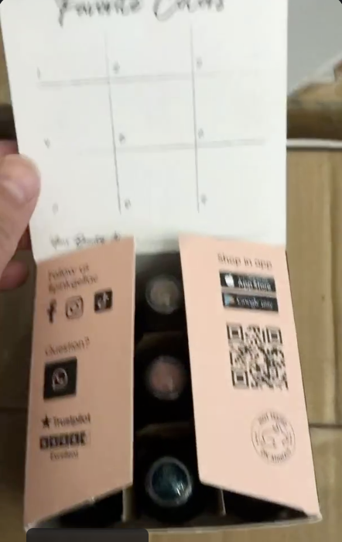 | 