Website Discussion Draft

Screen 1- Landing Page
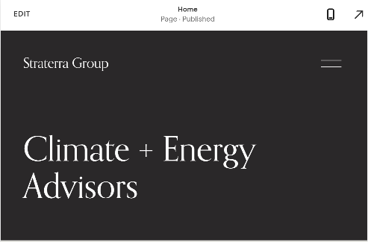
Climate, Technology and Clean Energy Advisors – we provide organisations with insights and strategies to enable the transition to a cleaner world.
Navigating a path to decarbonization in rapidly changing times can be challenging. We are energy systems, climate policy and early-stage technology deployment experts. We work at the nexus/intersection of clean energy, clean tech innovation, funding mechanisms, policy and business strategy. We have experience working in the private, public and non-profit sectors and bring a unique point of view to sustainability challenges. Straterra can help guide your organization through the complexities of achieving net zero targets by providing clear actions to set you up for success. Our expertise and knowledge of markets, trends and upcoming regulations can provide opportunities to future proof your existing business or launch new ones.
Let Straterra advance your understanding of what’s possible.
Contact us
Follow us on LinkedIn, Twitter, Instagram

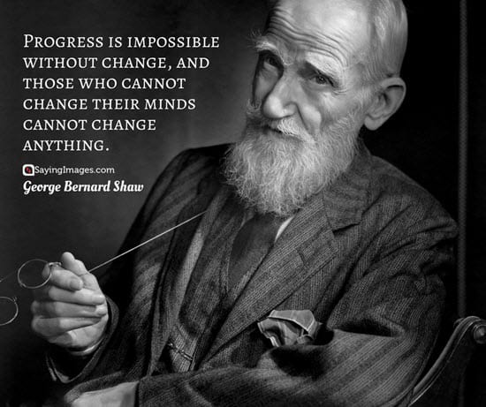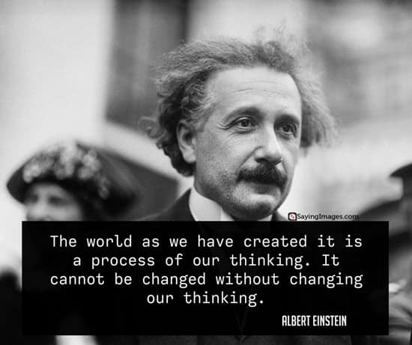
https://sayingimages.com/change-quotes/

Screen 2- About



Passion, Innovation, Experience
At Straterra Group, sustainability and innovation is at the core of what we do. We are passionate about changing the status quo and embracing the potential of a new era where clean energy, technology and policy align to create a prosperous and equitable future. We are a Vancouver based consulting firm specializing in enabling organizations in their transition to a low carbon economy.

We provide strategies, insights and tools for businesses, clean tech innovators, governments and policy makers to meet climate targets and stakeholder expectations. We bring together expertise in business, clean tech, market and partnership development, advocacy, policy development and modelling.

Our mission is to help identify leading edge sustainability solutions though:
- Identifying optimal emissions reductions pathways that maximize opportunities and minimize risk
- Amplifying the role of low carbon enabling technologies
- Assessing the emissions reduction potential of emerging technologies
- Identifying market and policy gaps and impacts to deploying new technologies
- Advocating for strong, integrated and aligned energy policy and regulatory environment

Screen 3- Areas of Expertise/ Services
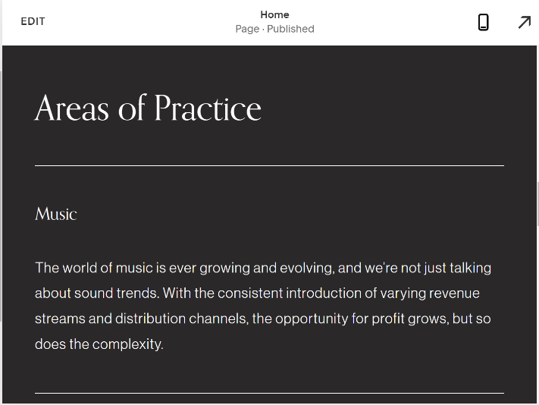
Meeting Climate targets requires rapid transition, flexibility, keen insights and the courage to lead into uncharted territory. Our core skills include:

Clean Economy (Energy and Transportation)
- Climate/ environmental legislative and regulatory policy analysis,
- Policy development , advocacy and regulatory support
- Energy systems, low carbon energy assessments production and distribution and credit systems, carbon tax impacts(Hydrogen, RNG, renewable electricity, Biofuels)
- Clean transportation – heavy duty and fleet vehicles, including fuel and storage technologies
Clean Technology and Innovation
- Clean technology funding applications, incentive programs, and tax credit systems
- Integrating early stage and advanced clean technologies into markets, demonstrations, partnerships
- Governance, ethics & business implications of applying AI/ML in climate tech

Market and Technical Intelligence
- GHG and techno-economic modelling and assessments
- Technology market assessments
- Legislative and regulatory scans and risk assessments

Business Strategy
- Energy transition strategies and roadmaps
- ESG Strategies and Reporting
- Partnership and consortia development
- Government relations

- Areas of knowledge- (should this go in a presentation instead of listing on the website?)
- Firm grasp on federal and provincial climate, environmental, and energy policies including carbon pricing, low carbon fuel standards, zero emission vehicle mandates, vehicle emission standards, financial incentives , renewable portfolio standards etc.
- Extensive knowledge of available emerging technologies for energy decarbonization including alternative transportation (BEV, PHEV, FCEV etc.), renewable electricity (wind, solar, small modular reactors etc.), energy storage (batteries, pumped hydro, flywheels, etc.), carbon capture and storage (physical solvents absorption, separation membranes etc.), negative emission technologies (direct air capture, BECCS etc.), buildings (heat pumps, building automation systems etc.), and industrial (heat pumps, heat recovery etc.)
- Expertise with alternative fuels including the hydrogen economy, RNG, advanced drop-in biofuels production pathways (thermo-chemical conversion, hydrogeneation etc.), synthetic fuels (DAC-derived fuels, e-fuels etc.), and alternative fuel combustion technologies (CNG, HICE etc.)
- Knowledge on the role of artificial intelligence and machine learning for climate and clean energy applications
- Deep understanding of the shifting dynamics of energy systems in an increasingly decarbonized world

Screen 4 – Meet our team


Barbar Moawad- Partner
Barbar has over eight years of experience consulting businesses, governments, and non-governmental organizations on emission reduction pathways, strategies, and policies. He deeply understands energy systems, low-carbon energy technologies, and Canada’s provincial and federal energy policy landscape. His best honed skills include techno-economic modelling, abatement cost analyses, and business strategy development. With his multi-disciplinary background in engineering, economics, and business, Barbar aims to guide organizations in navigating the energy transition’s uncertainties.
Outside of work Barbar is on an endless pursuit for the best bites in Vancouver. To burn off the calories, he cycles, plays beach volleyball, and hikes.

Laura Guzman- Partner
Laura brings 25 years experience in the environmental and technology sectors and has a long track record of creating opportunities for business and advancing partnerships with industry and government.
She has worked in international business development, cleantech and climate policy. Beginning her career in the information and technology sector in Latin America, Laura implemented and managed technology based projects for business and government clients. She has successfully supported companies identify and penetrate new markets, and overcome commercialization and implementation barriers.
Laura has led in the development and implementation of carbon-pricing policies, and greenhouse-gas emissions reduction programs. During her five years with the British Columbia Government Climate Action Secretariat, she worked closely with industry and the clean-tech sector supporting the development of projects that have reduced carbon emissions, and energy consumption. Her work also included the provision of financial viability to early-stage clean-tech companies. Laura’s efforts help clean-tech companies to successfully secure funding, as well as assisting then in the development of carbon offset projects, ones that they ultimately sell. Her services also include linking these firms to consumers, as well as partnerships with governmental agencies, academia and industry as a means of piloting the technologies they produce.
Laura is passionate about exploring how technology, policy and market incentives are combined in ways that effectively reduce GHG emissions globally. In addition to her consulting practice, she continues to conduct research in the field of personal carbon emissions.

Tahra Jutt, MEB- Partner

Tahra joins Straterra with over 15 years business experience in clean technologies, low carbon energy, government relations, climate policy and regulatory affairs. She brings a decade of experience from the clean technology sector specifically in market development and the deployment of low carbon heavy duty transportation and alternative fuels at Westport Fuel Systems. She has a strong background in navigating complex regulatory and policy barriers to introducing and advancing new and early stage clean technologies in Canada and the United States. Tahra has also advised on the development of clean technology funding, working with all levels of government, industry and technology customers on available funding and incentive and credit programs. She has served on the boards of several industry associations and has been involved in government /industry consultations promoting clean transportation technologies and low carbon energy. Tahra’s most recent work at the Pembina Institute focused on climate policy in BC, specifically on the linkage between energy and economy, the landscape for low carbon fuels, the energy transition, and pathways to reducing emissions to meet both provincial and national climate targets. Tahra graduated with a Bachelor of Arts in Geography from the University of British Columbia and a Master of Environment and Business from the University of Waterloo.

Screen 5 – Blog, “Climate Talks”
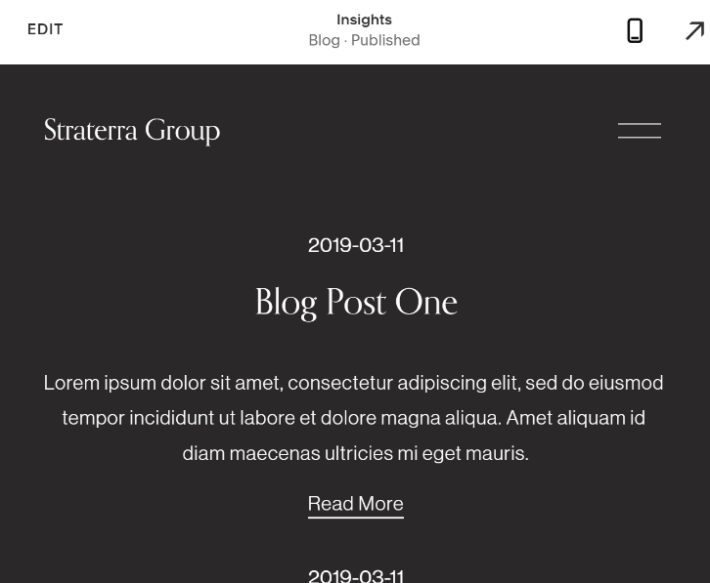
Screen 6 – Contact US


