Hampton Roads Chapter Logo should contain:
- Required
  - National APA logo based on criteria listed in the APA Marketing guide. Attached.
  - Available in multiple formats and sizes (1,2, & 3 inches) so logo is transferable to various mediums.

- Design Suggestions/Ideas for Logo Redesign
  - HRAPA represents seven cities
  - Include seven stars to represent each city
  - Hampton Roads Flag - see below
  - Water
  - Tidewater
  - Bridges
  - Suggested colors – Blue, Green

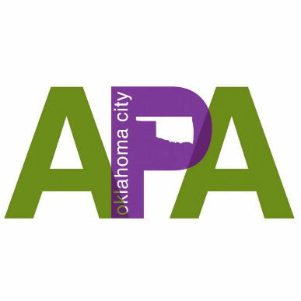
Examples of design style we are loking for:

