Section 1 (home page)

Header Tabs:
Contact Us button to bottom of page contact form
For Sale: with dropdowns to
Simcoe Cottage
Properties (no properties to list yet though)
The Difference
Print Brochure with dropdowns to
8.5x11 (in brief)
11x17 (in brief)
About the Builder: (do we need to inform that they will be leaving this page?)
Steve Weise-link to this for now: https://www.leadingforceedc.com/steve-weise
Gallery-link to this for now: https://www.leadingforceedc.com/project-gallery
PHOTO Replace with this photo included in Brief. Text: Selah Vista Homes and place Selah Vista Logo (without text) in sky in upper left corner. 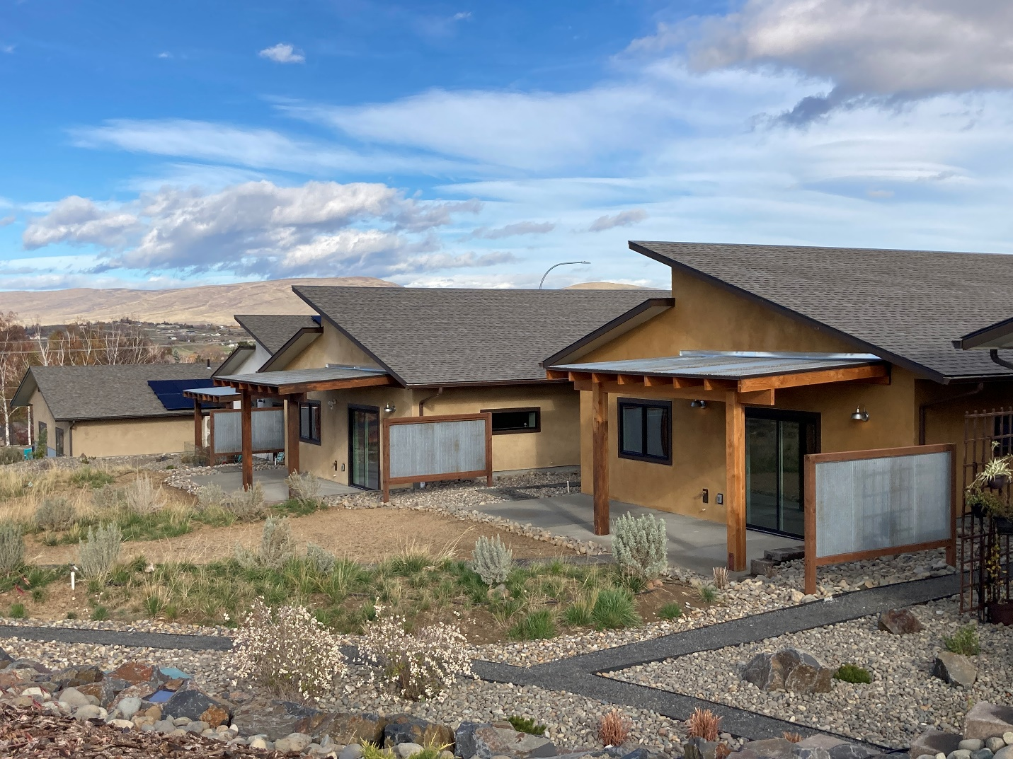
OR Place across bottom of photo or underneath
LOGO + Welcome to Selah Vista Homes
A 60 Home, Net Zero Community in Selah Washington

Section 2
PROPERTIES FOR SALE
Photo on right with Simcoe Cottage + description on left. A 399500 circled price in the bottom right corner of photo
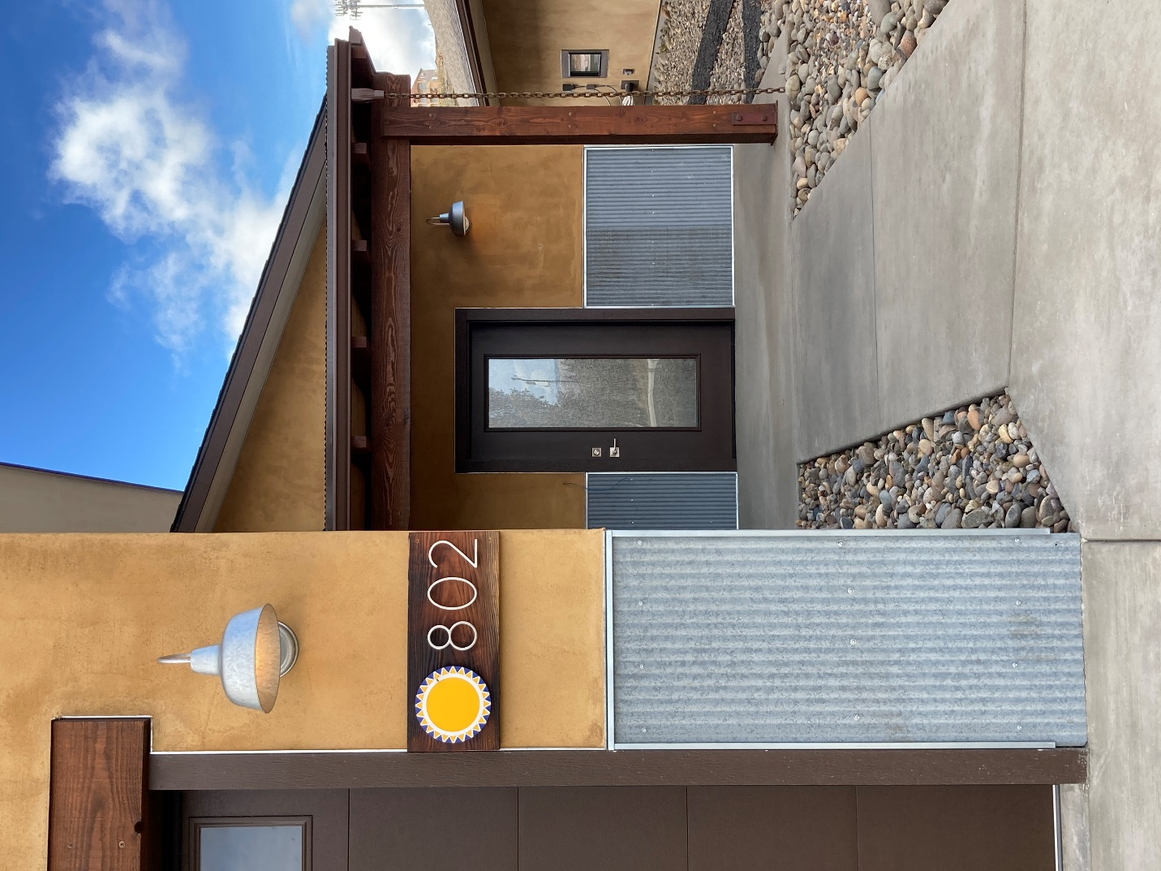
Below text add a MORE Button linked to mls4owners.com/580619
Insert bottom-half portion of Page three of Simcoe Cottage brochure here with property features, floor plans and two logos, for sale by builder etc
Logos link to : https://www.energy.gov/eere/buildings/housing-innovation-awards
https://www.epa.gov/indoorairplus/indoor-airplus-home-buyers

Note TO DESIGNER-WILL THERE BE THE ABILITY TO ADD FEATURED PROPERTIES FOR SALE HERE IN THE FUTURE? Possibly three squares in a row with photo and description below in each?

Section 3: title
THE SELAH VISTA DIFFERENCE
You already have most of it created. I’d like the What we Believe tab on all three photos.
Remove the first part in text boxes that say “we believe everyone, we believe that no one, We believe that we should and replace with these :
Selah Vista Homes are Healthy Homes (use plant photo from current square below)
Selah Vista Homes are Energy Efficient (try this photo)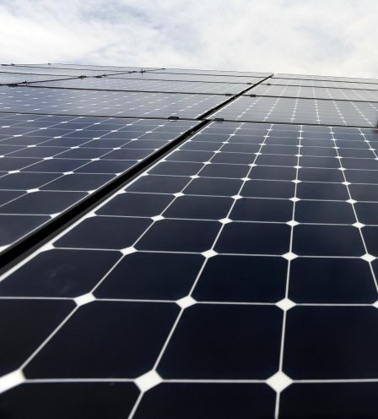

Selah Vista Homes are Built for Life (see construction photos below to replace with, whichever one looks best)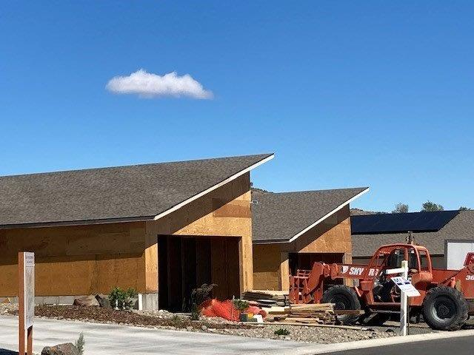

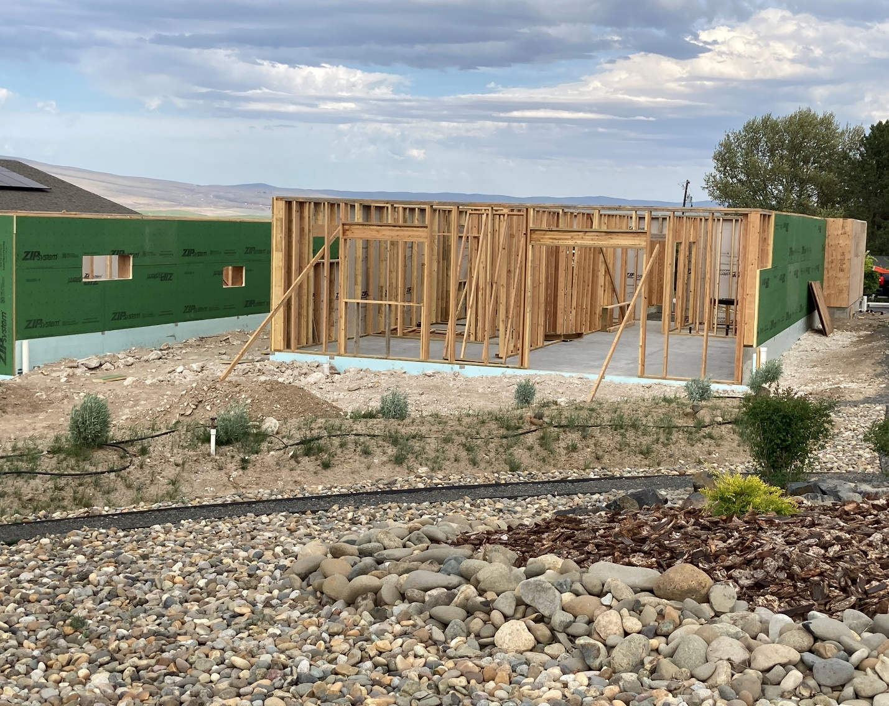
Keep with the bullet points in the squares and see if you can get all the points in each section.

SECTION 4:
COMPARE THE DIFFERENCES
- back page of brochure lists with a photo on side
Or List the Even more to Consider points and There’s More points side by side?

SECTION 5:
ALL SELAH VISTA HOMES ARE VERIFIED
BY A THIRD PARTY
Followed by the four logos in a horizontal line underneath. Links should be live
https://www.epa.gov/watersense/homes-certification
https://www.bpihomeowner.org/blog/technically-speaking-what-blower-door-test-tells-you
Contact us form with LOGO with Facebook and Instagram links,(need to be able to add YouTube later)
Phone: 509-571-1351 Opt3
Directions button to Google:
https://www.google.com/maps/dir/46.6037895,-120.5030045/selah+vista+homes/@46.6340548,-120.5480134,13z/data=!3m1!4b1!4m9!4m8!1m1!4e1!1m5!1m1!1s0x5499d9e3e1ba12db:0xfd0ed6a7f6b422ea!2m2!1d-120.541859!2d46.665035

Footer tabs same as header

